**Tacoma Mountaineers**

**2019 Basic Climbing Course Instructors Manual**

Table of Contents

The Mountaineers Standards for Personal Conduct 2

General Field Trip Teaching Instructions 2

Introduction 2

Teaching Standards 3

Instruction Phases 3

Overall 3

Starting Out 3

In the Trenches 3

Down the Line 3

Clothing and Equipment Requirements for Students 4

General 4

Footwear 4

Seat Harness 4

Helmet 4

Gloves 4

Belay devices 4

Student Skills and Evaluation 4

Essential Skills 4

Critical Skills 5

Student Performance Standards and Evaluation 5

1. Three Point Scale for demonstrating/practicing skills 6

2. Two point Scale for TESTING critical and essential skills 6

Knots Evaluation Standards 6

Field Trip #1 Prep – Fundamentals (Clubhouse) 8

Field Trip #1 – Prusik, Belay, Tie-off with Escape, and Knots Practice 12

Field Trip #2 – Prusik, Belay and Tie-Off with Belay Escape Test 18

Field Trip #3 – Winter Overnight (Paradise, Mt. Rainier) 26

Field Trip #4 Prep - Rock Prep 41

Field Trip #4 - Rock I 34

Field Trip #5 - Rock II (Leavenworth) 43

Field Trip #6 Prep - Crevasse Rescue (Clubhouse) 49

Field Trip #6 - Snow 2 - Crevasse Rescue Test (Panorama Point) 51

Field Trip #7 – Snow 2 – Ice Axe Arrest Test (Glacier Vista) 60

# The Mountaineers Standards for Personal Conduct

All members of the mountaineers, in order to support the club’s purposes – “To explore, study, preserve and enjoy the natural beauty of northwest America” – In a spirit of good fellowship, shall subscribe to the following standards:

1. To exercise personal responsibility and to conduct themselves on Club activities and premises in a manner that will not impair the safety of the party, or prevent the collective participation and enjoyment of others.
2. Private property must be respected.
3. To enter the “outdoors” as a visitor, leaving behind no debris, environmental scars, or other indications of their visit, which would reduce the enjoyment of those who follow.
4. To minimize the environmental impact on the outdoors by using campfires only in properly constructed areas and extinguishing completely after use; conducting human sanitation and washing away from water-courses; and carrying out all solid waste brought into the outdoors.
5. The use of alcohol and other drugs or medications, when incompatible to Mountaineer activities because of their effects on ability and judgment, is prohibited on Club activities and premises in which such use would affect the safety of the party or impair the collective participation and enjoyment of others.
6. Pets, firearms, or any other item(s), which will impair the safety or enjoyment of others, shall not be brought on Mountaineer premises or taken on Club activities.
7. To obey all applicable specific regulations of governmental agencies which affect Mountaineers activities and property.
8. To obey those specific regulations imposed by the Board of Trustees, Branches and Divisions of the Mountaineers, which are necessary to implement the above.

Those Mountaineers who deviate from the philosophy and from the specific Club regulations may be subject to the disciplinary procedures of the Club, including expulsion.

# General Field Trip Teaching Instructions

## Introduction

Many of our students are here to see if they would like mountaineering. The Basic Course can go a long way toward making that happen. While we must maintain the high standards that have been set in the past, at the same time we don’t want to forget that all of us, students and instructors alike, are in this to have **FUN**. As an instructor, you are key to making the course enjoyable and rewarding and to bringing new climbers into the club. Some things you can do are:

1. Get to Know the Students – Introduce yourself and take the time to talk to them to understand where their skills and abilities lie. Use that knowledge to acquaint them with the activities. Share your experience and knowledge.
2. Be Patient – Most of the students will have had little or no mountaineering experience. Someone may take longer to learn a skill, but that doesn’t mean that he/she will be any less able to apply it in the long run.
3. Be Supportive and Instill Confidence – Inform the students that safety is a prime consideration and that field trip activities are conducted under tightly controlled conditions. Encourage them to continue trying.
4. Maintain High Standards – If you condone substandard performance, you debase the entire course. You are responsible for signing off the student’s skills, therefore you should feeling confident of their skills to climb with any leader. Think of it as a reflection of you.
5. Challenge the Students – Push the students to their limit; make them proud of their accomplishments.
6. HAVE FUN – If you’re having fun as the instructor, so are the students.

## Teaching Standards

1. Responsibility – The things you teach will be the foundation on which all of a student’s future climbing is supported. How well you do your job will be a major factor in determining how good and safe a climber he/she will be and how well you or another unsuspecting leader are belayed on the climbs you lead.
2. Be an Example – As an instructor, you are a representative of the Mountaineers. All instructors should set the example by meeting or exceeding the standards expected of the students.
3. Preparation – On some field trips you will be assigned a group of students and stay with them all day. On others, you will be assigned a topic(s) to teach and may be rotated to other stations during the day. Therefore, you must **be prepared to teach any and all of the material to be covered on that field trip**. Please take time before the trip to review pertinent material in this manual. If you aren’t sure about a skill, ask.
4. Instructional Material – The Basic Course teaches a STANDARD set of skills that can be safely used by all climbers under a wide range of conditions. TEACH ONLY THE APPROVED METHODS. While you have the experience and judgment to know when one can safely deviate from standard procedures few, if any, of the students possess this knowledge.
5. Safety – Most, if not all, of the students are new to climbing and may be unaware of the consequences of their actions. Be alert for unsafe acts on their part and use every opportunity to stress safety. Continuously check the students and stress that they must check and double-check both themselves and their fellow climbers.

## Instruction Phases

Overall

1. Be outgoing, friendly and always open for questions or clarification. You are the “expert” and are trusted by the students – make sure to only tell them what you know, if you do not know, ask somebody else.
2. Be positive and confident in what you are teaching, not hesitant or “AUTHORITARIAN!” Remember, the students trust your words and actions and want to do it right.
3. Make the students feel comfortable learning by example (you). Remember how you felt learning these skills for the first time.

Starting Out

****Be Prepared - Do your homework before the field trip so you are teaching correct methods. If you have a question about technique, be sure to ask the field trip leader.

1. Review each student’s Field Trip Record Book to ensure the completion and signoff of prerequisite skills.
2. Learn everyone’s name and make sure they know yours, especially if you are with them all day.
3. Keep your words and actions clear, simple and short.
4. Teach by demonstration and participation. Use a student model when appropriate.
5. Teach one concept at a time until everyone has mastered it. Continuously check and test progress. Back up and re-teach if necessary.
6. Plan your words and keep them concise.
7. If students don’t ask questions, ask them questions to ensure understanding.

In the Trenches

1. Adjust each situation to the individual student’s speed and ability to learn each skill. Have students help each other.
2. Be informative without boring them.
3. Be patient; let students learn by their mistakes and successes.
4. Describe the task to be learned and monitor student progress to ensure proper technique is being followed. Provide constructive feedback as they are proceeding, stressing the KEY points and proper techniques.
5. Make sure everyone has something to work on if possible.

Down the Line

1. Make sure everyone has learned the same techniques even if they are not proficient at this time.
2. Present yourself professionally and confidently.
3. Make sure to keep the field trip leader aware of any needs you or the students may have.

# Clothing and Equipment Requirements for Students

General

Check each student has all necessary clothing and required equipment prior to beginning field trip activities. Students who do not have adequate clothing and equipment will not be permitted to participate in the field trip. In particular pay attention to the following equipment:

Footwear

1. Students are required to wear sturdy leather hi top boots with Vibram or similar Soles for all field trip activities. Crampon compatible mountaineering boots are required no later than Field Trips 3. Students may substitute sturdy hiking boots at Field Trip 1 Prep and Field Trip 1.
2. Rock shoes should not be used at the rock climbing field trips, but may be worn for additional practice. Rock shoes may be allowed on climbs at Leader discretion.

Seat Harness

1. Each student must have a commercially constructed seat harness in good condition as approved in the student manual. All seat harnesses are to be used according to the manufacturer’s instructions.
2. Instructors should inspect for proper fit on the hips and legs. Sufficient webbing should be visible to double back all loop buckles with at least 2 inches tails. Harnesses should fit well both with many layers and with a t-shirt and pants. Proper fit should be checked at each field trip and at tie-in.
3. Seat harnesses without belay loops are not acceptable (i.e. the Alpine Bod harness is no longer acceptable). Gear loops on the waist belt are recommended.
4. Harness check and sign off is required at Field Trip 1 Prep.

Helmet

1. Students are required to wear UIAA approved climbing helmets at all field trips and should have their helmet by Field Trip 1. Instructors may need to provide their helmet for students use at the Field Trip 1 Prep. Students absolutely must have their own helmets by Field trip 2.
2. Ensure that each student’s helmets fits properly, especially if being supplied by an instructor, and emphasize that the chin strap is to be kept fastened.
3. Instructors are required to wear UIAA approved climbing helmets at designated field trips. Wear your helmet. Students will follow your example.

Gloves

Students and instructors are required to wear gloves for all belays and rappels.

Belay devices

Students must use a tubular belay device or tubular device with friction grooves. The figure 8, Sticht plate and the Petzl Gri Gri are not approved belaying devices.

# 

# Student Skills and Evaluation

## Essential Skills

All skills taught in the Basic Climbing Course are essential for safe and successful climbs. Field trips are designed to help the students learn through discussion, demonstration and practice. All of the skills taught will increase general knowledge. Many of these skills must be proficiently performed by the students in a test (without help from the instructor) or they will not be permitted to continue to subsequent field trips or climbs. Once a skill test has been completed, students are expected to perform that skill proficiently in all subsequent course activities.

* **Conditioning** is monitored at all course activities. The conditioning skill test is to complete a conditioner. Completion of a conditioner hike is required prior to Field Trip 3. Satisfactory completion (hiking ~4000ft in under 2.5 hours i.e. Mount Si) is required prior to Field Trip 5 and all Basic climbs.
* **Ten Essential Systems** acquisition is checked for reasonable progress at FT 1 and FT 2. A complete set must be acquired by the beginning of the Field Trip 3. Students must carry the Ten Essential Systems at all subsequent field trips and all Basic climbs.

NOTE: All junior students (ages 14 through 17) must carry a signed (by parent or legal guardian) “Consent for Medical Care and Treatment of a Minor” form.

* **Rock Climbing** is practiced at Rock I (FT 4) and tested at Rock II Field Trip 5. The student must demonstrate rock climbing proficiency at the Rock II field trip.
* **Crevasse Rescue Methods**
* 3:1 (Z) Pulley Method - is demonstrated at the Field Trip 2, practiced at Field Trip 3 and Field Trip 6 Prep, and then evaluated for proficiency at the Crevasse Rescue Field Trip 6.
* 2:1 (C) Pulley Method- is demonstrated at Field Trip 3 and practiced at FT 6 Prep. Evaluation is done at FT 6.
* **Prusiking** is demonstrated and practiced at the Field Trip 1 Prep and Field Trip 1. It is then evaluated for proficiency at the Field Trip 2.
* **Carabiner-Ice Axe Belay** is practiced at the Field Trip 3 and evaluated for proficiency at the FT 7.
* **Leader Tie-off with Belay Escape** is demonstrated at FT 1 Prep, practiced at FT 1, and tested at FT2.

## Critical Skills

A few of the essential skills have been identified as critical to successful climbing and to safety. Critical skills, if not performed properly, present an immediate risk of serious injury or death to the student and/or their climbing partner(s). Particular attention will be paid to critical skills during field trips. All of the critical skills must be proficiently performed by each student in a test (without help from the instructor) or they will not be permitted to continue to subsequent field trips or climbs. Once a skill test has been completed, each student is expected to perform that skill proficiently in all subsequent course activities and on climbs.

* **Knots** are demonstrated and practiced at the Field Trip 1 Prep and further practiced at subsequent field trips. The student must complete the knot test prior to Rock I Field Trip 4. Students will be expected to be proficient with all knots required at each subsequent field trip.
* **Ice Axe Arrests** are demonstrated and practiced at FT 3, and then tested at FT 7.
* **Belaying** will be accomplished by all students using a Münter Hitch and the PBUS technique with a belay device. Students will practice this technique at the Field Trip 1 and be tested at the FT2. Students will be expected to be proficient with belays at each subsequent field trip.
* **Rappels** will be completed by all students using the Extended Device and Carabiner Brake Methods. The student will demonstrate the use of an autoblock with both methods and a leg wrap tie off while rappelling with a device only at the Rock I Field Trip 4. The student will be tested on rappels at the Rock II field trip 5.

When the student passes the critical skills test with an evaluation of “S” (Safe), the instructor will note in Student’s Field Trip Record Book AND sign off the corresponding Critical Skill on the front cover of the student’s book.

If an instructor is unsure as to whether they should sign off based on their evaluation, they should first discuss students’ performance with the FT leader, Critical Skills coordinator, or instructor before signing off. Instructors do not sign off the critical skill on the front cover for a QS or NS evaluation.

## 

## Student Performance Standards and Evaluation

General

The following performance standards are used to let the students know how they are progressing, and to help the Basic Committee and Field Trip Leaders identify those students that may need additional assistance or who, in some cases, should not be permitted to continue with the class or on Basic climbs. The student’s *Field Trip Record Book* evaluations and instructor comments are used to monitor a student’s progress. Student evaluations should be carefully considered and comments should be complete and specific.

General Skills Evaluations

Some activities at field trips require the student’s preparation and participation but do not test their abilities. In such instances an **“S”** evaluation will represent sufficiently prepared or participated and a **“NS”** evaluation will represent NOT sufficiently prepared or NOT participating.

Essential and Critical Skill Evaluation

To give instructors latitude and to better identify those students that might require help, a three point rating scale for essential skills and a two point rating scale for critical skills– has been adopted. The following performance standards should guide you in evaluating each student’s performance.

### Scale for demonstrating/practicing skills

**S** **Safe** – After instruction is given, the student is able to demonstrate the skill with minimal or no prompting from the instructor.

**NS** **Not Safe** – After instruction is given, the student is not able to demonstrate the skill, even with major prompting from instructor.

A grade of **NS** on the three-point skill evaluation scale does not prevent student from continuing in the course. It means that the student needs additional practice, self-study, and/or should contact their mentor for additional instruction if needed.

### Scale for TESTING critical and essential skills

**S** **Safe** – a student is able to demonstrate the skill with **minimal or no prompting** from the instructor.

**NS** **Not Safe** – The student is not able to demonstrate the skill without prompting from the instructor.

A student receiving a grade of **NS** on a skills testcannot participate in any further field trips or climbs which requires that skill. The student must contact the Critical Skills Coordinator for the course and his/her mentor to make a plan for corrective action, which will include a requirement for the student to be able to demonstrate the skill with a **Safe** evaluation before continuing in the course.

Knots Evaluation Standards

This is a critical skills test.The following procedures will be used for the knots test:

1. When a student has learned all of the required knots, he may request that he be evaluated for the “Knot Test” at any of the first 4 field trips. No review will be given prior to the test.
2. To pass, the student must (without assistance) correctly tie all knots and know the principal use(s) of each. The student is allowed to self-correct errors in tying the knots, but the instructor may not provide any assistance or guidance prior to the retry. Once any knot has been presented by the student to the instructor, it must be correct or the student fails the test.
3. PASSES – Instructor will print name and insert comments on the back cover and sign-off “Knot Test” on the front cover of the student’s *Field Trip Record Book*.
4. FAILS – Student must retake the test at a subsequent field trip

Applying the ratings and standards:

1. The performance standards are guidelines and are not intended to replace an instructor’s judgment. The instructor and field trip leader have the final say on a student’s rating.
2. When evaluating a student’s performance, consider the stage of the course, whether or not it is practice or a skills test, and the amount of progress expected on the field trip.
3. The performance ratings should reflect the student’s knowledge or ability at the end of each activity during field trip. Evaluate each student and enter your performance ratings and comments in their *Field Trip Record Book* immediately following each activity or phase of the field trip. Don’t wait until the end of the day when you can’t recall how each student performed in each activity.
4. For ratings of **Safe** and **Questionably Safe**, the student should be expected to require minimum supervision on a Basic climb and should neither cause delay nor endanger the party. **You would have no qualms about taking this student on a Basic climb where you were the climb leader.**
5. A **Not Safe** rating should reflect a set of failures, not a single failed attempt. **Comments are required in the student’s *Field Trip Record Book* for all Not Safe evaluations**. Please provide enough detail for the Basic Committee to determine how to help the student. Discuss all Not Safe evaluations and comments with the student and the field trip leader at the end of the day. Field trip leaders are to report all **Not Safe** ratings to the Basic Climbing Committee. Have the courage to stand behind and explain your evaluation.
6. Comments are appropriate at any time, the more the better. Include comments about the student’s attitude and judgment. Be especially free with comments recognizing students with positive attitude or outstanding performance.

# 

# Field Trip #1 Prep – Fundamentals (Clubhouse)

**Time:**  Instructors meeting at6:00 PM at clubhouse (students start at 6:30)

**Note**: It’s helpful if you have few instructors (3 –4) show up early (<5:30) to set up stations.

**Place**: Tacoma Mountaineer Clubhouse

Purpose:

|  |  |
| --- | --- |
| Check student’s seat harness | Construct and size Texas prusiks |
| Introduce and practice knots | Introduce and practice prusiking |
| Construct leader tie-off, chest harness, and slings | Demo belaying and leader tie off with belay escape |

Instructor Equipment:

|  |  |  |
| --- | --- | --- |
| Knife | Lighter | Pen/pencil |
| Tape measure | Helmet (for student use) | Field Trip Instructor Manual |
| Eqmnt for Leader Tie- off/Escape | Equipment for Prusiking Perlon/webbing (to demo knots) | |
|  |  | |

Instructions:

General

1. Check each student has all adequate **clothing** and required **equipment** prior to beginning the other field trip activities. Cotton is OK at this Field trip (emphasize it is the only time it will be allowed). Dresses are not appropriate. Sturdy boots are required for prusiking. **Students who do not have appropriate clothing and equipment will not be permitted to participate in those parts of the field trip in which their clothing would be a hazard.**
2. Integrate knot-tying instruction with the preparation of the texas prusiks and slings.
3. Prusik stations will be assigned dedicated instructors who will man the station for the evening. Have students rotate through the prusik station as it becomes available and the student is ready.
4. When all students have completed tying their slings & prusiks and done the prusik exercise. Have them watch the leader tie-off demo, practice other knots, and/or find some available space and demonstrate setting up a belay station and belaying a lead climber.
5. **Report** any student who is late, unprepared, making insufficient progress or delaying the group to the field trip leader. Make note in the student’s *Field Trip Record Book.*

Sling Construction Station

1. Students will be required to furnish 46 feet of 1 inch tubular webbing cut to following lengths for:
2. 1 Double sling – 10 feet
3. 1 Personal anchor – 11 feet (sizing to be adjusted)
4. 2 single slings – 6 feet each
5. 1 Short sling – 4 feet
6. 1 Chest harness – 9 feet
7. Two 4 feet sections of 5 and 6mm perlon for leader tie-off slings
8. 8 feet of 5 or 6mm perlon for pack sling (or 6 feet of 1 inch tubing – not included in 46 feet listed above)
9. 25 feet of 5 or 6mm perlon for Texas Prusiks (**DO NOT cut** until sized correctly).
10. Mention the need to seal the ends with a flame or hot knife and to **label each webbing sling with the date of construction.**
11. Show the students how to tie the water knot and double fisherman’s to make their slings and explain where and when each sling is used.

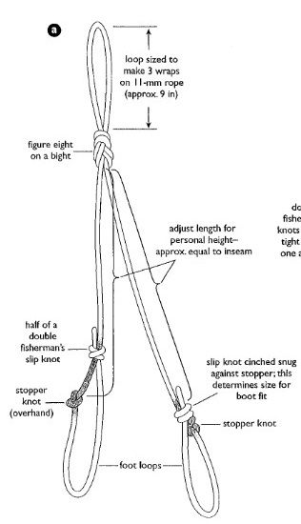**Tying the Texas Prusiks**

|  |  |  |
| --- | --- | --- |
| Approximate Sling Lengths | | |
| **Climber Height** | **Foot Sling Length** | **Waist Sling Length** |
| 60 inches | 132 inches | 60 inches |
| 65 inches | 138 inches | 65 inches |
| 70 inches | 144 inches | 70 inches |
| 76 inches | 156 inches | 76 inches |

Pictures can be found in Freedom 9 pg. 395 or Freedom 8 pg. 380.

1. **Foot Prusik (diagram a)**

The foot prusik consists of a figure 8 on a bight in the center of a piece of perlon and two foot loops with over hand stopper knots sized with a double fisherman that will cinch down on top of it. You can use the chart above to approximately length of the perlon, however prusik should extend from the boot to the waist.

* 1. Start by wrapping a loop of perlon around the students boot, leaving extra length at the end to tie an over hand knot and a double fisherman’s knot to construct the first foot loop.
  2. While the loop is still around the students foot, have the student tie an overhand knot centered above the laces of the boot in the “long end” of perlon.
  3. Then with the “short end” of the perlon help the student tie a double fisherman’s knot (making a relatively tight loop around the boot) above the overhand knot to complete the first foot loop. Make sure there is sufficient tail at the end of the double fisherman’s knot and adjust if necessary
  4. With the students boot in the first foot loop, pull the perlon up to the students waist/belay loop. Bend the perlon over to make a bite approximately 9 inches long and tie a figure eight (making a figure 8 on a bight with the bight being 9 inches long)
  5. Have the student use the rest of the perlon and sizing of the first foot loop to make the second foot loop.
  6. Adjust length as necessary

**Chest/Waist Prusik (diagram b)**

The chest/waist prusik is a piece of perlon with the ends tied together using a double fisherman’s knot and a figure eight on a bight(optional) to keep the double fisherman’s knot from moving/getting in the way. This prusik should extend from the belly button (when attached to a locking carabiner off the seat harness belay loop) to the eyebrows.

1. Take a bite of perlon, roughly the length from the belly button to the eyebrow and loosely tie the ends together with a double fisherman’s knot.
2. 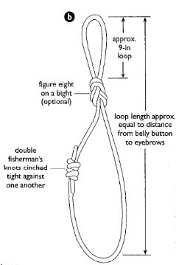Tie a figure eight on a bight approximately 9 inches in one end of the sling, making sure to keep the double fisherman’s knot centered on the side of the second “bigger’ loop (i.e. the figure eight will create two loops, one side of the sling will be used to tie the prusik knot on the rope, the other loop will be used to attach to the seat harness belay loop.
3. Adjust length as necessary

Knots

Double fisherman’s Figure 8 on a bight Prusik

Water knot Rewoven figure 8 Bachmann

Munter Hitch Clove Hitch Girth Hitch

Device Mule Overhand Munter Mule Overhand Flat Overhand Bend

Single Bowline Bowline on a Coil

1. Stress the importance of knots and how they are used (see appendix). They are a critical skill and a part of the climber’s safety system. All knots should be double checked to confirm that they are properly tied.
2. Explain what is meant by “dressing” a knot (strands parallel and not twisted, kinked or crossed) and the need to “dress” both Figure Eight’s, Prusik, Bachmann, and Water Knot. Explain that a dressed knot is stronger and is easier to confirm as properly tied.
3. Ensure the students understand the importance of tying-off the Single Bowline, Bowline-on-a-Coil, Mule knot, and the importance of leaving at least 2 inch tails (12-18” for a flat overhand bend) on all knots
4. Caution the students to **check the tightness of the water knots on webbing slings each use and to make sure there is at least 2 inch tails on all slings** prior to each use.

**Performance Standards**

1. **Safe:**Correctly ties the knot and knows its major uses.
2. **Questionably Safe:** Correctly ties the knot but requires some instruction or does not know its major uses.
3. **Not Safe:** Cannot tie the knot even after instruction.

Belaying and Leader Tie-off with Belay Escape Demo Station

The main purpose of this station is to introduce the students to climbing signals, belaying, leader tie-off and belay escape. See appendix for step-by-step instructions

**Performance Standards**

* Sufficient : They watched the demo
* Not Sufficient: They did not have time to watch the demo

Prusik Station

Harness Check

1. Each student must have a commercially constructed seat harness in good condition. The Alpine bod is not an acceptable harness. All harnesses must have a belay loop. Gear loops are highly recommended.
2. Instructors should inspect for proper fit on the hips and legs and sufficient webbing to double back all loop buckles with at least 2 inches tails. Make sure the harness can be adjusted and fit correctly for adding layers, but can also be cinched down tight enough for a t-shirt.
3. **Sign off on the front cover of the student’s *Field Trip Record Book*** for an acceptable harness.

Clothing/Equipment Check

Student must have sturdy footwear and be dressed appropriately for prusiking. The student must have all of the supplies for building their prusiks and slings and a seat harness.

**Performance Standards**

1. **Sufficient:** Has adequate clothing and all required equipment.
2. **Not Sufficient:** Does not have adequate clothing or all required equipment. Student will not be permitted to prusik in the field trip prep. (Refer to field trip leader.)

Prusiking (HELMETS REQUIRED)

General: Explain prusiking fundamentals and use.

1. Show the students how to tie in to the rope:
   1. End of the rope - use a rewoven figure 8
   2. In the middle of the rope - use a butterfly knot and attached to the belay loop of the seat harness with opposite and opposed locking carabiners.
2. Have students attach their prusiks to the rope explaining that the chest prusik goes above the foot prusik (assuming they are tied into the end of the rope). Explain what they would do if they were in the middle of the rope (one prusik on each side of the tie in), but for today have the student put the prusiks above the tie in.
3. Have the students attach their chest/waist prusik to their seat harness with a locking carabiner attached to the belay loop.
4. Double check to make sure the student is tied in correctly, has their chest harness, backpack, pack sling and helmet on and instruct them on ascending the rope.
   1. Explain that by first weighting the foot prusik they are free to move the chest/waist prusik up, then by weighting the chest/waist prusik they are free to move the foot prusik up.
   2. Explain to the student they have to unweight the prusik before they can move it, so to be careful when descending to not let the chest/waist prusik touch the foot prusik, this can cause problems.
   3. Mention that if the rope was icy and they were having trouble ascending the rope it would be advantageous to tie “stopper” knots below the foot prusik as they ascend.

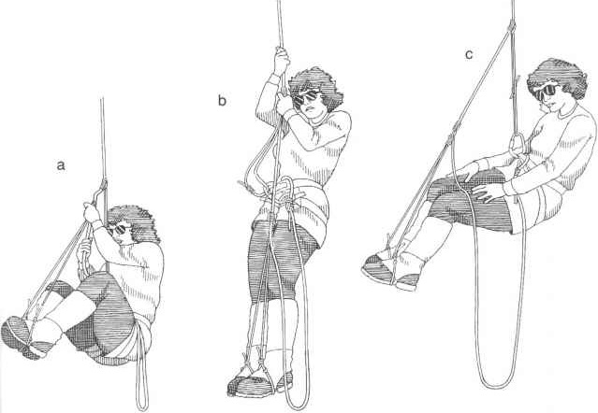

1. When the student gets half way up the rope, teach the student to softly drop their pack by attaching the pack sling to the rope between their legs and slowly lower the pack.
   1. Explain why it is important to not just drop the pack (shock load the anchor or your partners).
   2. Explain when you would (when it is pulling you backwards or impeding your ability to climb up an icy wet rope and out of a crevasse) or would not (you can easily climb or walk out of the crevasse) want to drop your pack.
2. Have the student finish ascending to the rafters and then descend to the ground.

**Performance Standards**

1. **Safe:** Can ascend the rope, and softly drops their pack.
2. **Questionably Safe:** Can ascend the rope but with much difficulty and/or drops their pack.
3. **Not Safe:** Cannot ascend the rope

# Field Trip #1 – Fundamentals (Clubhouse)

**Time:** 7:00 a.m. for instructors 8:00 a.m. for students

**Place:** Tacoma Clubhouse

Purpose:

|  |  |
| --- | --- |
| Practice knots | Discuss anchor systems, and how to attach to an anchor |
| Practice prusiking | Practice rope coiling and discuss rope care |
| Practice belaying | Practice Leader tie-off and belay escape |

Instructor Equipment:

|  |  |  |
| --- | --- | --- |
| Ten essential systems | Carabiners (including locking) | Helmet (for student use) |
| Mountaineering boots | Slings (for belay anchors) | Belay gloves |
| Seat & chest harness | Leader tie off | Pen/pencil |
| Pear-shaped locking carabiner | Texas prusiks | *Field Trip Instructor Manual* |
| Belay device | Perlon/webbing (to demo knots) |  |

Instructions:

General

1. Check each student has all necessary **clothing** and required **equipment** prior to beginning the activities of the field trip. Students may still be learning the knots, be prepared to assist/demonstrate them for each activity.
2. **Double check all** **harnesses and helmets** to ensure the students are wearing them properly prior to permitting a student to belay or prusik.
3. Students are required to wear gloves for all belays.
4. Belaying, prusiking, and leader tie-off with belay escape are the most important activities of the field trip. Complete Ten Essential Systems, knots, rope coiling, etc. in between primary activities.
5. **Stress safety:** use the knot, belay and prusik instruction to reinforce this.
6. Students are to keep their pack/equipment with them at all times. If anyone leaves it behind, have them go get it.
7. **Report** any student who is late, unprepared, making insufficient progress or delaying the group to the field trip leader.

Clothing/Equipment

Student must have, at a minimum, sturdy hiking boots (mountaineering boots are not required until FT 2) and clothing to provide a sufficient level of protection under all reasonable weather conditions. Student must have all required equipment.

**Performance Standards**

1. **Safe:** Has all necessary clothing and required equipment.
2. **Not Safe:** Does not have adequate clothing or all required equipment. Student will not be permitted to participate in the field trip (refer to field trip leader).

Ten Essential Systems

Have all of the students in your group get out their Ten Essential Systems. Have an open discussion on what are appropriate items and the importance of each.

**Performance Standards**

Students should be making an effort to acquire all required items. They are not expected to have a complete set at this time.

1. **Safe:** Has all required items, and in sufficient quantities.
2. **Not Safe:** Has few required items (refer to field trip leader).

Knots

Double Fisherman’s Figure-8 on a Bite Prusik

Water Knot Rewoven Figure-8 Bachmann

Munter Hitch Clove Hitch Girth Hitch

Device Mule Overhand Munter Mule Overhand Flat Overhand Bend

Single Bowline Bowline on a Coil

1. Stress the importance of knots. They are a critical skill and a part of the climber’s safety system.
2. Demonstrate the knots, and explain their major use(s).
3. Explain what is meant by “dressing” a knot (strands parallel and not twisted, kinked or crossed) and the need to “dress” a rewoven figure-8, prusik, Bachmann, and water knot. Explain that a dressed knot is stronger, is easier to confirm as properly tied, and easier to untie.
4. Have each student practice tying each knot under realistic conditions (with gloves on).
5. Ensure the students understand the importance of tying-off/adding a back-up knot to the single bowline, bowline-on-a-coil, mule knot, and rewoven figure-8.
6. Ensure the students understand importance of leaving adequate tail. It is recommended to have **at least** two to three inch tails for the water knot, double fisherman’s, and any back-up knot. At least, 12-18 inches is recommended for a flat overhand bend.
7. Caution the students to check the tightness of the water knots before each use as it does not self-tighten and can loosen by rough handling. Demonstrate loosening of the water knot by rolling the knot 15-20 times between the palms of your hands.

**Performance Standards**

1. **Safe:**Correctly ties the knot and knows its major uses.
2. **Not Safe:** Cannot tie the knot even after instruction (refer to field trip leader).

Rope Care and Coiling

1. Show students how to butterfly coil and carry a rope on their pack. Each student should practice.
2. Explain why you DON’T STEP ON A CLIMBING ROPE.
3. Discuss care and storage of a climbing rope, and some criteria for when one should be retired.

Note: Students should have read about rope care in (FOH 9th edition pg 152-154), so don’t hesitate to ask them questions first.

**Performance Standards**

1. **Safe:** Can proficiently coil a rope.
2. **Not Safe:** Requires excessive instruction (refer to field trip leader).

Prusiking HELMET REQUIRED

1. Discuss texas prusik applications/scenarios and how they are carried for glacier travel.
2. Have the student first try to correctly tie into the rope and set up prusiks, then help them if they are incorrect or struggling. Remember: For middle climber tie-in, we are using one locking and one non-locking carabiner opposite and opposed.
3. When the student is correctly tied into the rope, have them ascend, drop their pack, continue to ascend, and then descend the rope. NOTE: Students must start from a suspended position, then don foot loops, and climb with the pack suspended from the rope.
4. Make any necessary adjustments to the sizing of the prusiks.

**Performance Standards**:

1. **Safe:** Can proficiently tie in, ascend the rope, and softly drops their pack.
2. **Not Safe/Needs more practice:** Requires excessive instruction.

Belay Station (Münter Hitch and PBUS method with Device) GLOVES REQUIRED

The primary focus of this field trip is to teach the students how to safely belay. Please ensure that all students get adequate practice before moving to the next station.

**Station Set Up:** This station will simulate climbing in a gym, utilizing a top rope system solely for the purpose of belay practice and use of climbing signals. **Students will not be tying-in nor attaching to an anchor.**

**Student Requirements**: Each student must be able to:

1. **Set up the belay (Münter hitch and device):** Rope is correctly threaded through the device and locked to the belay loop of the harness with a locked locking carabiner. Munter hitch is tied correctly with the braking strand on the spine of the carabiner.
2. **Belay using the PBUS method, both right and left hands, Munter hitch and belay device**: Make sure the students are able to take up slack, payout rope, and arrest a falling climber with the correct braking positions.

**Belay Technique – PBUS**

* Student must master coordinated hand movements, showing how to take up slack and pay out rope.
* Student must belay with the brake hand NEVER leaving the rope.

**Braking Technique**

* **Münter Hitch Belay** : braking position is with braking hand forward
* **Device Belay**: braking position is with braking hand pulled back toward hip.

1. **Demonstrate proper use of climbing signals below:**

Commands must be short and spoken in a loud, crisp manner so that they can be easily understood under adverse conditions. Don’t embellish them, use exactly as written. Remind them to use their partner’s name.

**“On Belay?” “Climbing” “Slack”**

**“Belay On” “Climb on” “Take”**

**“Watch Me” “Falling”**

**Performance Standards**:

1. **Safe:** Demonstrates climbing signals and all belaying skills.
2. **Questionably Safe** Has made adequate progress on demonstrating climbing signals and belaying skills. Student will require some practice prior to being prepared for the Belaying field trip.
3. **Not Safe:** Consistently makes errors. Needs major practice.

**Belay Set–Up, Leader Tie-Off, and Escaping the Belay Station**

**General**

Although rarely used in the field, especially on Mountaineer’s approved basic rock climbs, we teach Leader Tie-off and Belay Escape not only to introduce rope and rescue systems, but to instill a sense of responsibility in the basic students. Make sure to discuss with the students the circumstances when Leader Tie-Off and particularly escaping the belay would be necessary.

**Station Set Up**: Anchor should be built for student to clip into.

**Belay Set-up and Stance:**

NOTE: The students are not expected to set-up an anchor, however, they must be able to clip into an available anchor. The students must demonstrate the set-up of each belay method using the right and left hand to brake.

1. Demonstrate and discuss the importance of flaking out a climbing rope. Showing them the importance of placing it near the anchor and positioning it on the side of the belayer that they will be using as a braking hand.
2. Have each student tie into the climbing rope with a correctly dressed rewoven figure-8 backed-up with an overhand knot, showing them that the belayer uses the bottom of the flaked out rope and the climber uses the top.
3. Have the belayer attach to the anchor and explain the need for good body positioning: using a clove hitch tied to a locking carabiner (clipped down-and-out). Tether to the anchor (within arm’s reach), the ability to see the route, protection from rock fall, and belayer in-line with the pull from a fall. )
4. Make sure the student understands that potentially necessary equipment (i.e. Leader tie-off, extra biners, webbing) should be easily accessible before starting the belay.
5. Have the students do a safety check: checking harness, knots, etc.
6. Now have the students practice belaying and using climbing signals. NOTE: The climber should only climb if being top rope belayed by the instructor as well.

**Münter Hitch Belay:** ensure the student has tied the knot correctly and recognizes the “rolling R” characteristics when correctly tied and has locked the carabiner. When braking, they should pull forward.

**Device Belay:** ensure the student has threaded the rope through his device properly and has locked the carabiner. Emphasize that with the correct braking hand movement, pull slack through and then immediately down (making an arch), the device will do the work and provide the friction to slow and stop a fall.

1. Have the climber clip their rope to the wall, to weight the rope for the belay, and have to belayer start leader tie-off.

**Leader Tie-off with Belay Escape:**

See PowerPoint

**Performance Standards**:

1. **Safe:** Demonstrates attaching to an anchor, climbing signals, all belaying skills, and does leader tie-off without assistance from an instructor.
2. **Questionably Safe** Has made adequate progress on demonstrating attaching to an anchor, climbing signals, belaying skills, but needs assistance from the instructor. Student will require some practice prior to being prepared for the Belaying field trip.
3. **Not Safe:** Consistently makes errors. Needs major practice.

**Anchors Systems Station**

**General**

The purpose of this station is to introduce the students to anchor systems, construct their personal anchor, and to help them understand when and how to attach to an anchor.

**Personal Anchors Systems**

1. **Set up/Sizing**- A students Personal Anchor will be constructed with an 11 foot piece of webbing with the ends tied together using a water knot. An overhand knot should be tied in slightly off center, so the student can set up an equalized extended rappel. Below are direction for correct placement of the overhand knot:
2. Have the student girth hitch the tied sling through both hardpoints of their harness, paying attention so that the water knot is further away from their harness, but not at the end of the girth hitch.
3. Take a locking carabiner and attach the PA to the belay loop.
4. Pull the PA away from the harness producing a bend in the webbing, which will show where to tie an overhand knot, and essentially creating an offset center. Mark/Hold this point, unclip the PA from the carabiner, and tie an overhand knot in the PA where the bend was marked. NOTE: Make sure that the water knot falls on the side that attaches back to the harness with the locking carabiner
5. **Describe scenarios of when to use a personal anchor**

A personal anchor is used when a climber is stopped in an exposed situation, and a reliable anchor has already been built. This includes:

1. When setting up/preparing to rappel
2. A secondary attachment to a rock climbing anchor
3. When stopped on a glacier, where there is the real possibility (or fact) of crevasses nearby
4. **Discuss why a clove hitch is the preferred method to use to attach to an anchor vs PA**

PA is static and not meant to take a fall. Clove hitch uses the rope, which is dynamic and can take a fall.

**Types of Rock Climbing Anchors and How to attach to them**:

Build each anchor on the wall outside and use the tree for the natural anchor. Talk through SERENE with each anchor set up.

1. Fixed Anchors (AKA Sport anchors – bolts and pitons) – commonly consists of two or more bolts with chains. If the anchor does not have chains, perlon or webbing should be attached to the bolt hanger(s) via a carabiner(s) to build an anchor. Students should clove into the master point if an anchor is built and can PA into the head of the piton or hanger of the bolt/piton with a locking carabiner.
2. Removable Anchors (Trad anchors) – students should clove into the master point with a locking carabiner, and can PA into the shelf for redundancy. Discuss with the students the importance of clipping to all 3 strands of the shelf if clipping to the shelf.
3. Natural Anchors (Big ass rocks or well rooted large tree) – clove hitch with a locking carabiner into the master point, if available, or all attached slings when no master point is available.

**Removable Anchors**

1. Evaluating an Anchor System (SERENE)

S – Solid, each individual component (protection, sling/perlon, and carabiners) should be solid

NOTE: We use solid, because you can sling a horn but it is not secure, or you can tie a shoe string on a tree limb but it is not strong

E – Efficient, efficiently built and dismantled

R – Redundant (multiple anchor points, more than one piece of webbing/perlon)

E – Equalized, rigging system equally distributes the load (the “V” between anchor points should be less than 60 degrees)

NE – No Extension – if one point fails, the anchor does not extend

1. Components of climbing anchors: power point vs shelf, how to clip into the shelf

**Performance Standards**

1. **Safe:** Understands how to clip into an anchor (with a clove hitch on the master point), when and how to use their PA and recognizes a SERENE anchor.
2. **Not Safe:** Requires excessive instruction on all points.

# Field Trip #2 – Belay, Prusik, and Leader Tie-off with Belay Escape Tests, and Glacier Travel Skills

**Time:** 7:00 a.m. for instructors 8:00 a.m. for students

**Place:** Tacoma Clubhouse

Purpose:

|  |
| --- |
| Critical Skills Test: Belaying (Munter and Device – PBUS method) |
| Essential Skills Tests: Prusik and Leader Tie-off with Belay Escape |
| Practice and/or take knot test (must be passed by the end of FT3)  10 Essential Systems checked  Practice roped glacier travel and snow belays  Practice the kiwi coil  Introduction to crevasse rescue systems: 3:1 (Z) pulley demo |

Instructor Equipment:

|  |  |  |
| --- | --- | --- |
| Ten Essential Systems | Slings (for belay anchors) | Ice axe |
| Mountaineering boots | Leader tie off | Helmet |
| Seat & chest harness | Pack sling | Belay gloves |
| Pear-shaped locking carabiner | Texas prusiks | Pen/pencil |
| Belay device | Rescue pulley | *Field Trip Instructor Manual* |
| Carabiners (including locking) | picket | Day pack |

Instructions:

General

1. Check each student has all necessary **clothing** and required **equipment** prior to beginning the field trip activity. **Students who do not have adequate clothing and equipment will not be permitted to participate in the field trip.** Students will wear and should have their own helmet.
2. **Double check all** **harnesses** to ensure the students are wearing them properly prior to permitting a student to belay or prusik.  **Stress safety**
3. Students are to keep their pack with them at all times, make them go back and get it if they leave it behind.
4. **Report** any student who is unprepared, making insufficient progress or delaying the group to the field trip leader.

Clothing/Equipment

Student must have helmets, mountaineering boots, and clothing to provide a sufficient level of protection under all reasonable weather conditions. They must have all required gear for the day.

**Performance Standards**

1. **Safe:** Has all necessary clothing and required equipment.
2. **Not Safe:** Does not have adequate clothing or all required equipment.

Ten Essential Systems

Students are expected to have a nearly complete set of the Ten Essential Systems by this time, except map. Be critical in your evaluation.

**Performance Standards**

1. **Safe:** Has all required items (except map) and in sufficient quantity.
2. **Not Safe:** More than one required item missing, unsatisfactory, or incomplete.

Knots for Field Trip

Students must be able to tie all knots used in the field trip. Each student will be evaluated on their ability to correctly tie knots for all field trip activities. Prompt students to take the knots test, as it must be completed by the end of Field Trip 3.

**Performance Standards**

1. **Safe:** Correctly ties all knots without hesitation or instruction, and knows their uses
2. **Not Safe:** Requires excessive time or instruction to tie any knot.

**Belay Tests (Münter Hitch and Device)** **HELMET and GLOVES REQUIRED**

The primary focus of this field trip is to test the student’s ability to perform the **critical skill** of belaying and catching a falling climber. Each student must be able to:

1. Properly tie-in to the anchor, including flaking out the rope and using the “down & out” usage of clipping carabiners.
2. Belay and catch falling weight. Four belay drop tests will be evaluated; both right and left handed, munter hitch and device. Each test should include taking-in and paying-out rope and catching a falling weight/climber.
3. Properly use the climbing commands.

**Student Assumptions/Scenario**: The leader has just finished building the anchor (the instructor will have an anchor built for the student), the student now needs to set up the belay in order to start the rock climb.

**Grading Criteria**

**System Setup and Stance**

1. Flake out the rope. Look for the students to have flaked out the rope on the same side as their braking hand.
2. Correctly tie-in. Look for a dressed rewoven figure 8 and overhand back up knot, attached to their seat harness through both hard points, using the “bottom” of the stack of rope.
3. Tie into the anchor. Look to make sure the student has clove hitched into the anchor with the rope, no more than an arm’s length away.
4. Set up the belay. Look to make sure the student has taken the rope coming from the climber, and correctly attached it to their seat harness either using a belay device with a locking carabiner attached to their belay loop or with a munter hitch on a locking carabiner to their belay loop (make sure the carabiner is locked).
5. Safety check between the belayer and climber. Looking for the following checks:
6. Check that all harness buckles are double-backed (if applicable) and the harness is on correctly.
7. Check that the figure 8’s are tied, dressed correctly, and backed up with an overhand knot.
8. Check that the rope is tied through both hard points of the harness.
9. Check that the belay device/munter hitch is set up correctly and the carabiner is locked.
10. Check that the anchor is SERENE (or as close to SERENE as possible) and all carabiners are locked.

**Climbing Signals**

Commands must be short and spoken in a loud, crisp manner so that they can be easily understood under adverse conditions. Instructors watch to make sure the students take the correct action with each command.

**"On Belay?" "Slack" "Off Belay"**

**"Belay On" "Take" "Belay Off"**

**“Climbing**” **“Rock!" "Falling!"**

**"Climbing on" "Watch Me"**

**PBUS Belay Technique**

1. Look for proper and coordinated hand movements with the PBUS method of belay.
2. Look for proper rope management and minimal slack.
3. Make sure the brake hand NEVER leaves the rope.

**Braking Technique (with weight drops)**

Watch to make sure the student brakes correctly and catches the weight of the climber.

1. **Münter Hitch Belay**: Munter hitch braking position is with arm straight pointing forward. They can brake with hand pulled backward too, however, preferred method is foward.
2. **Device Belay:** Device braking position is with braking hand pulled back toward hip.

**Lowering Technique (with weight)**

Ensure the student can smoothly lower the weight to the ground, maintaining control of the lower at all times. Have them stop the lower to see they have control.

**Performance Standards**

**This is a critical skills tests.** Students should need no coaching or instruction. Upon completion of this field trip, students should be capable of safely belaying climbers. Think about it this way….would you want this person belaying you.

REMEMBER: Sign off on the front cover of the student's *Field Trip Record Book* if they pass.

1. **Safe:** Can proficiently demonstrate climbing signals, catching a falling climber and each of the belay methods with no instruction and can be expected to safely apply the skills when belaying an actual climber.
2. **Not Safe:** Requires instruction or cannot safely belay or does not catch the falling climber. Student will not be allowed to participate in subsequent field trips or Basic climbs. (Refer to field trip leader.)

**Leader Tie Off with Belay Escape Testing**

**General**

1. Students must complete one leader tie off with belay escape using their device, they can choose to either use their left or right hand for belay.
2. Students must complete the tie off with a brake hand NEVER leaving the rope, but they can intentionally switch break hands.

**Student’s Assumption/Scenario**: You are setting up to go on a rock climb, and the leader has just finished building the anchor (the instructor will build the anchor). After you set up the belay (same as the belay test station) the lead climber begins to climb, falls, and cannot be lowered so you must tie them off and escape the belay to go get help.

**Grading Criteria**

1. System Setup and Stance (same as belay test station)

2. Climbing Signals (same as belay test station)

3. Belay Technique (same as belay test station)

4. Braking Technique (same as belay test station)

5. Leader-Tie Off

**SEE ATTACHED POWERPOINT**

**Performance Standards**

This is an essential skills tests. Students should need very little to no coaching or instruction.

1. **Safe:** Can proficiently demonstrate leader tie-off with belay escape and needing no instruction, and can be expected to safely apply the skills if needed on an actual climber.
2. **Not Safe:** Requires instruction or does something unsafe.

**Self-Crevasse Rescue (Texas Prusik) Testing HELMET and GLOVES REQUIRED**

**General**

1. Students should all be able to correctly tie into the rope.
2. All students should start with their prusiks on the top side of their tie in knot, even if they are supposedly in the middle of the rope.
3. Students will have a 20 minute time limit to ascend the rope and touch the rafters.

**Student’s Assumption/Scenario**: The students has fallen uninjured into a crevasse, and is able to maneuver around. The rope is icy and their heavy pack is impleading their ability to get out, so they decide to drop the pack to get out of the crevasse more efficiently.

**Grading Criteria**

1. Tying In/Attaching Prusiks (also see section below: roping up for glacier travel on a 3 or 4 person team)

a. End of the rope tie-in: use a dressed rewoven figure 8 and overhand back up knot, attached to your seat harness through both hard points. Prusiks go above the overhand knot with the chest prusik above the foot prusik. The chest prusik should be attached to the belay loop of your seat harness with a locking carabiner.

b. Middle of the rope tie-in: use a butterfly knot. Attach the butterfly knot to the belay loop of your seat harness with two locking carabiners opposite and opposed. Your prusiks should be attached to either side of the butterfly knot. Your chest prusik is placed on the same side of the butterfly knot as the lead climber. Then attached to the belay loop of your seat harness with another locking carabiner. The foot prusik is attached to the opposite side of the knot (going to the following climber).

Grading: Instructors check that the students have correctly tied-in, attached their prusiks, and locked their carabiners.

2. Ascending/Descending

Suspended in the air, the student should don their foot prusiks and connect their chest prusik to their chest harness. Once this is complete, they should start ascending the rope until they have enough slack to softly drop their pack. Then they should continue ascending the rope until they reach the rafters, then descend to the ground.

Grading: Instructors make sure the students SOFTLY drop their pack. NS grade should be given if they sharply drop their packs.

**Performance Standards**

This is an essential skills tests. Students should need very little to no coaching or instruction.

1. **Safe:** Can proficiently demonstrate tying in, ascending the rope, and SOFTLY drops their pack with no instruction, and can be expected to safely apply the skills if needed on an actual climber.
2. **Not Safe:** Requires instruction or takes longer than 20 minutes to ascend the rope.

### Glacier Travel Skills Station

The purpose of this station is to start getting the students ready for FT3. Have the students tie in to a climbing rope and set up their gear (pickets, pulleys, etc) as if they were going on a glacier.

### Roping Up for Glacier Travel and Gear Set Up

**EVERYONE:** personal anchor should be girth hitched to the hard points of the students seat harness and pack sling girth hitched to their packs.

**End Climber:**

* Tie in: Use a Rewoven Figure-8 on the rope attached through the hard points of the seat harness. The lower (foot) prusik tied on next to the Figure-8 and the foot loops are tucked into the pockets to keep them out of the way. The upper (chest/seat harness) prusik is tied on above the foot prusik and clipped into a locking carabiner off of the belay loop of the seat harness.
* Picket set up: a single sling girth hitched to the top hole in the picket. Make sure your water knot is not at the end of the sling where you would clip a carabiner to set up your anchor. It is helpful to carry your picket with a locking carabiner already clipped to the sling.
* Additional items: Have a tie-off sling attached to its own non-locking carabiner, so you can quickly set up your Bachmann. Have your pulley attached to its own non-locking carabiner

**Middle Climber:**

* Ties in: Use an Alpine Butterfly, secured to the harness using two opposite and opposed locking carabiners. Typically the seat/chest prusik is tied into the rope going to the leader and foot prusik is tied into the rope going to the end climber. The foot loops are tucked into paockets or clipped to the harness to keep them out of the way. The chest/seat prusik loop is clipped into the belay loop of the seat harness using a third locking carabiner.
* Picket set up: a double sling girth hitched to the middle hole of the picket. Make sure your water knot is not at the end of the sling where you would clip a carabiner to set up your anchor. It is helpful to carry your picket with a locking carabiner already clipped to the sling.
* Additional items: Have a tie-off sling and a pulley attached to a non-locking carabiner.

**The Kiwi Coil**

The "Kiwi Coil" is commonly used for glacier travel when the rope needs to be shortened, resulting in closer spacing between climbing partners. Typically only the end climbers will coil and carry the extra rope.

NOTE: your prusiks are placed on the rope after the coil is finished.

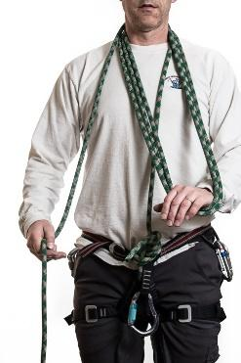

Figure 1

Step 1: Tie into the end of the rope with a rewoven figure 8 through both hard points of the harness, back up the figure 8 with an overhand knot.

Step 2: Start coiling the rope over your neck and around your hand with your palm facing down as seen in figure 1 (your palm should be at or very near your belay loop, the pictures have the coils too short, which can pull on you neck in the event of arresting a fall). Continue coiling up the rope until you have taken in the desired amount. Typically 8-12 coils, but it depends entirely on the specific situation.

Step 3: Take the coils, keeping them around your neck, but putting your arm through the center so that they are now over the shoulder opposite the hand you used to coil around. The free end of the rope should come down from behind the shoulder the coils were placed over (figure 2).

Step 4: Take free rope end into your hand (figure 2) and begin to “tie off.” Make a bight in the free end and pass it through your belay loop (figure 3). Pull the bight through the belay loop with your other hand (figure 4). Pull out roughly 18" to 24" (figure 5).

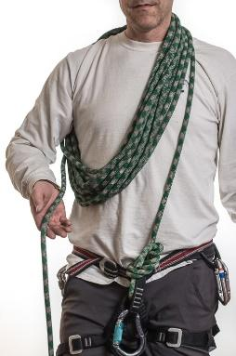

Figure 2

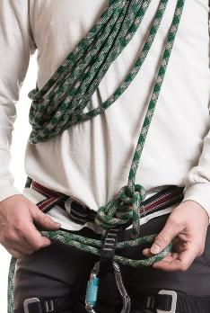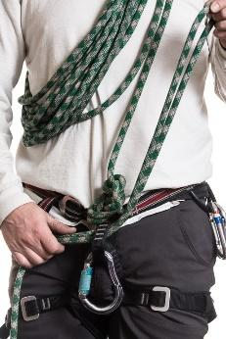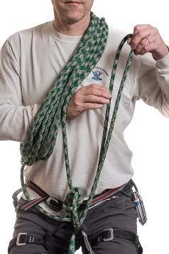

Figure 3

Figure 4

Figure 5

Step 5: Now reach under the coils at your chest and grab the bight with the hand that the coils cover the shoulder (figure 5). Now, draw the bight back through the chest coils to the other side (figure 6).

Figure 6

Figure 7

Figure 8

Figure 9

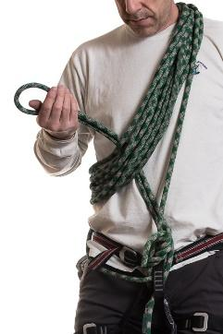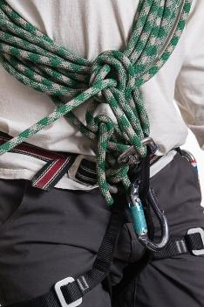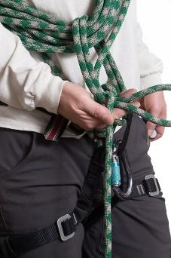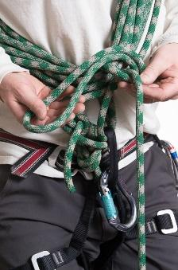

Step 6: Take the bight and wrap it under the rope leading to your partner (figure 7). Continue wrapping it around this strand (figure 8) and then make an over hand knot with the bight upon itself (figure 9). It is important that the knot is finished with the end leading away from you.

Step 7: Finally, clip this end of the bight back into a locking carabiner onto the belay loop your harness. Now put your prusiks on the rope, and then you are ready to go.

**Performance Standards**

1. **Safe:** Understands the concept, and after practice can demonstrate its use.
2. **Not Safe**: Does not understand the concept, and cannot demonstrate how to do it.

**Belaying Fellow Rope Team Member Into/Out of Rest Stops and Camps on a Glacier**

The purpose of belaying fellow rope team members into or out of rest stops and camps on a glacier, is to never allow a significant amount of slack in the rope between yourself and your rope team members. Less slack lowers the momentum that can be gained by a falling climber. The two main methods for quick and less formal belays taught in the Tacoma Basic Climbing Course are the Seat Harness Prusik Belay and Carabiner-Ice Axe Belay.

**Seat Harness Prusik Belay:** The Seat Harness Prusik belay is a simple and the fast method of establishing an anchor for belay into or out of rest areas and camp, where a bomb-proof anchor is not needed and slip is less likely.

Belaying into an area

NOTE: The leader will probe the immediate area for hidden crevasses when stopping on snow slopes of a glacier.

Step 1. Pull 3-5 feet of rope from your harness (moving your chest prusik along the rope).

Step 2. Tie a clove hitch, and slide it up the shaft of the ice axe to the base of the head. Then plunge the axe into the snow, with the head of the axe perpendicular to the direction of fall.

Step 3. Place your uphill foot on the head of ice axe (make sure not to step on the rope), and get into a sturdy belay stance.

Step 4. Use your seat harness/chest prusik to take up rope, belaying your team member in by pulling the climbing rope through the prusik knot.

The next climber in on the rope team would repeat step 1-4, however, a middle team member may be belaying the follower using their foot prusik. In this case, the prusik foot loops must be securely attached to the belayer’s belay loop with a locking carabiner.

Belaying out of an area

The same system can be used when departing an area, paying out the rope between climbers through the prusik knot. The major difference is that each climber (except the leader) will need to move their prusik to the part of the rope nearest to the climber in front of them. The last climber(s) out of camp should however have the system ready to set up (prusik closest to the lead climber), but remain ready to arrest in the chance that one of the earlier members falls.

**Performance Standards**

1. **Safe:** Understands the concept, and after practice can demonstrate its use.
2. **Not Safe**: Does not understand the concept, and cannot demonstrate how to do it.

**Carabiner-Ice Axe Belay/Standing Hip Belay**: The Carabiner-Ice Axe belay should be used to provide a top belay to a weak or tired climber whom is ascending or descending a slope and a slip may be more likely. Note: this is not a bomb-proof anchor which would be required if a fall (not slip) is more likely.

**System Setup and Stance** (see page 351 in Freedom of the Hills 8th Edition)

1. Girth hitch a short sling to the shaft of the ice axe, and plunge it into the snow as deep as possible with the pick perpendicular to the fall line. The sling should be at the snow line. Clip it with a carabiner.
2. The belayer should stand at a right angle to fall line facing the same side as the climber’s route (optional: clip your harness with a control carabiner). Brace the ice axe with the belayer’s uphill boot (parallel to the pick) and over the sling. Then firmly plant the downhill foot..
3. Run the rope from potential direction of pull, up through the carabiner on the sling, (optional: through the control carabiner) around the waist (in the direction of downhill to uphill), and into the uphill (braking) hand.

**Performance Standards**

1. **Safe:** Understands the concept, and after practice can demonstrate its use.
2. **Not Safe**: Does not understand the concept, and cannot demonstrate how to do it.

**Z Pulley Crevasse Rescue Demo**

A station will be set up to demonstrate the Z-pulley crevasse rescue system in order to allow the students to see how to set up the system and to help them get an idea of what steps are taken to complete a rescue.

**Performance Standards**

1. **Safe:** Watches demo
2. **Not Safe:** Does not watch demo

# Field Trip #3 – Winter Overnight (Paradise, Mt. Rainier)

**Time:** 7:00 a.m. for instructors 7:30 a.m. for students

**Place:** Longmire Parking Lot

**Note: Students must pass knot test by end of this Field Trip to participate in FT#4 (Rock 1)**

**Purpose:**

|  |  |
| --- | --- |
| Day 1 | Day 2 |
| Evaluate Ten Essential Systems | Test proficiency of ice axe arrests |
| Practice snow travel | Practice roped glacier travel & Team arrests |
| Practice ice axe arrest | Practice carabiner ice axe belay and snow anchors |
| Camp set up | Practice wanding and running belays |
| Practice team crevasse rescue  Discuss camp techniques, nutrition and etiquette | Practice emergency snow shelter construction  Practice team crevasse rescue system |

**Instructor Equipment:**

|  |  |  |
| --- | --- | --- |
| Overnight gear | Belay device | Ice axe |
| Ten Essential Systems | Carabiners (including locking) | Shovel |
| Mountaineering boots | Slings (for snow anchors) | Pickets |
| Crampons | Perlon | Helmet |
| Snow shoes | Pack sling | Wands |
| Seat & chest harness | Texas prusiks | Pen/pencil |
| Pear-shaped locking carabiner | Rescue pulley | Appropriate Clothing |
| Mt. Rainier Map | GPS Tracks: <https://caltopo.com/m/KPUP> | |

**General**

1. **Check** each students 10 Essentials. This is a test, they must have all 10 Essentials. Sign off on the front cover, if they haven’t gotten a signature already. **Students who do not have adequate Ten Essential Systems will not be permitted to participate in the field trip.**
2. Check each student has all necessary **clothing** and **required equipment** prior to leaving the Longmire parking lot. **Students who do not have mountaineering boots, adequate clothing, and/or equipment will not be permitted to participate in the field trip.**
3. **Stress safety:** ensure all ice axes have leashes and adzes are taped. Students must wear helmets. Monitor the students to ensure they use sunscreen and sunglasses, are eating and staying hydrated. Be alert for indications of hypothermia and dehydration. Monitor avalanche conditions.
4. **Double check all** **harnesses** to ensure the students are wearing them properly. Students should be double checking harness and tie-ins for themselves as well as others.
5. **Report** any student who is late, unprepared, making insufficient progress or delaying the group to the field trip leader. Make note in the student’s *Field Trip Record Book.*

**Procedure**

**Rope team leaders “walkers”**: will be assigned 2-4 students, a team number (consisting of a total of 10-12 students and 4-5 rope leaders) and a team/group campsite area. Rope Team Leaders you are responsible for the navigation, well-being and education of your students. Be prepared with knowledge of all the material being taught at each station. You will be directed by the station instructors to help teach at each station.

**Station Instructors:**  are responsible for teaching the students specific material at your assigned station. Please come prepared with the knowledge pertaining to your station. You will have the help of rope leaders as well.

**DAY 1: Saturday**

**Station Instructors**: After the gate opens at Longmire, go up to Paradise, make sure to park in the overnight lot. Whenever you are ready, hike in to the Deadhorse area to set up your tent. Please be ready at your station by 10:45 AM. Students and instructors should be arriving no later than 11 AM. If you are tenting with a rope leader please set up your tent in rope leader’s assigned group area.

**Day 1 Stations:** Station instructors will have sixty minutes to teach the proposed material at each station on day 1. Station Instructors should promptly start each station at the required time. Rope leaders will have thirty minutes to move between stations.

* **Camp Set Up/Overnight Camping**
* **Camp Etiquette/ Techniques / Nutrition**
* **Crevasse Rescue**
* **Ice Axe Arrest Practice**

**Rope Team Leaders**: When students arrive at Longmire you will need to get your rope team together and do the following:

* 10 E System Test
* Check to make sure they have adequate clothing and all required gear. Students must have mountaineering boots to participate in the field trip.
* Check to see if any students have health issues that we should be aware of, report them to the WFA.
* Determine whether or not they have passed the knots test. If they have not, you are required to complete the test with them before the end of the field trip.
* Give one of your students a rope to carry (you will get a rope from the field trip leader).
* Give another student the bear can.
* Give your students a rundown of the day, and make sure they are packed and can be ready to start hiking within in 15 minutes of arriving at the Paradise overnight lot.
* Make sure your students know how to put on their crampons and snowshoes
* Go over how to tie in and gear set up (pickets, pulley, perlon, pack slings, etc) for glacier travel.
* Discuss with the team what needs to happen when you get to camp so you can make sure to get to your station on time.

NOTE: Report back to the Field trip leader if any student does not come prepared.

Around 9 AM the gate should open and we will head up to the paradise overnight parking lot (make sure you are parking on the correct side). When you arrive at the Paradise overnight lot, get your rope team ready. Start navigating and hiking to your team (group) campsite by 9:45 AM. When you arrive at your group campsite, have the students stomp out a platform for **your tent ONLY**. While you set up your tent, have the students take out the gear they will not be needing for the day (sleeping bag, extra clothes, stoves, etc), they will need their “summit packs.” Have them place all unneeded gear in your tent. The group will finish setting up camp when it is their turn at the camp set up station. At this point, all rope teams should start to act as if you are climbing on summit day…you and the team should rope up, have the students carry group gear and move to each station. Start moving by 10:30 AM. Station Instructors are expecting teams to arrive and be ready by 11AM.

**DAY 2: Sunday**

**Station Instructors**: Be ready at your stations by 7AM.

**Day 2 Stations**: Station instructors will have ninety minutes at each station to teach the proposed material. Station instructors will promptly start each station at the time required. Rope team leaders will have thirty minutes to move to the next station.

* **Snow Anchors and Carabiner Ice Axe Belay**
* **Emergency Shelters and Running Belays**
* **Crevasse Rescue**
* **Ice Axe Arrest Testing**

**Rope Team Leaders:** will lead students on a simulated glacier climb practicing skills as you proceed to “the summit”. Everyone should be tied in carrying, their summit packs, and have assigned group gear. The teams will need to depart camp by 3:30 AM. During “the climb”, team leaders should practice glacier travel skills, rope team skills, ascending, descending, and crampon techniques. Then be back at your starting station by 7 AM.

At the end of the day (around 3 PM) bring your team back to break down camp. Do not let them waste time, we have to get out of the park before the gate closes. We will hopefully do a final debrief down at Longmire at 4:30 pm (maybe earlier). Below is a timeline of how both days should go. If extra time permits at a station, work on the skills the students need more practice with.

|  |  |  |  |  |  |
| --- | --- | --- | --- | --- | --- |
| DAY 1 : Saturday | Start time | End time | DAY 2 : Sunday | Start Time | End Time |
| Meet at Longmire | 7:00 | 9:00 | **Glacier Travel/crampon skills** | 3:00 | 6:30 |
| Paradise/instructor tent set up | 9:30 | 10:30 | **Station 1** | 7:00 | 8:30 |
| Station 1 | 11:00 | 12:00 | **Station 2** | 9:00 | 10:30 |
| Station 2 | 12:30 | 13:30 | **Station 3** | 11:00 | 12:30 |
| Station 3 | 14:00 | 15:00 | **Station 4** | 13:00 | 14:30 |
| Station 4 | 15:30 | 16:30 | **Camp Break-down** | 15:00 | 16:00 |
| Get ready for the next day | 17:00 |  | **Longmire - group discussion** | 16:30 | 17:00 |
| NOTE: You will have 30 minutes to move between stations and to continue to practice rope team skills. If your students are late to a station, you will need to make sure they get any information they miss. | | | | | |

**Ten Essential Systems Check/Test**

Confirm that all students including those who are signed off for the Ten Essential Systems Test have their Ten Essential Systems with them. Students are expected to have a complete set of the Ten Essential Systems (including map) by this time. Be critical in your evaluation.

**Ten Essential Systems Performance Standards**

1. **Safe:** Has all required items in sufficient quantities
2. **Not Safe:** One or more required item is missing or incomplete. Student will not be permitted to participate in the field trip and will be recheckedbefore being allowed to participate in a subsequent field trip. (Refer to field trip leader.)

**Clothing/Equipment**

Student must have crampon compatible mountaineering boots, snowshoes, and clothing to provide a sufficient level of protection under all reasonable weather conditions. Student must have all required equipment for ice axe arrest, crevasse rescue, overnight camping and roped glacier travel.

**Clothing and Equipment Performance Standards**

1. **Safe:** Has all necessary clothing and required equipment. Clothing provides for deteriorating weather.
2. **Not Safe:** Does not have adequate clothing or all required equipment. Student will not be permitted to participate in the field trip.

**Conditioning**

Students must be in good enough physical condition to keep up with the group during field trip activities.

**Conditioning Performance Standards**

1. **Safe:** Demonstrates adequate conditioning for participation on Basic climbs.
2. **Not Safe:** Does not demonstrate adequate conditioning. Slows down the group and must stop a lot. Would not be an ideal candidate for participation on Basic climbs.

**Knots for the Field Trip**

Students must be able to tie all knots used in the field trip. Each student will be evaluated on their ability to quickly and correctly tie all knots for the field trip activities. If during any of these activities a student hesitates or requires instruction to tie a knot, mark their *Field Trip Record Book* appropriately.

**Knots for the Field Trip Performance Standards**

1. **Safe:** Correctly ties all knots without hesitation or instruction.
2. **Not Safe:** Requires excessive time or instruction to tie any knot. (Refer to field trip leader.)

**Snow Camp Set Up/Overnight Camping Station**

One of the primary purposes of this field trip is to give the students a relatively controlled environment to practice/experience camping on snow and preparing for a glacier climb. Discuss with the students the following topics:

1. **Site selection and location:**

* Probing a safe area
* Not camping in avalanche or rock fall path
* Nearby water source (if available), but keep 200 ft (about 75 steps) away
* Leave no trace principles of picking a campsite:
  + rock/snow **>** sand/dirt/gravel **>** grassy area **>** lake/water front
* Protection from the elements
* Relatively flat space for tents
* How changes in temperature/wind might affect location (camping in a basin versus on a ridge)

1. **Site preparation –** stomping out a platform**,** use shovels to make it level
2. **Setting up Tents**

* How to use snow stakes
* Digging out vestibules

1. **Kitchen/Latrine area –** discuss best place for these camp features and have them build a kitchen to use for dinner that night.
2. **Wind walls** – if time permits, have them make a wind wall.

**Snow Camp Set up Performance Standards**

Students must set-up camp area and tents.

1. **Safe:** were able to set up camp after minimal instruction.
2. **Not Safe:** Unable to accomplish the tasks without significant instruction and would be an excess burden on a climb.

**Camp Techniques / Nutrition / Etiquette Station**

The purpose if this station is to help new climbers/campers understand camp techniques, etiquette, and nutrition. You will teach them the skills and techniques necessary to have a good experience and to be responsible members of the climbing party. In addition, if time permits, you should discuss how to be a good rope team member.

1. **Camp Priorities -** Stress priorities upon arriving at camp:
   1. Water
   2. Shelter
   3. Food
2. **Camp Comfort ideas**
3. Nalgene: for in sleeping bag or for pee bottle
4. Dug out vestibule area
5. Boots in dry sack in sleeping bag
6. Drying out clothes needed for the next day
7. Importance of changing in to dry clothes asap
8. **Keeping food from animals**
9. Make sure to keep food, toiletries, or anything with a smell at least 100 yards upwind of camp
10. Importance of not leaving ANY FOOD in your tent
11. Hang food or put in bear can
12. **Leave No Trace – Explain the concept of Leave no Trace and why it is important**
13. Blue Bag System – hand sanitizer and toilet paper
14. Destroy any snow shelters
15. Garbage: Pack it in, pack it out
16. **Stoves/pot/fuel systems**
17. Discuss each system and the pros and cons of each system. If available, show how to use each type of stove system.
    1. Typical canister stoves:
       1. Jet Boil
       2. MSR Reactor
       3. Pocket rocket
    2. Typical liquid fuel stoves:
       1. Whisperlite
       2. Whisperlite International
18. Discuss when a stove/pot/fuel vs a jet boil system is should be used.
19. Discuss the variable to consider when determining about how much fuel per person per team
20. **Water**
21. Sources:
    1. Snow, lakes, streams, etc.
    2. Near rocks, under snow pack, etc.
    3. Purification with filters, boiling, tabs, etc.
22. Show how long it takes to melt snow using stove, tell them to add water to pot to help
23. Show using a filter while melting snow to purify water instead of boiling every time
24. Tips / techniques to keep water from freezing at night and while climbing.
25. **Dressing for roped glacier travel and staying warm at rest stops**
26. Layering systems
27. Starting cool because you will heat up quickly
28. Put on mid/heavy layer at all stops before you start to get cold, even if it is short
29. **Rope Team Etiquette**
30. Carry food and eat when the team stops
31. Go to the bathroom and changing clothes when the team stops
32. Change clothes when the team stops
33. Importance of keeping the rope taut

**Camp Techniques / Nutrition / Etiquette Station Performance Standards**

1. **Safe:** Student uses this time to learn techniques and improve processes, participates in discussion
2. **Not Safe:** Student does not attend station

**Both Days: Crevasse Rescue Station**

The purpose of this station is to give the students their first hands on chance to practice building the 3:1 (Z) and 2:1 (C) pulley team crevasse rescue systems in snow. Have the students construct both systems, walking them through the steps. Make sure to discuss the characteristics of each anchor (Deadman and vertical top clip picket) as these will not be covered until day 2. Have the student practice building the anchors

**3:1 (Z) Pulley (single rope) Crevasse Rescue**

**NOTE: Lead climber is C climber, middle climber is B Climber, and the end/following/fallen climber is A Climber.**

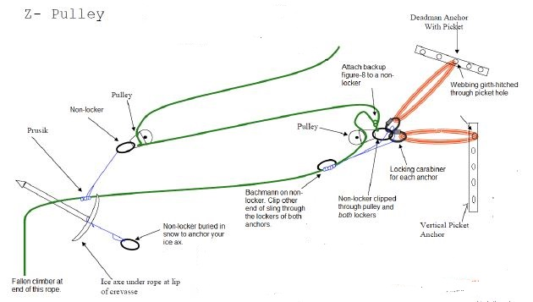**Step 1:** Climber C and B arrest the fall.

**Step 2:** Climber C yells back to check with Climber B to see what happened. It is determined that Climber A has fallen into a crevasse, then Climber C asks Climber B if they can hold the load of fallen Climber A. Climber C slowly gets up and transfers the full load to Climber B so they can start the rescue.

**Step 3:** Climber C self-belays (pulling their chest prusik along the rope) back to Climber B while probing the path, and then probes all around Climber B, and down 5-10 feet to check for crevasses.

**Step 4:**  Climber C builds the initial anchor (vertical top clip picket) about 5-10 feet toward fallen climber A.

**Vertical Top Clip Picket Characteristics:**

1. Only useful in very hard snow (if you can drive your gloved finger into the snow, the anchor will be iffy)
2. Picket should be Inline/parallel to the rope
3. Picket should be placed 10-15 degrees from perpendicular from slope, away from the direction of pull
4. Picket should be driven down into the snow to where the webbing is clipped (at the snow line).
5. A single or short sling should be girth hitched to the top hole of the picket.

**Step 5:**  Climber C attaches a Bachmann hitch to the rope between fallen climber A and climber B, and runs the perlon of the Bachmann to a locking carabiner attached the sling of the initial anchor.

**Step 6**: Climber C guards the anchor (uphill foot over the sling adjacent to the anchor), ready to arrest again if needed. Climber B slowly starts to get up to see if the Bachmann and Anchor will hold the weight of the fallen Climber..

**Step 7:**  Climber B personals into the anchor and then quickly swaps guarding the anchor with Climber C

**Step 8:** Climber C then attaches their pulley to the unweighted rope above the Bachmann with a non-locking carabiner clipping the non-locker to the locker of the initial anchor.

**Step 9:** Climber C, then ties a backup figure 8 on a bite and clips it into the non-locking carabiner NOTE: All carabiners should be clipped down and out

**Step 10**: Now Climber C takes Climber B’s picket and double runner, and builds a secondary (Deadman) anchor, and attaches the perlon of the Bachmann knot and the non-locking carabiner of the pulley to a locking carabiner off the sling of the Deadman. **NOTE:** Deadman anchor sling should form no more than a 30 degree angle with the initial anchor sling.

**Deadman (aka T-slot) Characteristics**

1. Dig a trench at least as deep as the picket, if not more, perpendicular to the direction of pull.
2. Girth hitch at a minimum a double runner to the midpoint of the picket (or whatever item is being used). The trench should be at least a couple of feet behind the initial anchor
3. Cut a slot in the snow as deep as the trench for the double sling. If the slot is too shallow there will be an upward pull, weakening the anchor.
4. There should be no slack in the runner.

**Step 12:** Climber B unties from the rope, gives climber C a non-locking carabiner with a pulley and perlon, and then goes back to guarding the anchor.

**Step 13:** Climber C then prusiks down the rope making sure to keep it taut, to assess the situation of fallen Climber A. While down there, they try to pad the lip of the crevasse, placing their ice axe under the rope (the head of the ice axe should be facing downhill), and put a non-locking carabiner on the leash and bury it in the snow.

**Step 14:**  Climber C, ties a prusik to the rope leading to fallen climber A, then takes the rope between themselves and climber B, attaches a pulley and uses the non-locking carabiner to attach the pulley to the prusik. Make sure you attach the prusik in a spot that will allow you to get back to the anchor.

NOTE: make sure climbers C’s prusik knot is on the rope between them and the pulley, and not on the side between the pulley and the anchor.

**Step 15:**  Climber C then prusiks back to the anchor, personals in to both anchor slings, unties the figure 8, and both climbers begin to pull out fallen climber A.

**Step 16**. Reset the system when the secondary pulley prusik gets close to the Bachmann.

**2:1 (C) Pulley (Double Rope) Crevasse Rescue**

Discuss with the students when and why you would use the C-pulley system:

1. You have 2 rope teams
2. Its faster
3. Rope is entrenched
4. Climber is conscious

NOTE: Lead climber is climber 1, middle climber is climber 2, and end climber is climber 3. Climber 2 may need to re-tie in closer to climber 3 in depending on the amount of rope needed to get to fallen climber A. First team should have anchors built.

**Step 1:** Second team approaches the first team and climber 2 and 3 clove hitch in to the both slings of the anchor.

**Step 2**: Climber 2 belays climber 1 to the lip of the crevasse.

**Step 3**: Climber 1 builds an anchor system with 2 of the following anchors: a vertical top clip picket, vertical mid-clip picket and/or a Deadman.

**Step 4:** Climber 1 pads the lip of the crevasse to keep the rope from entrenching, where the rescue rope will pass over the lip.

**Step 5:** Climber 1 attaches a pulley and locking carabiner to bite in the rescue rope.

**Step 6:** Climber 1 lowers the pulley and locking carabiner to fallen climber A, and has them clip the locking carabiner to their belay loop on their seat harness, making sure that the rope that is being pulled on by the team is coming out of the top of the pulley. Climber A should also be instructed to clip that rope to their chest harness.

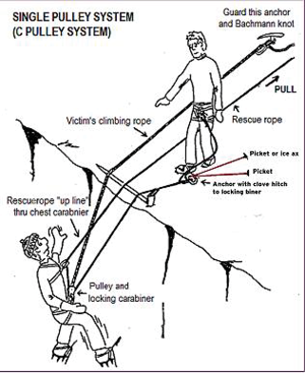**Step 7:** The remaining climbers (Climber C, Climber 2, and Climber 3) start to pull fallen climber A out of the crevasse. At this time, it is critically important for Climber B to pull the slack out of the system in the original accident rope, so the Bachmann can grab if someone slips or they need a break. Keep the existing back up figure eight on a bight tied to the anchors while the other climbers are pulling. Retie the figure 8 after the Bachmann bites the rope.

NOTE: Fallen climber A can also pull on the anchored end of the rope to help pull themselves out of the crevasse, this will help the secondary team pull them out quicker.

**Crevasse Rescue Station Performance Standards**

1. **Safe:** Student was able to construct the system with little help from the instructor.
2. **Not Safe:** Student was unable to construct the system.

**Both Days: Ice Axe Arrest Station** HELMETS REQUIRED

One of the primary purposes of this field trip is to allow student the chance to practice the Critical Skill of Ice Axe Arrest. On Saturday, students will get the chance to practice ice axe arrest. On Sunday they will have to show proficiency.

1. Discuss when you would need to arrest, and the use of self-belay to prevent the need for self-arrest.

* If in loose snow of winter or early spring, usual self-arrest may be useless and best brakes may be widely spaced feet, knees and elbows. In these conditions, the greatest drag potential is to thrust the shaft of the ice axe into the snow.

1. Demonstrate proper arrest positions: ice axe held on head and near spike; ice axe head just above shoulder, pick down; shaft crossing chest and spike held close to opposite hip; legs stiff and spread apart; back arched, placing weight on axe head and toes, head turned away from the ice axe adze.
2. Demonstrate transitioning into arrest from each falling position.

* Emphasize rolling toward the head of the ice axe and not the spike.
* Emphasize to arrest rapidly and to continue trying if first attempt is not successful.

1. Have the students form a chute for arrests by practicing glissading .Students are to complete arrests on each side (with ice axe in both right and left hands) from each of the following positions. Have them practice with their pack on if time permits.
2. **Head Up on Back -**Emphasize rolling toward the ice axe head and jabbing the pick into the snow.
3. **Head Down on Stomach -**Emphasize reach downhill and off to the side in order to jab the pick into the snow which is then used as a pivot point to swing the body around and to position the legs downhill.
4. **Head Down on Back -**Emphasize holding the ice axe across the torso while sliding on back, and sliding the pick (using it as a pivot point) into the snow on the ice axe head side of your body, while using a twisting/rolling “sitting up” motion to get on to your stomach with feet downhill.

**Ice Axe Arrest Performance Standards**

1. **Safe:** Consistently uses proper technique for rapid and effective arrest. Student is capable of safely participating in a Basic climb on steep soft snow.
2. **Not Safe:** Student consistently uses incorrect technique or is unable to effectively arrest. Student is not capable of safely arresting on steep soft snow.

**Day 2: Emergency Snow Shelters Station and Running Belays**

**Emergency Snow Shelters**

The purpose of this station is to give the students the experience of working as a team to build a snow shelter in a short amount of time with a minimum amount of equipment in the event of an emergency situation. Students should use shovels (or whatever they have) to dig and incorporate tarps or other equipment from their packs. Allow the students 20 minutes to complete the task.

**Emergency Snow Shelters Performance Standards**

1. **Safe:** Team of students proficiently establishes a snow shelter for everyone in the party in the allotted amount of time.
2. **Not Safe:** Team of students is unable to make significant progress toward constructing a usable snow shelter in the allotted amount of time or individual student did not make an effort to participate.

**Running Belays**

This will be the students’ first chance at practicing running belays/passing a picket

1. Discuss why and when you would use a running belay:
   1. Faster than fixed belays
   2. Safer than arresting (no belay)
   3. Offers an intermediate level of protection
      1. when the team needs to move quickly on steeper terrain
      2. when terrain has a bad run out
2. Set up a running belay
3. Show the student how to properly pass a picket without unclipping from the rope
4. Give them ample practice.

**Running Belay Performance Standards**

1. **Safe:** Student learns to pass a picket with little help from the instructor
2. **Not Safe:** Student needs ample help from the instructor cannot do this on their own.

**DAY 2: Snow Anchors and Belays Station**

At this station, the students should see and discuss the characteristics of each type of snow anchor. Then have the students set up the carabiner ice-axe belay and practice belaying another student up a slope.

**Snow Anchors**

Each student will get a chance to build a Deadman and vertical top clip picket during the crevasse rescue station. Use this time to discuss the characteristics of each anchor. Then have them construct a bollard and vertical mid-clip (sierra) picket. If time allows, demonstrate the strength of the anchors by having the students pull on them. Make sure the students are wearing their helmets in case it pops-out.

1. **Deadman:** Discuss-
2. Objects that can be used to construct a Deadman
3. Snow pack that is best for this type of anchor:
4. Snow that is very weak (soft) and cannot be compressed to become stronger (because it is very cold or wet). Backfilling is optional, but don’t try to compress it.
5. Snow that can be compressed to make it denser:
   1. Work harden the snow in front of the trench and larger than the stress cone (45°out from the picket).
   2. Backfill the trench with snow and compress it (work harden).
6. How deep the object should be buried versus snow pack, typically at least 12-18 inches.
7. Direction of the Deadman (ie perpendicular to the direction of pull).
8. How a slot should be cut for the sling.
9. Discuss the length of the sling and how it should be girth hitched to the hole in the picket.
   1. The longer it is the more snow it has to drag before failure.
   2. The longer it is the less likely it will affect the initial anchor.
10. **Vertical Top Clip Picket:** Discuss-
11. Snow pack that is best for this type of anchor: typically knife hard snow, that is not compressible and cannot have a slot cut into it (fails the snowball test). Will hold around 6kN force before starting to fail in compression.
12. Used as an initial anchor because it is very quick and easy to build
13. Picket should be placed 10-15 degrees back from perpendicular
14. **Vertical Mid Clip Picket:** Discuss-
15. Snow pack that is best for this type of anchor:
    1. Knife hard snow that is not compressible but can have a slot cut into it. Fails the snowball test.
    2. Snow that can be compressed to make it denser. Should backfill the trench and try to compress it
16. How to build this anchor when the snow is (knife) hard and not compressible:
    1. Cut a slot with an ice ax pick for the sling or cable
    2. Hammer in the picket at a 10-15 degree angle from perpendicular away from the direction of pull until the attached cable or sling reaches the bottom of the slot.
17. How to build this anchor when the snow is compressible:
    1. Carve a trench as deep as the picket to the length of the attachment cable or sling. Note: placing the whole picket slightly under the surface of the snow will make it even stronger.
    2. Work harden the snow at the base of and in front of where the picket will be placed, to and area wider than the stress cone (45 degrees from the picket).
    3. Backfill the trench with snow and compress it.
18. **Bollard**
19. Discuss proper size for snow conditions
20. Horseshoe shape
21. Undercut to prevent rope riding up and out.
22. Channel for rope leading from bollard.
23. Pad rear of bollard, and discuss the need to periodically check for the rope cutting through if not padded.

**Snow Anchors Performance Standards**

1. **Safe:** Participates.
2. **Not Safe:** Does not participate.

**Carabiner-Ice Axe Belay/Standing Hip Belay**:

The Carabiner-Ice Axe belay should be used to provide a top belay to a weak or tired climber whom is ascending or descending a slope and a slip may be more likely. Note: this is not a bomb-proof anchor which would be required if a fall (not slip) is more likely. Demonstrate and then have each student set-up and practice carabiner ice axe belay by belaying a fellow student up a slope.

1. **System Setup and Stance** (see page 351 in Freedom of the Hills 8th Edition)
2. Girth hitch a short sling to the shaft of the ice axe, and plunge it into the snow as deep as possible with the pick perpendicular to the fall line. The sling should be at the snow line. Clip it with a carabiner.
3. The belayer should stand at a right angle to fall line facing the same side as the climber’s route (optional: clip your harness with a control carabiner). Brace the ice axe with the belayer’s uphill boot (parallel to the pick) and over the sling. Then firmly plant the downhill foot.
4. Run the rope from potential direction of pull, up through the carabiner on the sling, (optional: through the control carabiner) around the waist (in the direction of downhill to uphill), and into the uphill (braking) hand.
5. **Belay Technique**
6. Emphasize the importance of proper rope management to avoid tangles and knots.
7. Student must master a coordinated hand movement.
8. Student must brake with the brake hand NEVER leaving the rope.
9. Student should allow minimal slack in the rope.
10. **Braking Technique**
11. Student must belay with the brake hand NEVER leaving the rope.
12. Braking position is with braking arm across the front of the body.

**Carabiner/Ice Axe Belay** **Performance Standards**

This is an essential skill. Students should be coached until they can do with very little instruction.

1. **Safe:** Student can rapidly set-up a carabiner/ice axe belay and consistently uses proper technique.
2. **Questionably Safe:** Student takes an extra time to set-up a safe belay, uses adequate techniques.
3. **Not Safe:** Student cannot set up a carabiner/ice axe belay or consistently uses incorrect technique. Student is not capable of safely belaying on steep soft snow.

**Day 2: Glacier / Snow Travel:**

**Roped Glacier Travel**

**General**

1. HELMET REQUIRED
2. Conduct the initial portion like a summit attempt on a glacier climb: belaying out of camp, using wands, kicking steps, steady pace, rest step, good communications along the rope, short breaks; use breaks to eat, drink, etc... Remind them to pass the word that it's a break, not just a short stop.
3. Lead the students over various types of terrain including steep slopes allowing them to practice ascending and descending technique.
4. Stress rope management; rope on downhill side and ice axe on uphill side; talking to other team members, and pacing to slowest person.
5. Night before preparation after snow camp evening meal
6. Conduct a meeting as if you are leading a glacier climb.
7. Discuss the intended route and conditions.
8. Discuss and determine the climbers’ position on the rope.
9. Discuss personal gear and group gear allocation among the party.
10. Discuss wake-up time (around 2:30 AM) and departure time (3:30 AM).
11. Have students layout and prepare ropes for Sunday (Note: Instructors do not need to be roped).
12. Students should practice and show proficiency with the following skills:
13. **Handling and Carrying an Ice Axe (NOTE:**  **should not be attached to the seat harness**).
    1. Knows different methods for carrying ice axe when not in use.
    2. Understands the difference between “self-belay” and “self-arrest” positions.
    3. Carries axe in the uphill hand when in use.
14. **Putting On Crampons**
15. Even if conditions are not suitable for crampon use, have students put them on long enough to ensure proper fit and that they can independently don crampons in a timely manner.
16. Discuss the importance of proper fit of straps or bales.
17. Discuss the importance of proper sizing to boots without cutting off circulation and readjustment as feet swell during the climb.
18. Students should be able to independently and correctly don crampons in a timely manner. Check that the strap buckles are on the outside of their feet and that any loose ends are secured.
19. **Tying In**
20. Correctly dons seat harness and chest harness.
21. Correctly attaches rope to seat harness and correctly puts on prusiks.

Leader/End Climbers**:** Ties into the rope with a Rewoven Figure-8. Foot prusik tied on next to the Figure-8 and the foot loops are tucked into the pockets to keep them out of the way. The chest prusik is tied on above the foot prusik and clipped into a locking carabiner off of the belay loop of the seat harness.

Middle**:** Ties in with an Alpine Butterfly, secured to the harness using two opposite and opposed locking carabiners. Typically the seat/chest prusik is tied into the rope going to the leader and foot prusik is tied into the rope going to the end climber. The foot loops are tucked into pockets or clipped to the harness to keep them out of the way. The chest/waist prusik loop is clipped into the belay loop of the seat harness using a separate locking carabiner.

1. Double checks tie in of other climbers.
2. **Kiwi Coil (see below)**
3. **Belay into and out of camp**

The purpose of belaying fellow rope team members into or out of rest stops and camps on a glacier, is to never allow a significant amount of slack in the rope between yourself and your rope team members. Less slack lowers the momentum that can be gained by a falling climber. The two main methods for quick and less formal belays taught in the Tacoma Basic Climbing Course are the Seat Harness Prusik Belay and Carabiner-Ice Axe Belay.

**Seat Harness Prusik Belay:** The Seat Harness Prusik belay is a simple and the fast method of establishing an anchor for belay into or out of rest areas and camp, where a bomb-proof anchor is not needed and slip is less likely.

Belaying into an area

NOTE: The leader will probe the immediate area for hidden crevasses when stopping on snow slopes of a glacier.

Step 1. Pull 3-5 feet of rope from your harness (moving your chest prusik along the rope).

Step 2. Tie a clove hitch, and slide it up the shaft of the ice axe to the base of the head. Then plunge the axe into the snow, with the head of the axe perpendicular to the direction of fall.

Step 3. Place your uphill foot on the head of ice axe (make sure not to step on the rope), and get into a sturdy belay stance.

Step 4. Use your seat harness/chest prusik to take up rope, belaying your team member in by pulling the climbing rope through the prusik knot.

The next climber on the rope team would repeat step 1-4, however, a middle team member may be belaying the follower using their foot prusik. In this case, the prusik foot loops must be securely attached to the belayer’s belay loop with a locking carabiner.

Belaying out of an area

The same system can be used when departing an area, paying out the rope between climbers through the prusik knot. The major difference is that each climber (except the leader) will need to move their prusik to the part of the rope nearest to the climber in front of them. The last climber(s) out of camp should however have the system ready to set up (prusik closest to the lead climber), but remain ready to arrest in the chance that one of the earlier members falls.

1. **Rope Management**
2. Discuss the importance of not stepping on or otherwise damaging the rope.
3. Keeps proper tension on rope to climber in front and behind.
4. Leader sets a pace that others can follow.
5. **Travel on Rope**
   1. **Moving in Balance** (see ascending and descending techniques below)
   2. **Self-Belay (with Ice Axe)** (see ascending and descending techniques below)
   3. **Kicking Steps** (see ascending and descending techniques below)
   4. **Rest Step** (see ascending and descending techniques below)
   5. **Switch-backing**
6. Leader spaces switchbacks far enough apart to prevent rope management problems.
7. Rope team communicates and works together to keep rope taut while turning corners.
8. **Crampon Techniques (if conditions allow)**
9. Discuss self-arrest with crampons – keeping feet up and trying to dig knees in to the snow.
10. Emphasize keeping feet as flat as possible on the surface of the snow for maximum point penetration when both ascending and descending.
11. Discuss and practice ascending and descending using the following techniques:
    1. French technique (flat foot or duck walking)
    2. German technique (front pointing)
    3. American technique (combo)
12. Discuss snow balling on bottom of crampons and show how to knock it off with ice axe.
13. Students should be able to move with feet spaced sufficiently in a coordinated manner without tripping, stepping on the rope or impaling themselves.
14. **Team Ice Axe Arrest (without crampons)**

Emphasize this important skill! Practice this on slopes in varying scenarios – arrange to have a student or instructor put a “live” load on the rope to simulate the force of a falling team member.

1. Quickly assumes proper self-arrest position.
2. Faces away from the direction of pull.
3. Holds the fallen rope team members.

**Glacier / Snow Travel Performance Standards**

1. **Safe:** Demonstrates proficiency at all skills as a rope team member.
2. **Questionably Safe:** Demonstrates proficiency at most skills as a rope team member. Still need practice at some skills
3. **Not Safe:** Lacks many skills as a rope team member. Needs a lot of practice.

**Ascending and Descending Techniques**

1. **Moving in balance**
   1. Discuss and practice the difference between being in balance and out of balance

**In Balance:** Inside (uphill) foot is forward with body weight equally distributed between both feet.

**Out of Balance:** Outside (downhill) foot is forward with all the body weight on the lower leg.

* 1. Moves ice axe to higher anchor position only when feet are stationary and stance is “in balance”.
  2. Changes directions: beginning with stance “in balance,” plant ice forward, bring back foot forward transitioning to feet splayed around the ice axe, then take a step with the new uphill foot to be in balance and move the ice axe forward.
  3. Uses ice axe for support but does not lean into slope.

1. **Self-Belay with Ice Axe**
2. Holds head of axe in “self arrest” position.
3. Keeps ice axe in uphill hand and on uphill side of body.
4. Places shaft of ice axe firmly enough to serve as an anchor.
5. Remains self-belayed when changing directions.
6. If feet slip, uses implanted ice axe to stop and only uses self-arrest if self-belay fails.
7. **Kicking Steps**
8. Leader kicks short evenly spaced steps, which allow other climbers to follow in balance.
9. Follower improves steps by deepening and compacting.
10. Keeps weight over toes and does not lower the heel (which blows out a step).
11. **Rest Step**
12. Supports body weight on locked rear leg while front leg relaxes for a mini-rest.
13. Synchronizes breathing with step sequence.
14. **Plunge Step**
15. Holds ice axe in self-belay or self-arrest position.
16. Steps and drives heels assertively into the snow.
17. Leans slightly forward and avoids leaning back into the slope.
18. Understands the possibility of post-holing and injury from plunging too deep.
19. **Backing Down a Slope**
20. Student plunges axe into the snow using self-belay hand position
21. Then kicks two steps down to get a sturdy stance
22. Repeats
23. **Sitting Glissade**
24. Holds ice axe outboard of body with pick pointing away from leg and adze away from face.
25. Uses spike and heels to steer.
26. Remains under control and travels at a safe speed.
27. Understands not to glissade while wearing crampons, when the runout is poor, or without an ice axe.

**Ascending and Descending Techniques Performance Standards**

1. **Safe:** The students uses proper techniques with confidence. Student is capable of safely participating in a Basic climb on steep soft snow.
2. **Questionably Safe:** Consistently uses proper techniques for hesitates. Student needs practice more before participating in a Basic climb on steep soft snow.
3. **Not Safe:** Student consistently uses incorrect technique or lacks confidence. Student is not capable of safely traveling on steep soft snow.

**The Kiwi Coil**

The "Kiwi Coil" is commonly used for glacier travel when the rope needs to be shortened, resulting in closer spacing between climbing partners. Typically only the end climbers will coil and carry the extra rope.

NOTE: your prusiks are placed on the rope after the coil is finished.

Step 1: Tie into the end of the rope with a rewoven figure 8 through both hard points of the harness, back up the figure 8 with an overhand knot.

Step 2: Start coiling the rope over your neck and around your hand with your palm facing down as seen in figure 1 (your palm should be at or very near your belay loop, the pictures have the coils too short, which can pull on you neck in the event of arresting a fall). Continue coiling up the rope until you have taken in the desired amount. Typically 8-12 coils, but it depends entirely on the specific situation.



Figure 1

Step 3: Take the coils, keeping them around your neck, but putting your arm through the center so that they are now over the shoulder opposite the hand you used to coil around. The free end of the rope should come down from behind the shoulder the coils were placed over (figure 2).

Step 4: Take free rope end into your hand (figure 2) and begin to “tie off.” Make a bight in the free end and pass it through your belay loop (figure 3). Pull the bight through the belay loop with your other hand (figure 4). Pull out roughly 18" to 24" (figure 5).



Figure 2



Figure 3

Figure 4

Figure 5

Step 5: Now reach under the coils at your chest and grab the bight with the hand that the coils cover the shoulder (figure 5). Now, draw the bight back through the chest coils to the other side (figure 6).

Figure 6

Figure 7

Figure 8

Figure 9



Step 6: Take the bight and wrap it under the rope leading to your partner (figure 7). Continue wrapping it around this strand (figure 8) and then make an over hand knot with the bight upon itself (figure 9). It is important that the knot is finished with the end leading away from you.

Step 7: Finally, clip this end of the bight back into a locking carabiner onto the belay loop your harness. Now put your prusiks on the rope, and then you are ready to go.

**Performance Standards**

1. **Safe:** Understands the concept, and after practice can demonstrate its use.
2. **Not Safe**: Does not understand the concept, and cannot demonstrate how to do it.

# Field Trip #4 Prep - Rock I

**Time:** 5:30pmfor instructors 6:30pm for students

**Place:** Tacoma Branch Clubhouse

**Purpose:**

Take 10 Essential systems test

Take knot test

Practice rock climbing technique

Utilize belaying skills

Practice carabiner brake rappel set up

Practice rappelling

Practice self-belay on rappel (leg wrap & auto-block)

**Instructor Equipment:**

|  |  |  |
| --- | --- | --- |
| Ten Essential Systems | Belay device | Helmet |
| Mountaineering boots | Carabiners (including locking) | Belay gloves |
| Seat harness | Slings (for anchors) | Pen/pencil |
| Pear-shaped locking carabiner | Leader tie off | *Field Trip Instructor Manual* |

## Stations: 1. Into to Rock Climbing (Tie in, climb and belay)

## 2. Intro to hand holds, type and techniques.

## 3. Intro to Pro. Place and remove while on traverse.

## 4. Intro to Rappeling (Ground and staircase)

## 5. Intro to Anchors. Sport and Traditional anchors.

## Field Trip #4 - Rock I

**Time:** 7:00 a.m.for instructors 8:00 a.m. for students

**Place:** Tacoma Branch Clubhouse

**Purpose:**

|  |  |
| --- | --- |
| Practice cleaning rock protection | Practice setting up a belay |
| Practice rock climbing techniques | Practice lead belaying |
| Practice extended device and carabiner brake rappel  Size and use autoblock for rappels  Practice fireman belays and leg wrap | Practice prusiking on a handline and arm rappel  Discuss Rappel anchors |

**Instructor Equipment:**

|  |  |  |
| --- | --- | --- |
| Ten Essential Systems | Belay device | Helmet |
| Mountaineering boots | Carabiners (including locking) | Belay gloves |
| Seat harness & personal anchor | Slings (for anchors) | Pen/pencil |
| Pear-shaped locking carabiner | Leader tie off | *Field Trip Instructor Manual* |

**Instructions:**

**General**

1. You will be assigned a station at the beginning of the field trip and will work there all day or until rotated to another station as directed by the field trip leader.
2. Check each student has all necessary **clothing** and required **equipment** prior to beginning the other field trip activities. **Students who do not have adequate clothing and equipment will not be permitted to participate in the field trip.**
3. Instructors will construct all belay and rappel anchors. Each anchor will be double-checked by another instructor.
4. All **climbing** (except the traverse and friction) will be done with anchored, **overhead belays**. **All Belayer’s must be anchored**.
5. **Rappelling** from the tower will be done with **belay from below or self belay (auto block)**. An instructor will check the student rappelling prior to letting the rappel begin.
6. **Knot Test – Do a knots test with the students prior to starting the field trip.**

Water knot Single Bowline Bachmann

Figure 8 on a bite Prusik Flat Overhand Bend

Rewoven Figure 8 Clove hitch girth hitch

Double Fisherman’s munter hitch alpine butterfly

Bowline on a coil Device Mule Munter Mule

1. **Double check all harnesses** to ensure the students are wearing them properly prior to activities.
2. **Stress safety:**
3. Remove rings and watches before climbing.
4. All students and instructors will wear a **UIAA-approved climbing helmet** when climbing, rappelling or belaying. Students and instructors will wear **gloves** for all rappels and belays.
5. Have students check each other, but the instructor will check both the belayer and climber prior to letting the climb begin.
6. All climbers, belayer’s, and rappeller’s on top of the rock must be anchored. Only those students who are preparing to climb or rappel, and are anchored, will be permitted near the edge of the rock.
7. There will be a lot of climbers and belayer’s in close proximity. Stress the need to **use proper commands**, to use each other’s name and to speak loudly.
8. Review with all students the techniques of belaying and lowering – stress the importance of the belayer managing the speed and safety of the climber when climber is being lowered.

**Rock Climbing** HELMET and BELAY REQUIRED

**General**

The purpose of this activity is to introduce the students to rock climbing. Your function is to help the students improve their rock climbing technique. Be patient and supportive of those having problems and demanding of the better students. Point out (demonstrate, if appropriate) suitable techniques to use on each pitch. Suggest different types of holds.

1. Students must attempt each of the climbs listed in the *Field Trip Record Book*. They may do more as time permits.
2. Explain that they need to be able to climb in boots because many alpine climbs at the basic level are accomplished wearing boots.
3. Have students use climbing signals. Insist that both climbers and belayers use commands correctly.
4. Watch for common mistakes: “hugging the rock;” excessive use of arms; not maintaining a three-point stance; and not planning a move.

**Climbing Signals**

Commands must be short and spoken in a loud, crisp manner so that they can be easily understood under adverse conditions. Don’t embellish them, use exactly as written in *Freedom 8* or the *Basic Manual*. To alert the partner, precede a command with the individual's name.

**"On Belay?" "Slack" "Off Belay"**

**"Belay On" "Up Rope" "Belay Off"**

**"Test Belay" "Take" (preferred to “Tension”) "Rock!"**

**"Climbing" "Watch Me"**

**"Climb" "Falling!"**

**Rock Climbing Techniques**

* Traverse **(**Belay not required. Keep students low on the rock.) Emphasize weight over the feet; use hands for balance; “climb with the eyes;” three-point suspension.
* Face Climb - Emphasize weight over feet, use of small holds, “climbing with the eyes”, testing holds, 3-point suspension, resting on straight arms, down climbing and smooth movement. A common mistake is “hugging the rock”.
* Chimney Climb **(**student may select either the chimney with the chock stone or the chimney by the tower) Emphasize stemming - requires using some form of counter-force (arm vs. arm, back vs. legs, etc.) Down-pressure holds are also used. Look for braced position; smooth, coordinated movement; use of legs.
* Crack Climb - Emphasize jamming techniques- consists of wedging parts of the body, such as hands or feet, securely enough into a crack to bear weight.
* Lieback Climb - Emphasize lieback technique - which depends on tension of both arms pulling against one side of crack while feet push against the other. Stress keeping arms straight so skeletal system, not muscles, takes weight.
* Friction Climbing – Emphasize keeping foot flat against the surface of the rock and bending the ankle forward. Untie boots down to the ankle or lower.
* Cleaning Protection – show students how to remove the protection and clip to their harness before removing the sling from the rope. Show/have them remove:
  + Cam
  + Tri cam
  + Hex
  + Nut/chock

**Lead Belaying Station**

The purpose of this station is to get a student ready for rock climbs, and practice belaying a leader.

**Station Set Up**: Anchor should be built for student to clip into.

**Belay Set-up and Stance:**

NOTE: The students are not expected to set-up an anchor, however, they must be able to clip into an available anchor. The students must demonstrate the set-up of each belay method using the right and left hand to brake.

1. Demonstrate and discuss the importance of flaking out a climbing rope. Showing them the importance of placing it near the anchor and positioning it on the side of the belayer that they will be using as a braking hand.
2. Have each student tie into the climbing rope with a correctly dressed rewoven figure-8 backed-up with an overhand knot, showing them that the belayer uses the bottom of the flaked out rope and the climber uses the top.
3. Have the belayer attach to the anchor and explain the need for good body positioning: using a clove hitch tied to a locking carabiner (clipped down-and-out). Tether to the anchor (within arm’s reach), the ability to see the route, protection from rock fall, and belayer in-line with the pull from a fall. )
4. Make sure the student understands that potentially necessary equipment (i.e. Leader tie-off, extra biners, webbing) should be easily accessible before starting the belay.
5. Have the Belayer set up their belay device. Ensure the student has threaded the rope through his device properly and has locked the carabiner.
6. Have the students do a safety check: checking harness, knots, etc.

**Lead Belaying**

Now have the student practice lead belaying and using climbing signals. NOTE: The climber should only climb if being top rope belayed by the instructor as well.

1. Make sure the student understands proper rope management:
   1. Give out rope, making sure not to short rope the leader
   2. Give out rope when they are trying to clip a piece
   3. Give out less rope while the climber is closer to the ground, and more as the climber gets higher
   4. Do not give out so much rope kthat the leader would deck if they were to fall.
2. Emphasize to always keep their hand on the brake strand.
3. Emphasize proper hand movements while giving out slack.

**Catching a Leader Fall**

Emphasize that with proper rope management and correct braking hand movement, catching a leader fall is not much different than a top rope fall.

**Performance Standards**

This is the first exposure to rock climbing for many of the students. Evaluations should be based on the extent to which each student seems to know and be trying to apply the appropriate techniques. As a rule, Needs Work ratings are given only if the student is totally incapable of performing the task or demonstrates a willful disregard for safety

1. **Safe:** Generally applies proper techniques and reaches the top of the pitch. Student is ready to progress to the Rock II field trip.
2. **Questionably Safe:** Sometimes fails to apply proper techniques but makes a reasonable attempt to reach the top of the pitch. Student will require some practice prior to being prepared for the Rock II field trip.
3. **Not Safe:** Consistently fails to apply proper techniques or lacks the required strength to make significant progress toward the top of the pitch. Student will not progress to the Rock II field trip without remedial instruction. (Refer to field trip leader.)

**Rappels** HELMET and GLOVES REQUIRED

**General**

The purpose of this station is to **introduce** the students to rappelling. For each type of rappel, discuss the proper set up, technique, and auto block set up. Then each student will perform at least one belayed (from below) rappel off of the tower and one self-belay (using auto block) rappel off the tower. Insist that the student rappel use commands correctly.

NOTE: Every student rappel should be backed up with either an autoblock or with a fireman's belay. They should have their personal anchor attached prior to climbing up the tower. At the top of the tower everyone should be PA’ed in. Students are allowed to unclip there PA only when the rappel is completely set up and has been checked by the instructor.

**Rappel Commands**

Emphasize that commands should be short and spoken in a loud, crisp manner so that they can be easily understood under adverse conditions. To alert the partner, precede a command with the individual's name.

**"Rope" "Off Rappel"**

**"Rappelling" "Rock!"**

**Carabiner Brake Rappel** HELMET and GLOVES REQUIRED

1. Have student assemble a carabiner brake rappel system. Answer any questions he may have about the use of the brake or about the rappel process.
2. Have the students attached their autoblock
3. Check the student prior to permitting them to rappel.
4. 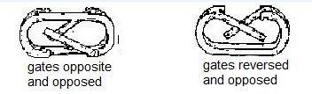Stress the need for a systematic check of all components. Key elements: secure anchor, rope looped, not tied off, so it can be retrieved; harness straps rewoven; brake properly assembled; autoblock wrapped correctly, knots in end of rope; knife on a lanyard and accessible; no loose clothing or hair that can get caught in brake system.

**Carabiner Brake Rappel System Setup**

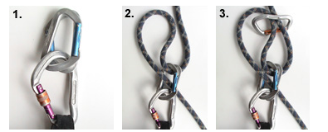Step 1. Take 2 (preferable oval) carabiners and clip them to either a locking carabiner off your belay loop (as showing in the picture) or directly to your belay loop, the gates should be opposite and opposed.

Step 2. Pull a bight of rope through the opposite and opposed carabiners, pinching it to rope going to the anchor.

Step 3. Clip 2 carabiners (with gates reversed and opposed) through the bight and the climbing rope going to the anchor so the rope runs over the spines of the reversed and opposed carabiners.

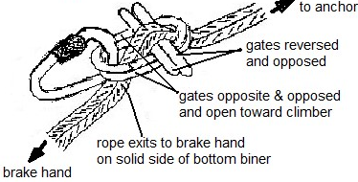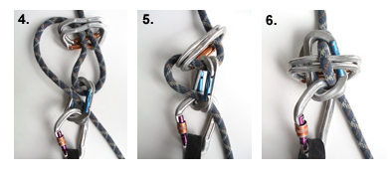Step 4. Figure 5 Slide the reversed and opposed carabiners over the opposite and opposed carabiners, making sure that the braking strands of the rope exits the opposite and opposed carabiners on the spine side of the bottom carabiner.

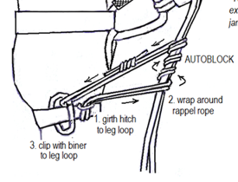**Auto Block Set-Up for Carabiner Brake Rappel**

Step 1. Girth hitch your autoblock to your leg loop of your seat harness.

Step 2. Wrap your autoblock up the rope (4 coils is recommended)

Step 3. Clip the end of the autoblock loop back to the leg loop of your seat harness with a locking carabiner. Lock the carabiner.

**Rappel Technique**

As the student descends, stress that the braking hand controls the amount of friction therefore speed as it runs through the brake set-up and auto block, and that the brake hand never leaves the rope.

1. The brake hand rides above the autoblock to tend the coils as you rappel and the rappel rope should be to the side of the climber.
2. Correct any problems with position or technique--feet should be flat on face, knees flexed, and legs spread and approximately perpendicular to the rock.
3. Emphasize a smooth rappel, no bouncing – its bad for the anchor and rope

**Performance Standards**

1. **Safe:** Independently sets up the rappel system and confidently uses safe technique to descend. Student is ready to progress to the Rock II field trip.
2. **Questionably Safe:** Sets up the rappel system and uses safe technique to descend but requires instruction or lacks confidence. Student is ready to progress to the Rock II field trip.
3. **Not Safe:** Unable to safely rappel. Student will not be allowed to progress to the Rock II or Crevasse Rescue field trips without remedial instruction. (Refer to field trip leader.)

**EXTENDED RAPPEL DEVICE METHOD**

1. The Extended Rappel is the primary method of rappel taught in the Tacoma Basic Course due to its safety.
2. <https://www.mountaineers.org/blog/how-to-extended-rappel>

EXTENDED RAPPEL SET UP WITH AUTOBLOCK

THE SET-UP – While Waiting

1. Attach PAS to anchor.
2. Thread half of a double-length (120 cm) sewn sling through harness hard points and tie both ends into a figure eight on a bight.
3. Add carabiner and device through both distal loops.
4. Tuck hair and any loose objects out of the way.

WHEN NEXT UP TO RAPPEL

1. One can attach the autoblock and carabiner to the rope while the preceding climber is on rappel.
2. A properly sized autoblock will not slide down the rope when left on the rope.

SETTING UP

1. Attach autoblock to belay loop with its locking carabiner.ExtendedRappel1_Updated.jpg
2. Pull rope up through autoblock to form bight of rope for threading device -the autoblock holds the weight of hanging rope strands.
3. With device located as close to anchor as practical thread rope bight through rappel device.
4. Clip device into both distal extending sling loops with carabiner.
5. Lock the carabiners.

TESTING

1. Review the system in a serial manner from anchor to landing: SERENE anchors, rope threading, autoblock, device, carabiner, belay loop, harness, stopper knots and landing.
2. Slide autoblock up toward device, and with gloved brake hand on both strands and being careful not to tension the PAS, loosen brake hand enough to weight the autoblock to make sure it will hold and that it cannot not reach into the device to defeat the autoblock.
3. With braking applied, slide autoblock down to create enough slack to body weigh the device while being careful not to tension the PAS or autoblock.

ON RAPPEL

STARTING RAPPEL

1. With brake hand on both strands well below device use other hand to remove PAS from anchor and stow.
2. Use brake hand to maintain friction.
3. Place non-brake hand on autoblock and begin sliding it.
4. To begin descent reduce friction in brake hand while sliding the autoblock.

WHILE RAPPELLING

1. One hand slides the autoblock while the other hand controls the braking friction on both strands of rope.
2. To change hands remove hand from autoblock and transfer brake control from one hand to the other, never letting go. Original brake hand will now manage autoblock.
3. If additional friction is needed slide brake hand under climbers seat.
4. In an emergency, or to engage the autoblock, let go of the autoblock while maintaining brake hand friction. Lessen friction only after autoblock is securely holding the rope.
5. To go hands free first assure the autoblock is holding. A leg wrap can be added for a greater security to the autoblock. To go hands free while hanging a back-up leg wrap is used as a back-up.

**Leg Wrap Tie Off**

1. Minimum of three wraps around the leg with a tuck, keeping the brake hand on the rope until the wraps are completed and tested with weight.
2. When the student is partway down have him/her do a tie-off. Make him/her remove both hands from the rope. Stress that he/she must assume the braking position BEFORE he/she unties. Key points: brake hand stays on rope during tie-off; minimum of three wraps on leg opposite braking hand; rope tucked under all wraps; student holds end of rope in the tuck while releasing the braking hand and releases other hand when the leg wrap holds; assumes braking position prior to untying leg wrap.

**Rappel Self Back Up:**

The purpose is to acquaint students with a method of backing up a rappel, then allow them to practice its set up and use. Thereafter, it will be the student’s choice as to when and whether to employ a rappel backup. Discussion with students should explain that the successful use of the autoblock rappel backup is dependent on several variables including the person’s harness, body height and weight, additional weight being carried on the rappel, length of autoblock loop and number of autoblock wraps on the rope. **All factors must combine in such a manner that there is no possibility of the autolock sliding knot entering the rappel device** (If there is, the device may have to be extended away from the harness with a suitably sized quick draw (which in itself introduces another variable in the system). Thus, a student must practice and develop **a 100% reliable autoblock set up** on safe practice rappels (e.g., this field trip with the assistance of others) before using it in the field.

**Performance Standards**

1. **Safe:** Understands the mechanics of the autoblock rappel backup, the variables affecting its successful use, and its risk vs. reward potential. Successfully sets up and demonstrates the use of each rappel backup, including with rappel extension.
2. **Not Safe:** Unable to comprehend or demonstrate its use (Refer to field trip leader.)

**Auto Block Set-Up**

* Girth-hitch the loop to your belay loop. Wrap the loop about four times towards the rappel device and around both ropes below the rappel device.
* Clip the remaining tail of the perlon loop to your leg loop with a carabiner, non-locking is acceptable.
* **When extending your rappel, the autoblock is girth hitched to your belay loop, wrapped around the rope and re-attached to the belay loop with a locking biner.**

**Performance Standards**

1. **Safe:** Independently sets up the rappel system and confidently uses safe technique to descend. Student is ready to progress to the Rock II field trip.
2. **Questionably safe:** Sets up the rappel system and uses safe technique to descend but requires instruction or lacks confidence. Student is ready to progress to the Rock II field trip.
3. **Not Safe:** Unable to safely rappel. Student will not be allowed to progress to the Rock II or Crevasse Rescue field trips without remedial instruction. (Refer to field trip leader.)

**Arm Rappel** HELMET and GLOVES REQUIRED

This will be shown to the students at the glacier slab without a belay. Each will be given a chance to set up the rappel and descend the glacier slab. Emphasize that this is a simple non-mechanical system used to quickly descend a low-angle slope

**System Setup**

1. Rappel rope behind the back, under the armpits and wrapped once around each arm.
2. If wearing a pack, be sure the rope goes behind the pack rather than on top or underneath.

**Rappel Technique**

Control the rate of descent by hand grip and foot position.

**Performance Standards**

1. **Safe:** Independently sets up the rappel system and confidently uses safe technique to descend. Student is ready to progress to the Rock II field trip.
2. **Questionably Safe:** Sets up the rappel system and uses safe technique to descend but requires instruction or lacks confidence. Student is ready to progress to the Rock II field trip.
3. **Not Safe:** Unable to safely rappel. Student will not be allowed to progress to the Rock II or Crevasse Rescue field trips without remedial instruction. (Refer to field trip leader.)

**Self-Belay with Friction (Prusik) Knot on a Fixed Handline**

Fixed hand lines are used as a safety backup, for an unroped party on less technical but exposed terrain (where a slip and/or fall could severely injure or kill a climber) to save the time it would take to belay multiple party members across. It is not to be used in Class 5 rock situations where climbers should be properly belayed. If the slope is so steep that the climber cannot safely use one or both hands to slide the prusik knot along the fixed line then an anchored belay should be set up and utilized.

**PROCEDURE:** Tie a properly dressed prusik knot (a loose or sloppy prusik with not bite the rope if a fall occurs) onto the fixed line, and secure it with a locking carabiner to the climber's belay loop of their seat harness. The climber slides the knot along the rope with one or both hands constantly checking the knot to ensure that it is snug and dressed.

**Discuss Crampon use on Rock (Moving in Balance)** HELMET REQUIRED

Have students put on crampons and practice scrambling on rock, including changing direction. Little or no use should be made of hands. Explain practical use of crampons on snow and rock mixed climbing.

**Performance Standards**

1. **Safe:** Participates
2. **Not Safe:** Does not participate

**Clothing/Equipment**

Student must have mountaineering boots and clothing to provide a sufficient level of protection under all reasonable weather conditions. Student must have all required equipment for navigation, rock climbing, belaying and rappelling.

**Performance Standards**

1. **Safe:** Has all necessary clothing and required equipment. Clothing provides for deteriorating weather.
2. **Not Safe:** Does not have adequate clothing or all required equipment. Student will not be permitted to participate in the field trip. (Refer to field trip leader.)

**Ten Essential Systems**

Checked at instructor’s discretion. There is no excuse for not having a complete set of the Ten Essential Systems by this time, so be critical in your evaluation.

**Performance Standards**

1. **Safe:** Has all required items in sufficient quantity.
2. **Not Safe:** One or more required items is missing or incomplete. Student will be rechecked before being allowed to participate in a subsequent field trip. (Refer to field trip leader.)

**Knots for Field Trip**

Students are expected to be able to tie all knots used in the field trip by this time. Each student will be evaluated on their ability to correctly tie knots for all field trip activities. If during any of these activities a student hesitates or requires instruction to tie a knot, mark their *Field Trip Record Book* appropriately.

**Performance Standards**

1. **Safe:** Correctly ties all knots without hesitation or instruction.
2. **Not Safe:** Consistently hesitates or requires instruction to tie any knot. Student will not be permitted to continue to participate in the field trip. (Refer to field trip leader.)

**Belays to Climbers** HELMET and GLOVES REQUIRED

1. Each student must, by this field trip, have selected and acquired an approved belay device.
2. Each student must do a minimum of 4 belays during the field trip. Rotate the students through several different belay stations; we want a number of instructors to evaluate their ability.
3. Each student must be able--**without assistance**--to tie into the anchor and safely belay a climber. Check the belayer prior to each climb.
4. Require both climber and belayer to use commands correctly.
5. Report any student who cannot safely belay to the field trip leader. **Any student who cannot safely belay will not be permitted to continue to participate in the field trip.**
6. **Performance Standards** -- Students are expected to be able to proficiently provide a safe belay to climbers by this time. Be critical in evaluation.
7. **Safe:** Can proficiently demonstrate climbing signals and safely belay without instruction. Student is ready to progress to the Rock II field trip.
8. **Not Safe:** Requires repeated instruction or cannot safely belay. Student will not be allowed to continue to participate in the field trip. Student will not be allowed to progress to the Rock II and e Rescue field trips or Basic rock and glacier climbs. (Refer to field trip leader.)

# Field Trip #5 - Rock II (Leavenworth)

**Time:** 6:30 a.m. for instructors 7:30 a.m. for students

**Place:** Bruce’s Boulder, Icicle Creek Road, Leavenworth  
 (Students will meet at parking lot above & behind Barney’s Rubble)

Purpose:

|  |  |
| --- | --- |
| Discuss rock climbing hazard awareness | Utilize belaying skills |
| Evaluate student's ability to climb rock | Practice cleaning protection |
| Evaluate student's ability to rappel |  |

Instructor Equipment:

|  |  |  |
| --- | --- | --- |
| Ten Essential Systems | Carabiners (including locking) | Helmet |
| Mountaineering boots | Slings (for anchors) | Belay gloves |
| Seat harness | Leader tie off | Pen/pencil |
| Pear-shaped locking carabiner | Pro (if you own) | *Field Trip Instructor Manual* |
| Belay device | Chock pick | Parking Permit |

Instructions:

General

1. You will be assigned a station at the beginning of the field trip and will work there all day or until rotated to another station as directed by the field trip leader.
2. Check each student has all necessary **clothing** and required **equipment** prior to beginning the other field trip activities. **Students who do not have adequate clothing and equipment will not be permitted to participate in the field trip.**
3. We do not have exclusive use of the climbing area--it is public property used on a “first come, first served” basis. However, once established at a site, if other climbers interfere with your station, notify the Field Trip Leader.
4. There will be a lot of climbers and belayers in close proximity. Stress the need to **use proper commands**, to use each other’s name and to speak loudly.
5. **Stress safety:** be alert for falling rocks. Remind students to warn other climbers if they knock down a rock. Only those students who are preparing to climb or rappel, and are anchored, will be permitted near the edge of the rock. Remove rings and watches before climbing.
6. All **climbing** will be done with anchored, **top roped belays**. Only instructors will construct belay anchors. Each anchor will be double-checked by another instructor. An instructor will check the belayer and the climber prior to permitting the climb to begin. **All belayers must be anchored**
7. All **rappelling** will be done with **belay from below**. Only instructors will construct rappel anchors. Each anchor will be double-checked by another instructor. An instructor will check the rappeller prior to permitting the rappel to begin.
8. Instructors on the rock will be anchored by a **safety rope**.
9. **Double check all** **harnesses** to ensure the students are wearing them properly prior to permitting a student to belay, climb or rappel. Students should double check harness tie in for themselves as well as others. Remind them to re-weave all buckles.
10. All students and instructors will wear a **UIAA-approved climbing helmet** when climbing, rappelling or belaying or on top of or in close proximity of the rock.
11. Students and instructors will wear **gloves** for all rappels and belays.
12. **Report** any student who is late, unprepared, making insufficient progress or delaying the group to the field trip leader. Make note in the student’s *Field Trip Record Book.*

Rock Climbing Hazard Awareness

**General**

1. Prior to the student tying in for their first belay, rappel or rock climb, discuss rock climbing hazards and in particular rockfall and exposure.
2. Emphasize to beware of those who may be below you especially your belayer.
3. Emphasize to always wear your helmet while rock climbing.
4. Discuss prevention of human caused rockfall.
5. Emphasize students who are rock climbing must at the top of their climb either be lowered or attach to the anchor.
6. Emphasize that a rock climb does not end until you are attached to the anchor at the top or safely away from the edge.
7. Discuss being aware of exposure but to concentrate on the task at hand in order to prevent mistakes instead of concentrating on fear.

**Performance Standards**

1. **Safe (Sufficient):** Participated in the discussion and was able to recognize hazards.
2. **Not Safe (Not Sufficient):** Did not participate in the discussion or was unable to recognize hazards or endangered himself or others by failure to avoid hazards. (Refer to field trip leader.)

Rock Climbing Tests

**General**

1. The purpose of this activity is to evaluate each student's ability to rock climb. Point out (demonstrate, if appropriate) suitable techniques to use on the pitch. Suggest different types of holds. Coach them only if they run into trouble during the climb.
2. Explain that they need to be able to climb in boots because many alpine climbs at the basic level are accomplished wearing boots.
3. Students must attempt each of the climbs listed in the *Field Trip Record Book*. They may do more as time permits.
4. Students should not require any assistance tying in.
5. Insist that both climbers and belayer use commands correctly.
6. Watch for common mistakes: “hugging the rock;” excessive use of arms; not testing holds; not maintaining a three-point stance; and not planning a move.

**Climbing Signals**

Commands must be short and spoken in a loud, crisp manner so that they can be easily understood under adverse conditions. Don’t embellish them, use exactly as written in *Freedom* 8 or the *Basic Manual*. To alert the partner, precede a command with the individual's name.

**"On Belay?" "Slack" "Off Belay"**

**"Belay On" "Up Rope" "Belay Off"**

**"Test Belay" "Take" (preferred to “Tension”) "Rock!"**

**"Climbing" "Watch Me"**

**"Climb" "Falling!"**

Slab Climb Test (Friction) HELMET and BELAY REQUIRED

Emphasize:

1. Maintaining balance by keeping weight over feet with body away from rock.
2. Liberal use of smearing holds, towering the heels.

Face Climb Test (Balance) HELMET and BELAY REQUIRED

Emphasize:

1. Maintaining balance by keeping weight over feet with body away from rock.
2. Use of 3-point suspension.
3. Use of hand and foot holds without using arms excessively.

Chimney Climb Test (Stemming) HELMET and BELAY REQUIRED

Emphasize:

1. Use of counterforce.
2. Use of down pressure and friction.

Crack Climb Test (Jamming) HELMET and BELAY REQUIRED

Emphasize:

1. Maintaining balance by keeping weight over feet with body away from rock.
2. Torquing or camming of hands and feet in constrictions in the crack for holds.

Crack Climb Test (Lieback) HELMET and BELAY REQUIRED

Emphasize:

1. Use of counterforce with hands pulling and feet pushing in opposition.
2. **Keeping** arms straight allowing the skeletal structure to carry weight.
3. Moving steadily upward.

**Performance Standards**

These are essential skills tests. Students should need very little coaching or instruction.

1. **Safe:** Consistently applies proper techniques and efficiently reaches the top of the pitch. Student is ready to participate in a Basic rock climb.
2. **Questionably Safe:** Generally applies proper techniques and makes significant progress toward the top of the pitch or requires some coaching. Student is ready to participate in a Basic rock climb.
3. **Not Safe:** Consistently fails to apply proper techniques or lacks the required strength to make significant progress toward the top of the pitch. Student will not be allowed to participate in a Basic rock climbs. (Refer to field trip leader.)

Rappel Tests

**General**

1. The purpose of this activity is to evaluate each student's ability to rappel. Discuss proper techniques prior to each rappel but coach them only if they run into trouble during the rappel.
2. Students should not require any assistance tying in.
3. Insist that rappellers use commands correctly.
4. Every student on rappel should always be belayed with a fireman's belay.

**Climbing Signals**

Commands must be short and spoken in a loud, crisp manner so that they can be easily understood under adverse conditions. Don’t embellish them, use exactly as written in *Freedom 8* or the *Basic Manual*. To alert the partner, precede a command with the individual's name.

**"Rope" "Off Rappel"**

**"Rappelling" "Rock!"**

Carabiner Brake Rappel Test HELMET & GLOVES REQUIRED

The student must make one descent using the carabiner brake set up. A tie-off is not required.

Students will be expected to do this rappel with the autoblock rappel backup.

**System Setup**

1. Have student assemble the carabiner brake system. Have the student set up the autoblock rappel back up. Answer any questions he may have about the use of the brake or about the rappel process.
2. Check the student prior to permitting him to rappel. Student has carabiner gates properly positioned; locking 'biner locked; brake rope coming across solid side of the bottom carabiner.

**Rappel Technique**

1. Student uses the braking hand to smoothly control the descent.
2. Brake hand never leaves the rope.
3. Student has proper posture relative to the rock.
4. Student manages autoblock knot to prevent hanging up or jamming

**Performance Standards for Carabiner Brake Rappel**

These are critical skills tests. Students should need very little coaching or instruction. **Sign off on the front cover of the student's *Field Trip Record Book*** for evaluations of “**Safe”**.

1. **Safe:** Independently sets up the rappel system and confidently uses safe technique to efficiently descend. Student is ready to participate in a Basic rock climb.
2. **Not Safe:** Requires significant instruction or lacks confidence. Student will not be allowed to participate in Basic rock climbs. (Refer to field trip leader.)

**Performance Standards for use of autoblock Rappel back up**

1. **Safe:** Sets up the autoblock back-up with little or no coaching and confidently uses safe techniques to manage the autoblock system while descending.
2. **Questionably Safe:** Sets up the autoblock back-up moderate coaching and confidently uses safe techniques to manage the autoblock system while descending.
3. **Not Safe:** Consistently fails to set up the autoblock back-up even with moderate coaching and/or cannot use safe techniques to manage the autoblock system while descending. (Refer to field trip leader.)

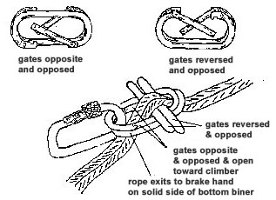Although complex, this rappel method is nearly impossible to fall out of and become separated from the rope. This method of rappel almost entirely eliminates body friction and is normally easy to control because the braking can be varied by either letting the free end of the rappel rope hang straight down after it passes through the carabiner brake, or by bringing it around the back to gain added body friction (as shown in the sketch on the next page). Of course, in either case it is absolutely necessary that the braking hand NEVER lose its grip on the rappel rope. Extreme caution should be used so that loose clothing, long hair or slings are not drawn into the braking system, which then generally have to be cut out.

Each student will perform at least one belayed (from below) rappel using their own device -chosen from the approved list.

**NOTE:** The method shown here and taught in this course differs slightly from the description in Freedom of the Hills.

**EXTENDED RAPPEL DEVICE METHOD**

1. The Extended Rappel is the primary method of rappel taught in the Tacoma Basic Course due to its safety.
2. <https://www.mountaineers.org/blog/how-to-extended-rappel>

EXTENDED RAPPEL SET UP WITH AUTOBLOCK

THE SET-UP – While Waiting

1. Attach PAS to anchor.
2. Thread half of a double-length (120 cm) sewn sling through harness hard points and tie both ends into a figure eight on a bight.
3. Add carabiner and device through both distal loops.
4. Tuck hair and any loose objects out of the way.

WHEN NEXT UP TO RAPPEL

1. One can attach the autoblock and carabiner to the rope while the preceding climber is on rappel.
2. A properly sized autoblock will not slide down the rope when left on the rope.

SETTING UP

1. Attach autoblock to belay loop with its locking carabiner.ExtendedRappel1_Updated.jpg
2. Pull rope up through autoblock to form bight of rope for threading device -the autoblock holds the weight of hanging rope strands.
3. With device located as close to anchor as practical thread rope bight through rappel device.
4. Clip device into both distal extending sling loops with carabiner.
5. Lock the carabiners.

TESTING

1. Review the system in a serial manner from anchor to landing: SERENE anchors, rope threading, autoblock, device, carabiner, belay loop, harness, stopper knots and landing.
2. Slide autoblock up toward device, and with gloved brake hand on both strands and being careful not to tension the PAS, loosen brake hand enough to weight the autoblock to make sure it will hold and that it cannot not reach into the device to defeat the autoblock.
3. With braking applied, slide autoblock down to create enough slack to body weigh the device while being careful not to tension the PAS or autoblock.

ON RAPPEL

STARTING RAPPEL

1. With brake hand on both strands well below device use other hand to remove PAS from anchor and stow.
2. Use brake hand to maintain friction.
3. Place non-brake hand on autoblock and begin sliding it.
4. To begin descent reduce friction in brake hand while sliding the autoblock.

WHILE RAPPELLING

1. One hand slides the autoblock while the other hand controls the braking friction on both strands of rope.
2. To change hands remove hand from autoblock and transfer brake control from one hand to the other, never letting go. Original brake hand will now manage autoblock.
3. If additional friction is needed slide brake hand under climbers seat.
4. In an emergency, or to engage the autoblock, let go of the autoblock while maintaining brake hand friction. Lessen friction only after autoblock is securely holding the rope.
5. To go hands free first assure the autoblock is holding. A leg wrap can be added for a greater security to the autoblock. To go hands free while hanging a back-up leg wrap is used as a back-up.

**Leg Wrap Tie Off.**

1. Minimum of three wraps around the leg with a tuck, keeping the brake hand on the rope until the wraps are completed and tested with weight.

**Performance Standards for Device Belay**

These are critical skills tests. Students should need very little coaching or instruction. **Sign off on the front cover of the student's *Field Trip Record Book*** for evaluations of “Safe”.

1. **Safe:** Independently sets up the rappel system and confidently uses safe technique to efficiently descend. Student is ready to participate in a Basic rock climb.
2. **Not Safe:** Requires significant instruction or lacks confidence. Student will not be allowed to participate in Basic rock climbs. (Refer to field trip leader.)

Cleaning Protection- A station will be set up for students to practice removing protection from ground level.

1. **Safe (Sufficient):** Participates.
2. **Not Safe (Not Sufficient):** Does not participate.

Belaying Lead Climber

A station will be set up for students to practice belaying a lead climber as on a short mock pitch of a rock climb. This can be done in a horizontal setting; no actual climbing needs to be done. Emphasis should be on the familiarizing the student with the climbing routine: when to tie in, when to follow, using commands and follow-up commands, how to clean gear, approaching the anchor, tying into the anchor, exchanging gear. Ideally, the leader will place one of each type of protection they have available. It is very important that the follower removes the gear, slings it on themselves properly, ties into the anchor, and prepares for the next lead.

1. **Safe:** Sets up belay, manages rope, maintains a safe belay, uses climbing commands properly
2. **Not Safe:** Requires significant instruction.

Clothing/Equipment

Student must have mountaineering boots and clothing to provide a sufficient level of protection under all reasonable weather conditions. Student must have all required equipment for rock climbing Field Trip.

**Performance Standards**

1. **Pass:** Has all necessary clothing and required equipment. Clothing provides for deteriorating weather.
2. **Needs Work:** Does not have adequate clothing or all required equipment. Student will not be permitted to participate in the field trip. (Refer to field trip leader.)

Ten Essential Systems

Checked at instructor’s discretion. There is no excuse for not having a complete set of the Ten Essential Systems by this time, so be critical in your evaluation.

**Performance Standards**

1. **Safe:** Has all required items in sufficient quantity.
2. **Not Safe:** One or more required items is missing or incomplete. Student will be rechecked before being allowed to participate in a subsequent field trip. (Refer to field trip leader.)

Knots for Field Trip

Students are expected to be able to tie all knots used in the field trip by this time. Each student will be evaluated on their ability to correctly tie knots for all field trip activities. If during any of these activities a student hesitates or requires instruction to tie a knot, mark their *Field Trip Record Book* appropriately.

**Performance Standards**

1. **Safe:** Correctly ties all knots without hesitation or instruction.
2. **Not Safe:** Consistently hesitates or requires instruction to tie any knot. Student will not be permitted to continue to participate in the field trip. (Refer to field trip leader.)

Belays to Climbers HELMET and GLOVES REQUIRED

1. Each student must do a minimum of 4 belays during the field trip. Rotate the students through as belayers. Don’t have the student do a number of belays at a single station; we want a number of instructors to evaluate them.
2. Each student must be able--**without assistance**--to tie into the anchor and safely belay a climber. Check the belayer prior to each climb.
3. Require both climber and belayer to use commands correctly.
4. Report any student who cannot safely belay to the field trip leader. **Any student who cannot safely belay will not be permitted to continue to participate in the field trip.**
5. Time permitting, discuss the various aspects of the anchors being used at your position (e.g., backed-up, equalized, how they were constructed, etc.)

**Performance Standards**

Students are expected to be able to proficiently provide a safe belay to climbers by this time. Be critical in your evaluation.

1. **Safe:** Can proficiently demonstrate climbing signals and safely belay without instruction. Student is ready to participate in a Basic rock climb.
2. Not Safe: Requires repeated instruction or cannot safely belay. Student will not be allowed to continue to participate in the field trip, in the Crevasse Rescue field trip or in Basic rock and glacier climbs. (Refer to field trip leader.)

# Field Trip #6 Prep - Crevasse Rescue (Clubhouse)

**Time: 6:00 p.m. for instructors 6:30 p.m. for students**

**Place: Tacoma Mountaineer Clubhouse**

Purpose:

|  |  |
| --- | --- |
| Practice Z-pulley crevasse rescue system | **Practice single pulley and direct pull crevasse rescue systems** |

Instructor’s Equipment:

|  |  |  |
| --- | --- | --- |
| Seat & chest harness | Pack sling | Ice axe |
| Pear-shaped locking carabiner | Texas prusiks | Pen/pencil |
| Carabiners (including locking) | Rescue pulley | *Field Trip Instructor Manual* |
| Leader tie off | Picket | Screwdrivers/Stakes (to anchor pickets in grass) |

Instructions - Crevasse Rescue Prep

General

1. You will be assigned a group of students and will be with them the entire evening.
2. Check each student has all necessary **clothing** and required **equipment** prior to beginning the other field trip activities. **Students who do not have adequate clothing and equipment will not be permitted to participate in the field trip prep.**
3. **Double check all** **harnesses** to ensure the students are wearing them properly. Students should double check harness tie in for themselves as well as others. Remind them to re-weave all buckles.
4. **Report** any student who is late, unprepared, making insufficient progress or delaying the group to the field trip leader. Make note in the student’s *Field Trip Record Book.*

Crevasse Rescue

**General**

1. Discuss relative strengths and weaknesses of each rescue method.
2. Review the basic steps in a crevasse rescue:
3. Arrest the fall.
4. Set up an anchor.
5. Check the fallen climber.
6. Devise a rescue plan.
7. Carry out the rescue plan.
8. For the crevasse rescue scenarios, assume that the students are on a normally equipped rope team of three persons, which is alone on a glacier and that the lead climber has fallen into a crevasse out of sight. All rope team members should be fully tied in with prusiks and chest harness, carry an ice axe and pack.
9. The use of gloves for practice should be emphasize since it is likely that weather conditions will require the use of gloves if having to perform a rescue on a climb. Gloves should always be worn when belaying the “victim” during the practical exercise in FT#6.

Z-Pulley Crevasse Rescue (See Crevasse Rescue Field Trip)

**Performance Standards**

1. **Safe:** Consistently uses proper technique for effective crevasse rescue. Student is ready to progress to the Crevasse Rescue field trip.
2. **Questionably Safe:** Uses proper technique for effective crevasse rescue with some instruction. Student is ready to progress to the Crevasse Rescue field trip.
3. **Not Safe:** Consistently uses incorrect technique or requires significant instruction. Student will not progress to the Crevasse Rescue field trip without remedial instruction. (Refer to field trip leader.)

Direct Pull and Single Pulley Crevasse Rescue (See Crevasse Rescue Field Trip)

**Performance Standards**

1. **Safe:** Consistently uses proper technique for effective crevasse rescue. Student is ready to progress to the Crevasse Rescue field trip.
2. **Questionably Safe:** Uses proper technique for effective crevasse rescue with some instruction. Student is ready to progress to the Crevasse Rescue field trip.
3. **Not Safe:** Consistently uses incorrect technique or requires significant instruction. Student will not progress to the Crevasse Rescue field trip without remedial instruction. (Refer to field trip leader.)

Clothing/Equipment

Student must have sturdy footwear and be dressed appropriately for practicing crevasse rescue outside. Student must have all required equipment for crevasse rescue.

**Performance Standards**

1. **Safe:** Has adequate clothing and all required equipment.
2. **Not Safe:** Does not have adequate clothing or all required equipment. Student will not be permitted to participate in the field trip prep. (Refer to field trip leader.)

Knots for Field Trip Prep

Students are expected to be able to tie all knots used in the field trip by this time. Each student will be evaluated on their ability to correctly tie knots for all field trip activities. If during any of these activities a student hesitates or requires instruction to tie a knot, mark their *Field Trip Record Book* appropriately.

**Performance Standards**

1. **Safe:** Correctly ties all knots without hesitation or instruction.
2. **Not Safe:** Consistently hesitates or requires instruction to tie any knot. Student will not be permitted to continue to participate in the field trip. (Refer to field trip leader.)

# Field Trip #6 - Snow 2 - Crevasse Rescue Section (Panorama Point)

**Time: 6:00 a.m. for instructors 7:00 a.m. for students**

**Place: Panorama Point, Mt. Rainier National Park (Meet at Paradise upper parking lot.)**

Purpose:

|  |  |
| --- | --- |
| Discuss glacier travel hazard awareness | Practice prusiking |
| Practice roped glacier travel | Practice single pulley crevasse rescue system |
| Evaluate student's ability to use Z-pulley crevasse rescue system | Practice direct pull crevasse rescue system |

Instructor Equipment:

|  |  |  |
| --- | --- | --- |
| Ten Essential Systems | Slings (for snow anchors) | Pickets for anchors |
| Mountaineering boots | Leader tie off | Wands (10 min) |
| Crampons | Pack sling | Helmet |
| Seat & chest harness | Texas prusiks | Belay gloves |
| Pear-shaped locking carabiner | Rescue pulley | Pen/pencil |
| Belay device | Ice axe | Walkie Talkies |
| Personal anchor sling | Shovel | Instructor Manual for this FT |
| Carabiners (including 3 locking) |  | Plastic Baggie for above |

Instructions:

General

1. Instructors will work as a pair. One instructor who has previously taught at Crevasse Rescue will be designated the Lead Instructor, the other as the Assistant Instructor. Each pair of instructors will be assigned a group of students (4 to 6) and will work with them all day.
2. Each group will need three climbing ropes. Enough for two rope teams of students and one for the instructors.
3. Check to make sure each student has all necessary **clothing** and required **equipment** prior to leaving the Paradise parking lot. **Students who do not have adequate clothing and equipment will not be permitted to participate in the field trip.**
4. Encourage students to do their potty breaks before leaving parking lot.
5. When instructed by the field trip leader, your group may proceed from the Paradise parking lot at its own pace, but keep your group (including instructors) together.
6. Students will be on anchored **belay** when in the “crevasse”. All belay anchors will be backed-up. Check them frequently since they will be subjected to repeated loads during the course of the day. Monitor the students to ensure they use sunscreen and sunglasses. Be alert for indications of hypothermia.
7. Double check all **harnesses** to ensure the students are wearing them properly prior to permitting a student to glacier travel or belay. Students should double check harness tie in for themselves as well as others. Remind them to re-weave all buckles.
8. Students and instructors will wear a **UIAA-approved climbing helmet** during roped glacier travel and crevasse rescue and when belaying.
9. Students will wear **gloves** for belays.
10. Review the safety checklist every cycle before lowering student into “crevasse”.
11. Students are to keep their pack with them at all times. If anyone leaves it behind, make them go back and get it.
12. **Report** any student who is late, unprepared, making insufficient progress or delaying the group to the field trip leader. Make note in the student’s *Field Trip Record Book.*
13. As the students arrive at the practice area, instruct the students on how to enter a break area or camp when roped on a glacier without creating slack in the rope – i.e., Using their seat harness prusik to keep taut to anchor or being belayed in on an carabiner-ice axe belay

**Performance Standards**

1. **Safe (Sufficient):** - Participated in the discussion and was able to recognize hazards.
2. **Not Safe (Not Sufficient):** - Did not participate in the discussion or was unable to recognize hazards or endangered himself or others by failure to avoid hazards. (Refer to field trip leader.)

Roped Glacier Travel HELMET REQUIRED.

1. Prior to going onto the “glacier”:
2. Review the carabiner/ice axe belay
3. Check each student’s harness, tie-in, prusiks, and crampons.
4. Remind students not to step on a climbing rope when wearing crampons.
5. While traveling, take the opportunity to point-out glacier features to the students and discuss glacier travel techniques and considerations.
6. Monitor and correct errors. More common ones include: rope on up-hill side; ice axe on downhill; too much or too little slack in rope; not using rest step or kick step when appropriate; edging with crampons; not using the ice axe for self-belay on steep terrain.

**Tying In**

1. Correctly dons seat harness and chest harness
2. Attaches climbing rope to seat harness properly.
3. Attaches prusiks to climbing rope and to seat harness and stows
4. Attaches pack sling between pack and seat harness
5. Double checks tie in of other climbers

**Putting On Crampons**

1. Even if conditions are not suitable for crampon use**, students should put them on** long enough to ensure proper fit and that they can put on crampons in an independent and timely manner.
2. Discuss the importance of proper fit of straps or bales.
3. Discuss the importance of proper sizing to boots without cutting off circulation and readjustment as feet swell during the climb.
4. Students should be able to independently don crampons in a timely manner. Check that the strap buckles are on the outside of their feet and that any loose ends are secured.

**Moving In Balance**

1. Coordinates foot movement with ice axe placements.
2. Does not move until ice axe is placed.
3. Uses proper foot movements and remains in balance while changing directions.

**Self Belay (with Ice Axe)**

1. Keeps ice axe on uphill side of body.
2. Places ice axe as an anchor before moving.
3. Remains self-belayed when changing directions.

**Switchbacking**

1. Leader spaces switchbacks far enough apart to prevent rope management problems.
2. Rope team communicates and works together to keep rope taut while turning corners.

**Rope Management**

1. Discuss the importance of not stepping on or otherwise damaging the rope.
2. Keeps proper tension on rope to climber in front and behind.
3. Leader sets a pace that others can follow.

**Crampon Techniques (if conditions allow)**

1. Discuss self-arrest with crampons (feet up).
2. Emphasize keeping feet flat on the surface of the snow for maximum point penetration.
3. Students should be able to move in a coordinated manner without tripping, stepping on the rope or impaling themselves.

**Performance Standards for cramponing**

1. **Safe:** Demonstrates proficiency at all skills as a rope team member. Student is ready to participate in a Basic glacier climb.
2. **Questionably Safe:** Demonstrates proficiency at most skills as a rope team member. Student is ready to participate in a Basic glacier climb.
3. **Not Safe:** Lacks many skills as a rope team member. Student will not be allowed to participate in Basic glacier climbs. (Refer to field trip leader.)

Z-Pulley Crevasse Rescue Test HELMET REQUIRED

1. You are responsible for the safety of the students while on the glacier.
2. When not on a rope team, everyone must be attached to an anchor.
3. Students should limit their movements within the wanded area and always carry an ice axe.
4. Students should stay clear of the crevasse rescue and belay ropes and the crevasse when not directly involved with the instruction in progress.
5. Helmets shall be worn by all Students and Instructors
6. Review the basic steps in a crevasse rescue:
7. Arrest the fall.
8. Set up the anchors to anchor the victim.
9. Check the fallen climber.
10. Devise & carry out the rescue plan.
11. Devise and communicate to all a way to identify and keep track of the midpoint of the rope being used by the climbers in the rescue scenario. We want the midperson (climber B) to always tie in at the midpoint.
12. For the crevasse rescue scenarios, assume that the students are on a normally equipped rope team of three persons, which is alone on a glacier and that the lead climber has fallen into a crevasse out of sight. All rope team members should be fully tied in with prusiks and chest harness, carry an ice axe and pack but **not wear crampons**.
13. Prior to lowering the first victim into the “crevasse”, review with students the steps of crevasse rescue and prusiking.
14. The victim in the crevasse will be belayed at all times and be fully clothed with raingear, hat and gloves and have a knife accessible. **Make sure the victim to go in “crevasse” has the rope clipped thru the chest harness carabiner before going in** and the ice axe is on leash. Likewise, make sure they have a pack sling attached to their pack. **Review the safety checklist each cycle.**
15. Lower the victim into the “crevasse” a decent distance – at least 10 feet – enough to allow room for prusiking before being rescued. 15 feet would be more like it if space allows.
16. Have students check each other out for proper tie in. Check out the belayer for proper set up before lowering victim. Victim and belayer should communicate with commands so they are in concert.
17. Have the students rotate through each position once including victim and belayer. If a student has difficulty with a particular position have them repeat it later in the field trip (maybe move them to a different team that is finishing ahead of you). If the student continues to struggle, refer them to the field trip leader.
18. Instructor at lip of “crevasse” should use the opportunity when climber A is at the lip of the “crevasse” evaluating the victim’s situation to discuss with endperson C the decision making involved in deciding which rescue method to use. It is an opportune time for the two participants to review and demonstrate as time allows, the scenario of how they would set up a single (“C”) pulley imagining Climber C was actually the lead climber of the second rescue rope team in this situation.
19. Monitor the progress of the victim being pulled from the “crevasse” and have the pulling paused when the victim reaches the lip so he/she can unclip from chest harness and safely negotiate this transition.
20. Make sure the belayer is taking in the slack and constantly keeping rope to victim in tension as the victim is raised.

## Belay Anchor Setup

1. Have the students set up anchors for use by a student to belay the crevasse rescue victim and for use by an instructor to attach a tether. This should be at least two buried deadmen equalized.
2. Discuss equalization (How to) and the need to minimize the angle between anchors. Note: the students are spending an hour on anchors at Snow 2 (FT 6).
3. Check the anchors often for any indication they may be working loose. Stomp Snow on anchors to pack in. Have the Field trip Assistant Leader (safety officer) check out your set up before lowering the first victim in crevasse.

**Performance Standards**

1. **Safe (Sufficient):** Participates.
2. **Not Safe (Not Sufficient):** Does not participate.

## Crevasse Rescue Procedure (from Student Manual)

Crevasse Rescue Step by Step Instructions

###### **Overall Summary**

1. First Response – victim yells “FALLING” – Rope Team arrests the fall.
2. Initial and Main anchors are set and the rope to the Victim is secured to the anchors.
3. Evaluate Victim’s situation and condition and then decide what method of rescue.
4. Implement the method
5. Perform the rescue.

###### **Rescue Methods**

If the victim is able, he or she may be able to extricate themselves. As the climber in the crevasse, ALWAYSbegin self-extrication. During a climb, the object of crevasse rescue is to remove the fallen climber from the glacier, not to set up a complicated pulley system. The fallen climber should make every effort to **establish and maintain communication** if able. Many times a fall is shallow (knee deep to a foot over your head); simply pull yourself out. If you find yourself hanging, begin the prusiking procedures you were taught at the Fundamentals and Belaying field trips. If you are wedged, do all you can to make sure your team knows it and try to get yourself free. Use your head; it’s your best piece of equipment.

If the victim cannot extricate themselves, then the rest of the party must chose a method to assist he victim out of the crevasse. The choice of which method to use is a decision that must balance available person power against the time and equipment needed. The choice is also influenced by the condition of the Victim and whether the rope is entrenched in the lip.

**Needed Person Power Method Time and Equipment**

Direct Pull

DECREASES Single Pulley INCREASES

Z-Pulley

**FIRST CHOICE** should be direct pull if the pulling power is available. This could be 2 or more rope teams.

**SECOND CHOICE** should be the single pulley method if 2 or more rope teams are available.

**THIRD CHOICE** should be the Z-pulley method, which can be done with 1 or more rope teams.

**NOTE:** Don’t use a more time-consuming system when you have the available power to carry out a quick rescue.

### Crevasse Rescue Procedure

Crevasse rescue can involve many different scenarios. During this field trip we cannot practice all the possible variations because of time limitations. In each scenario, the team will set up, implement and be evaluated on the Z Pulley method for rescue. We will also demonstrate the use of a C pulley set up using the free end of the climbing rope and demonstrate the set up of a C pulley using a separate rope teams climbing rope.

The following describes the step by step procedure for performing the Crevasse Rescue operation on this field trip using the Z-PULLEY system with one three person rope team. The narrative describes the process and actions required. This information is depicted in the figures shown on the pages following the narrative.

**Note:** Locking carabiners are preferred in setting up anchor attachments. If the party does not have enough locking carabiners to suffice, consider girth hitching the webbing to the hole in the anchor picket near the snow line. Another alternative would be to use two oval carabiners, gates opposed and opposite, in place of a locking carabiner.

**Note:** It is important that the middle climber B tie into the MIDDLE of the rope. Keep track of the midpoint of rope!!

1. **INITIAL FALL – ROPE TEAM ARREST!** Climber A has fallen into a crevasse. Climbers B and C have immediately gone into ice axe arrest and arrested the fall with their feet entrenched against the direction of pull and the rope to the victim taut.

**Note to the victim – Climber A**: If you are climber A in the crevasse you should have the climbing rope clipped thru your chest harness before entering the crevasse and your ice axe leash on your wrist (see the discussion on this subject in Freedom of the Hills, pg 393-395) and be sure you have a short sling girth hitched to your pack**. Be sure your gear, harness and tie in are checked out by a teammate or instructor before entering crevasse. Wear something warm, as you will be in at least ½ hour. Before approaching the crevasse lip or descending, check to be sure your belayer has you on belay (use climbing commands)** After descending (falling), you will clip the short sling from your pack onto the climbing rope between the seat harness and your prusiks, remove your pack and let it be suspended by this sling from the rope. Clip your ice axe to your harness and let it dangle. Then proceed to set up your Texas Prusiks. Do not start to climb with your Texas Prusiks until you are told the rope is anchored, then climb a few feet up the rope while awaiting rescue. You will want to unclip from chest harness when at lip of crevasse during rescue so as to safely negotiate yourself across lip.

1. **FIRST STEP --SET UP THE ANCHORS AND ATTACH & SECURE THE ROPE to the VICTIM (This IS Done in any Crevasse Rescue scenario):**
2. **Set Up Initial anchor**
3. 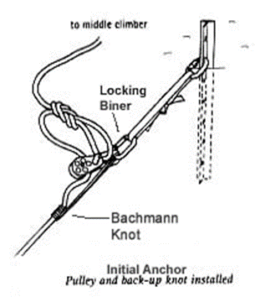Climber C communicates with climber B that he/she intends to slowly transfer the load of the fallen climber to climber B to see if climber B can hold the load alone.
4. If climber B can hold the load, climber C self belays him/herself on the rope to climber B by using his/her seat harness prusik sling (which is already tied into the rope). Climber C continues probing for hidden crevasses with his/her ice axe, prepared to arrest if climber B needs help.
5. Climber C then probes the area around climber B to detect any hidden crevasses and then proceeds to establish an initial anchor between climber B and the fallen climber (climber A). Choose a spot near the rope to the victim, about 5 to 10 feet from climber B (midperson), toward the victim. Climber C drives his/her picket in the slope at an angle of 15 to 20 degrees back from perpendicular to the slope, away from the direction of pull, to establish this initial anchor. A short or single webbing sling is attached to the picket at the snow line with a locking carabiner (option: girth hitch sling to hole in picket or use a regular carabiner). Next a Bachmann knot is tied to the climbing rope leading to the fallen climber (climber A) using a short perlon sling (hero loop) and carabiner. The loop from the Bachmann knot is clipped into the webbing from the anchor using a locking carabiner. Slide the Bachmann away from the anchor till tight to the anchor.

**Note:** A picket for the initial anchor is preferred. If no picket is available an ice axe can be used to establish this initial anchor. However, using an ice axe precludes C (and ultimately B’s) ability to self-arrest if the anchor fails.

1. Climber C guards this anchor by placing his/her uphill boot on the webbing adjacent to the anchor picket and takes a wide stance with the other boot toward fallen climber A.
2. Climber C, communicating with climber B (midperson), tells B initial anchor is in place and climber B slowly transfers the load of the fallen climber to the anchor. If the anchor holds, Climber B then stands up, clips into the anchor sling with his/her personal sling and takes over guarding the anchor by facing climber C, placing one boot on the short/single sling between the anchor and the anchor carabiner and takes a wide stance with the other boot toward fallen climber A. **Climber B MUST then guard this anchor until the rescue is complete.** If the anchor fails the whole rope team can be pulled into the crevasse. Climber B holds his/her ice axe in a ready to arrest position.
3. Climber C places his/her rescue pulley on the now unweighted bight of climbing rope between climber B and the Bachmann knot and uses a carabiner to clip the rescue pulley to the anchor carabiner (this can be non locking). It is easier to put the pulley on now, even though the team may decide to do a direct pull or C pulley.
4. Climber C then takes a bight of rope between climber B and the pulley, ties a figure 8 loop and clips it into the pulley’s biner. This is a backup, in case the Bachmann slips.
5. **Set up back up deadman anchor**
6. While climber B continues to guard the initial anchor, climber C sets up the Main anchor, a deadman. This anchor must be strong enough to hold the full weight of the victim and climber A for long periods.
7. Climber B (midperson) and climber C (endperson) collaborate on equipment. Climber C needs another picket, double runner, 2 locking carabiners, 2 oval carabiners, a pulley, a leader tie off sling and a shovel.

**Note:** Every rope team on a glacier climb should carry at least one shovel. (If C used his/her ice axe in the Main anchor, instead of picket, B will need to give C his/her ice axe).

1. Climber C attaches a double runner with a locking carabiner clipping thru both the tie off loop from the Bachmann and rescue pulley carabiner. An additional double or single runner is attached, extending them both, to help located the position of the main anchor. The webbing, attaching the main anchor to the initial anchor carabiner, should not have any slack when attached to the main anchor.
2. The main anchor should be further away from the crevasse than the initial anchor and as much as possible inline with the direction of force from the fallen climber (also at no more than a 30-degree angle to the initial anchor).
3. Note: In well consolidated snow, the best main anchor is a deadman made with a picket (fluke can also be used if a picket is not available). Using a shovel, dig a pit perpendicular to the direction of pull and lay in the picket with a runner attached (girth hitched or with a carabiner to the center hole on the picket). You may either tie or girth hitch a sling (single or double) or attach a sling with a carabiner to the middle hole of the picket. Extend out the runner in a channel toward the initial anchor. The deadman picket should be located so this runner and the runner extending back from the initial anchor clip together with little or no slack in the system. Cover the picket and stomp the snow securely.
4. DO NOT GIRTH HITCH AROUND THE ENTIRE PICKET AS SHOWN IN THE FIGURE TO THE RIGHT, ONLY GIRTH HITCH THROUGH THE HOLE. A GIRTH HITCH AROUND THE ENTIRE PICKET MAY CAUSE THE FINS TO COLLAPSE UNDER LOAD AND POSSIBLY CAUSE THE ANCHOR TO FAIL.
5. **SECOND STEP: EVALUATE VICTIM/SITUATION & DEVISE A PLAN (METHOD) FOR RESCUE**
6. Once the Main anchor is in place Climber B (midperson) unties from the rope to free it for use in the rescue. Climber B continues to guard the initial anchor.
7. Climber C then makes sure his harness prusik attached to the climbing rope is positioned such that he/she is taut to the anchor and proceeds to self-belay him/herself to the lip of the crevasse by sliding the prusik knot along the rope while probing with an ice axe for hidden crevasses.
8. At the edge of the crevasse, endperson (climber C) further determines the status of the fallen victim (climber A), evaluates his/her condition, and determines whether he/she will be able to help with rescue (assure the victim they are being rescued).
9. Climber C also evaluates the condition of the rope leading into the crevasse to the victim as to the extent it is dug into the lip of the crevasse (entrenchment).
10. Based on the evaluation and the resources available, this is the time in a REAL Crevasse Rescue to make a choice of rescue methods: Direct Pull vs. “C” pulley (“single rope” or “double rope” set-up) vs. “Z” pulley. The Direct Pull method is preferred, as no additional setup is required. However, a second team is required to provide pulling power. A “C” Pulley **will** be required if the victim’s rope is severely entrenched. A “single rope” or a “double rope” system may be employed to overcome the entrenchment. (Normally the victim must be conscious and able to clip a carabiner to their harness to use the “C” Pulley.) The “single rope” system is set-up using the victim’s rope. If there is not enough rope to reach the victim, the “Z” Pulley should be used to bring the victim to the crevasse edge, then the “C” Pulley placed to overcome the rope entrenchment. A “double rope” setup may also be used. This requires the use of a second team’s rope to reach the victim. (See the complete setup narrative under “Single or C Pulley System Double rope set-up”) Both the “single” and “double rope” setups require a second team to provide pulling power. **For the purposes of this field trip the plan of choice will be the single rope team Z-Pulley rescue**. Everyone must demonstrate his/her proficiency at each role of the Z pulley method. We will also set up and perform the Single pulley (AKA “C” pulley) rescue.
11. Climber C pads the rescue rope leading to the victim to prevent it from digging any further into the snow by placing an ice axe under the rope, as close to the edge as possible. Drive the pick into the snow (adze up and to downhill side to prevent rope from slipping off). This ice axe is anchored by putting a carabiner on a sling girth-hitched to the ice axe (or the leash) and burying the carabiner and some of the sling in a hole scooped in the snow away from the head of the ice axe. Climber C may also need to chop/clear a pathway in the lip so A can be pulled over the lip (Caution: This will rain debris on climber A).
12. 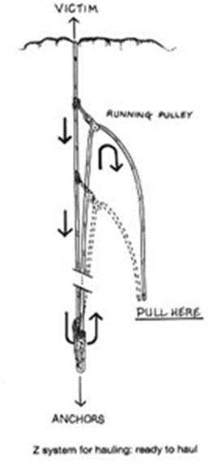**Always perform the steps above (#0 Thru #2) in any crevasse rescue scenario -- For instance, Set up the anchors, evaluate the victims condition and then choose the rescue system, such as a direct pull.**
13. **THIRD STEP: IMPLEMENT THE PLAN**

### 

### Setting up the Z-Pulley – 3:1 mechanical advantage

1. End person (Climber C) uses a leader tie-off loop to tie a prusik knot on the rope leading to fallen the victim (climber A) in the crevasse. The location of this prusik knot is several feet back from the crevasse lip.
2. Climber C then takes the rope section leading back to the anchor and first pulley and attaches the second pulley, clipping it into the prusik loop from the victim’s rope with a carabiner. There is nothing else between the two pulleys (other than the Figure 8 loop). Climber C then self-belays back to climber B at the anchor, clips into the anchor with his personal anchor sling and removes the figure 8 knot from the anchor and unties it.

**FOURTH STEP: PERFORM THE RESCUE**

Climbers B & C pull hand over hand on the climbing rope until the two pulleys are no closer than about one foot apart, or until the victim is out of the crevasse. While hauling, midperson (climber B) keeps an eye on the Bachmann knot to ensure it doesn’t jam in the pulley. Anytime the hauling is paused the load is eased back onto the Bachmann knot by extending it away from the anchor. This should be done when climber C needs to check victim A’s proximity to the lip or the system needs to be re-set as the victim is not yet out of the crevasse. Climber C will re-tie the figure-eight back-up before resetting the system. The system is reset by Climber C moving (resetting) the floating pulley prusik back toward the edge of the crevasse (while self belaying) and then returning to Climber B to resume hauling. This process is repeated until fallen Climber A is out of the crevasse.

**Note: In any rescue scenario, monitor the progress of the victim (climber A) to avoid pulling the victim into the crevasse lip, causing injury. As the victim approaches the crevasse lip, hauling should cease (pause) so the victim can remove the rope from his/her chest harness and negotiate crossing the lip safely with the assist of the rest of the rope team, if necessary.**  (There could be an overhanging lip which climber A needs to chop away with the ice axe).

**Note:** Climber B will assist in pulling on the rope but his/her primary duty is guarding the anchor and tending the Bachmann.

**InsTructors:**

**Performance Standards for Z Pulley Crevasse Rescue**

This is an essential skills test. Students should need very little coaching or instruction.

1. **Safe:** Consistently uses proper technique for rapid and effective crevasse rescue. Student is ready to participate in a Basic glacier climb.
2. **Not Safe:** Consistently uses incorrect technique or requires significant instruction. Student will not be allowed to participate in Basic glacier climbs. (Refer to field trip leader.)

**After everyone has completed all roles in performing the Z and C Pulley rescue, we will move on to practicing the C Pulley “Double Rope” rescue method. Steps #0 thru 2 above in arresting the fall and setting the anchors are the same. The remaining steps required in setting up the system and performing the rescue are described in the text and accompanying system diagram.**

### 

### C Pulley System (Single Pulley) “Double Rope” Setup 2:1 mechanical advantage

This system is used if the fallen climber is conscious and able to help with the rescue and if additional help is on hand (a second rope team) to set the system up and help pull the climber out of the crevasse.

In the description below, rope team one with the fallen climber A is assisted by a second rope team whose members are identified as 1, 2 & 3.

Rope Team one (A, B, C) completes setting the initial and main anchors as described in steps #0 – 2 of the crevasse rescue procedure on prior pages.

1. Depending on the depth of climber A’s fall, climber 2 on the rescue rope team may need to retie closer to climber 3 to allow enough rope to reach fallen climber A.
2. Discuss when this would be suitable (Victim’s rope entrenched, victim able to assist and another rope team available) and walk students through the procedure. Then set up and practice the single pulley as many times as time allows. Set the initial and back up anchors as in above Z pulley procedure. Have midperson on victim’s rope (Climber B) guard the anchors and tend the Bachmann knot taking up slack so the victim’s rope to anchor is always taut. Likewise have belayer keep the rope taut to victim as he/she is being raised.

**NOTE:** Normally, this rescue requires two rope teams. If a second rope team is not readily available and if you have a minimum of 2 instructors and 5 students, you may still perform the Single Pulley rescue. Lower the victim into the crevasse on belay. The victim is attached to initial and main anchors tended by climber B, and also on the belay rope. Form another rescue rope team with the remaining 3 students and practice set up and operation of Single Pulley. This second rope team (Climbers 1, 2 & 3) performs the actual rescue.

1. 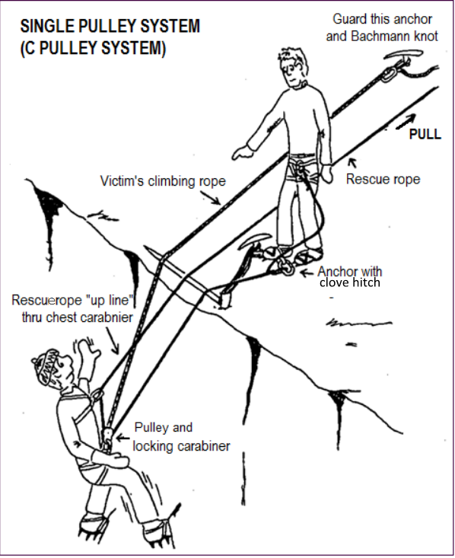Rescue rope team belays lead climber (climber 1) to lip of crevasse. Team may alternatively travel to crevasse edge on tight rope, ready to arrest should climber 1 also fall.
2. Climber 1 sets up an anchor with a vertical picket or ice axe driven in slope at a 15-20 degree angle from the slope, away from the direction of pull, as near the lip of the crevasse as possible. Next, he/she girth hitches a short/single sling to the anchor. (Note:the sling should point directly to the victim, the accompanying diagram is not correct.) A Figure-8 loop is tied in his/her climbing rope and clipped into the short/single sling with a locking biner. Allow enough length to stand while tending the anchor, when tying the figure 8.
3. Climber 1 places an ice axe at the lip of crevasse and secures the ice to the anchor they just placed. (**Do not attempt to position the ice axe under the rope to the victim**).
4. Climber 1 then places a pulley and locking carabiner on the bight of rope between his anchor and Climber 2. The pulley, carabiner and rope are placed over the ice axe and carefully lowered to fallen climber A. Climber 1 must guard the anchor at the lip from this point forward.
5. Victim (Climber A) clips the locking carabiner attached to the pulley into the loop formed by their figure-8 tie-in knot on his/her seat harness. The victim then clips the “up” rope (the portion of the rope that will be pulled) through his/her chest harness carabiner. He/she signals readiness to be hauled out. Maintain the hauling rope over the ice axe at the lip.
6. Climbers 2, 3 and C haul the rope hand-over-hand at climber 1’s direction. As slack becomes available in the rope between fallen climber A and climber B (tending the Main anchor), climber B pulls the slack through the Bachmann knot. (The safety belayer also continually removes slack in the belay line). As climber A nears the top of the crevasse, climber 1 stops climbers 2, 3 and C from pulling long enough for climber A to unclip the rescue rope from the chest harness. (Otherwise he/she would be pulled into the lip of the crevasse). Climber A is then carefully hauled over the lip.

**Performance Standards For Single (“C”) Pulley**

1. **Safe:** Consistently uses proper technique for rapid and effective single pulley crevasse rescue.
2. **Questionably Safe:** Uses proper technique for effective single pulley crevasse rescue with some instruction.
3. **Not Safe:** Consistently uses incorrect technique or requires significant instruction. Student will not be allowed to participate in Basic glacier climbs without remedial instruction. (Refer to field trip leader.)

### Direct Pull – 1:1 (No) mechanical advantage

Do as time allows. This procedure has no diagram. However, set up the anchors following steps 0 thru 2 in the crevasse rescue procedure above. This method can be used if the rope to the victim (climber A) is not entrenched and can be pulled over the lip of the crevasse.

1. Climbers pulling on the rope stand in back of Climber B’s anchor and pull the rope in hand-over-hand (remember to untie Figure-8 knot).
2. Climber B tends the Bachmann knot. This is quick if the people power is available to do it.

Prusiking HELMET REQUIRED

Performed while in the crevasse as the victim.

**Performance Standards**

Students are expected to be able to proficiently prusik by this time

1. **Safe:** Can don prusiks and ascend the rope while suspended in crevasse without instruction.
2. **Not Safe:** Requires instruction or excessive effort to ascend the rope. (Refer to field trip leader.)

Belay to Victim HELMET and GLOVES REQUIRED

Rotate students as belayers to the crevasse rescue victim.

**Performance Standards**

Students are expected to be able to proficiently provide a safe belay to climbers by this time. Be critical in your evaluation.

1. **Safe:** Can proficiently demonstrate climbing signals and safely belay without instruction.
2. **Not Safe:** Requires instruction or cannot safely belay. Student will not belay climbers without remedial instruction. (Refer to field trip leader.)

Conditioning

Students must be in good enough physical condition to keep-up with the group during field trip activities.

**Performance Standards**

1. **Safe:** Demonstrates adequate conditioning for participation in a Basic climb.
2. **Not Safe:** Does not demonstrate adequate conditioning for participation in a Basic climb. (Refer to field trip leader.)

Clothing/Equipment

Student must have mountaineering boots and clothing to provide a sufficient level of protection under all reasonable weather conditions. Student must have all required equipment for roped glacier travel and crevasse rescue.

**Performance Standards**

1. **Safe:** Has all necessary clothing and required equipment. Clothing provides for deteriorating weather.
2. **Not Safe:** Does not have adequate clothing or all required equipment. Student will not be permitted to participate in the field trip. (Refer to field trip leader.)

Ten Essential Systems

Checked at instructor’s discretion. There is no excuse for not having a complete set of the Ten Essential Systems by this time, so be critical in your evaluation.

**Performance Standards**

1. **Safe:** Has all required items in sufficient quantity.
2. **Not Safe:** One or more required items is missing or incomplete. Student will not be permitted to participate in the field trip and will be rechecked before being allowed to participate in a subsequent field trip. (Refer to field trip leader.)

Knots for Field Trip

Students are expected to be able to tie all knots used in the field trip by this time. Each student will be evaluated on their ability to correctly tie knots for all field trip activities. If during any of these activities a student hesitates or requires instruction to tie a knot, mark their *Field Trip Record Book* appropriately.

**Performance Standards**

1. **Safe:** Correctly ties all knots without hesitation or instruction.
2. **Not Safe:** Consistently hesitates or requires instruction to tie any knot. Student will not be permitted to continue to participate in the field trip. (Refer to field trip leader.)

## Safety Check List to be performed Each Cycle of Crevasse Rescue Exercise

1. Everyone is accounted for and everyone stays tied relatively taut to an anchor while in the practice area. Harnesses and tie ins have been mutually checked.
2. Everyone has their helmet on.
3. Belayer’s anchors are checked and are securely in place.
4. Belayer’s tie in and set up are checked to be proper.
5. Belayer understands that he/she is to allow no slack in rope during the rescue exercise, always taking up slack as the victim is raised from crevasse.
6. Climbers A, B & C on the rope team have tied in and checked each other out. Climber A is properly tied to climbing rope AND also properly tied in to belay rope.
7. Climber A (victim) has climbing rope clipped thru chest harness carabiner and ice axe is on leash on wrist. Pack is on and there is a pack sling attached
8. Climber A (victim) has on warm clothing and gloves – No crampons.
9. An instructor is in place and on anchor tether near edge of crevasse to supervise lowering the victim into crevasse.
10. Climbers B & C on the victim’s rope team stretch out the rope as in glacier travel and maintain little slack in the rope as victim is lowered into crevasse, always being ready to arrest.
11. As victim is hauled out of crevasse, instructor notifies haulers as victim approaches edge of crevasse so victim can negotiate the lip.
12. Remind all to continually apply sunscreen.

# Field Trip #7 – Snow 2 - Hard Snow (Glacier Vista – Panorama Point Area of MRNP)

**Time:** 6:00 a.m. for instructors 7:00 a.m. for students

**Place:** Parking lot at Paradise

**Purposes:**

|  |  |
| --- | --- |
| **Test** student's ability to use ice axe arrest on hard snow (With pack/without crampons) | **Practice then Test** student's ability to utilize carabiner/ice axe belay |
| Practice rope management as a rope team on a glacier and ascending/descending slopes | Practice belaying team members at or near crevasses. |
| Practice navigation skills in the field | Practice wanding & route finding |
| Discuss hazards traveling on hard snow | Practice traveling up & down slope with crampons |
| Practice team arrests | Practice Ice axe self belay on steep slopes |
| Practice construction of snow anchors | Practice safe glissading |

**Instructor Equipment:**

|  |  |  |
| --- | --- | --- |
| Ten Essential Systems | Leader tie off | Pickets or flukes & a shovel |
| Mountaineering boots | Pack sling & chest harness sling | Helmet |
| Seat & chest harness | Texas prusiks, rescue pulley | Belay gloves |
| Pear-shaped locking carabiner | Ice axe | Pen/pencil |
| Carabiners (including locking) | Walkie talkie if you have one | One rope for every 3 students |
| Slings (for snow anchors) | Crampons | *Field Trip Instructor Manual* |

**Instructions:**

**General**

1. You will be paired with another instructor, assigned a group of 6 students and will work with them all day. Organize your group in the parking lot and stay together as a group all day
2. Check each student has all necessary **clothing** and required **equipment** prior to leaving the parking lot. **Students who do not have adequate clothing and equipment will not be permitted to participate in the field trip.**
3. **Stress safety**: **Stress safety:** ensure all ice axes have leashes and adzes are taped. Monitor the students to ensure they use sunscreen and sunglasses. Be alert for indications of hypothermia. Caution students about the possibility of getting out of control and of injuring themselves when sliding on hard snow.
4. **Do Not allow students to wear crampons while doing ice axe arrest exercises**. Do remind students of how to arrest with crampons on their feet.
5. Double check all **harnesses** to ensure the students are wearing them properly prior to roped travel. Students should double check harness tie in for themselves as well as others. Remind them to re-weave all buckles.
6. Students will wear a **UIAA-approved climbing helmet** for ice axe arrest, roped travel and carabiner/ice axe belay. Instructors should set a good example by wearing a helmet when instructing these skills.
7. Students are to keep their pack with them at all times. If anyone leaves it behind, make them go back and get it.
8. **Report** any student who is late, unprepared, making insufficient progress or delaying the group to the field trip leader. Make note in the student’s *Field Trip Record Book.*

**Skills to be taught and evaluated**

**Snow Travel Hazard Awareness**

En route from parking lot to Glacier Vista, make a few stops to review the considerations in route selection on snow. Review avalanche avoidance considerations. Discuss snow pack strength variability depending on weather & temperature, time of day, slope aspect & angle, sunny vs shady, etc. Detecting crevasses or other hazards (streams) beneath snow cover from depressions in snow. Also discuss moats around rocks, trees, etc. Buried hazards & post holing – detecting and avoiding.

Discuss considerations in travel related to lack of run out on slope and consequences of a fall. Emphasize the need to observe terrain for evidence such as rockfall debris, avalanche debris, pits, depressions, etc. Discuss minimizing/avoiding rock fall hazards in relation to route selection.

Prior to roped glacier travel practice, discuss hard snow hazards and how to recognize them -- Make this an ongoing discussion during the day.

**Performance Standards**

1. **Safe (Sufficient):** Participated in the discussion and was able to recognize hazards.

* **Not Safe (not sufficient):** Did not participate in the discussion or was unable to recognize hazards or endangered himself or others by failure to avoid hazards. (Refer to field trip leader.)

**Ice Axe Arrest Test** -- **HELMET REQUIRED** (**Approx 120 minutes)**

**General -- Do not allow students to wear crampons for the ice axe arrest test**.

The field trip leader will designate a safe area in the vicinity between Glacier Vista and Panorama Point for the ice axe arrest exercise.

Integrate ice axe arrest exercises with instruction on snow travel techniques including glissading, kicking steps, rest step and self-belay with ice axe to prevent falling.

Students will first do ice axe arrests without packs and then with packs on. No external frame packs are allowed for this test. If a student has an external frame pack, have him/her borrow someone else’s pack. Caution students to remove breakables from pack.

Discuss glissading

When to, when not to – **Not** with crampons, **Not** when snow is too hard to self arrest, **not** when route is not visible, **No**t when there is little or no run out or rocks or trees below, **Not** when there are hidden hazards such as streams or marshes under snow, etc.

1. Discuss proper positioning of ice axe during glissading – self-arrest position – **Do not have adze in front of face.** Holds ice axe outboard of body with pick pointing away from leg and adze away from face.
2. Uses spike and heels to steer.
3. Remains under control and travels at a safe speed.
4. Understands not to glissade while wearing crampons, when the runout is poor, or without an ice axe.

Have the students form a chute for subsequent arrests by glissading and, at the end of the glissade, arrest (head up-hill, on back). They can practice kicking steps, rest step and self-belay when climbing up hill. Discuss active use of self-belay to prevent need for self-arrest recovery.

Ice Axe Arrest

Discuss when to wear ice axe on leash – when there is a danger of loosing. Also discuss the potential of being flayed be ice axe if falling and loose control.

1. Demonstrate proper arrest position: ice axe held at head and near spike; ice axe head just above shoulder, pick down; shaft crossing chest and spike held close to opposite hip; legs stiff and spread apart; back arched, placing weight on axe head and toes.
2. Demonstrate how to get into arrest position from each falling position.
3. Emphasize rolling toward the head of the ice axe and not the spike.
4. Emphasize to arrest rapidly and to continue trying if first attempt is not successful.
5. Without a pack -- Students are to complete 2 arrests on each side from each of the 4 falling positions without a pack. For the head up on back falling position, they may do either the tuck or roll-over.
6. With a pack -- Students are to complete 2 arrests on each side from each of the 4 falling positions without a pack. For the head up on back falling position, they may do either the tuck or roll-over.
7. Time permitting, have students practice arresting as if wearing crampons using their knees with their feet in the air.

**Head Up on Back**

1. Emphasize rolling toward the ice axe head and jabbing the pick into the snow.

**Head Down on Stomach**

1. Emphasize reach downhill and off to the ice axe head side in order to jab the pick into the snow which is then used as a pivot point to swing the body around and to position the legs downhill.

**Head Down on Back**

1. Emphasize holding the ice axe across the torso while sliding on back and sliding the pick into the snow on the ice axe head side.
2. Emphasize twisting and rolling (using a sitting up motion) and using the pick as a pivot point to position the body on stomach with feet downhill.

**Performance Standards**

1. **Safe:** Consistently uses proper technique for rapid and effective arrest. Student is capable of safely participating in a Basic climb on steep hard snow.

* **Not Safe:** Student consistently uses incorrect technique or is unable to effectively arrest. Student is not capable of safely arresting on steep hard snow. Student will not be allowed to continue to participate in Basic climbs. (Refer to field trip leader.)

**Snow travel –climbing in balance with ice axe (90 minutes)**

Practice climbing in balance on snow using ice axe for self-belay. First with crampons on while the snow is relatively hard and then with crampons off.

**Snow travel with crampons** -- **Techniques** (Approx 45 minutes)

Have students put on crampons for the first part of the snow travel exercise. Do this after ice axe arrest exercise is completed while snow is still firm or hard (hopefully). Assure the crampons fit and students can put on properly. Discuss potential hazards of cramponing (snow balling up, snagging yourself, arresting a fall or glissading with crampons, etc). Practice snow travel with crampons on varied terrain emphasizing always climbing in balance. Start out on some relatively flat areas, then moving to gentle slopes. Then to some relatively steep slopes. During this exercise, have students practice both ascending and descending with crampons: Also practice traversing up and down hill.

Demonstrate and have students practice:

* Flat footing keeping weight over feet and planting all ten points firmly (French Technique).
* Duck walk as slope steepens (en canard) planting all ten points firmly
* Then when slope is too steep for duck walk, climbing sideways to slope always planting all ten points.
* Discuss front pointing keeping heels low (German technique) when slope angle is severe – Most Basic climbs should not require this technique

**Climbing in Balance with ice axe**

Emphasize the techniques of self-belay with ice axe and moving in balance during all aspects of this snow travel exercise.

**Handling and Self belay with Ice Axe**

1. Knows different methods for carrying ice axe.
2. Understands the difference between “self-belay” and “self-arrest” positions.

Note: the wrist leash should be long enough to hold the axe in either hand without moving the wrist loop. The leash should not be attached to the seat or chest harness.

**Moving in balance**

1. Understands, when climbing diagonally, the difference between stance “in balance” and stance “out of balance”.

**In Balance:** Inside (uphill) foot is forward with body weight equally distributed between both feet.

**Out of Balance:** Outside (downhill) foot is forward with all the body weight on the lower leg.

1. Moves ice axe to higher anchor position only when feet are stationary and stance is “in balance”.
2. Changes directions beginning with stance “in balance”, transitioning to feet splayed and ending with stance “in balance”.
3. Uses ice axe for support but does not lean into slope.

**Self Belay (with Ice Axe)**

1. Holds head of axe in “self arrest” position.
2. Keeps ice axe in uphill hand and on uphill side of body.
3. Places shaft of ice axe firmly enough to serve as an anchor.
4. Remains self-belayed when changing directions.
5. If feet slip, uses implanted ice axe to stop and only uses self-arrest if self-belay fails.

**Kicking Steps**

1. Leader kicks evenly spaced steps, which allow other climbers to follow in balance.
2. Follower improves steps by deepening and compacting.
3. Discuss and briefly demonstrate how to chop steps with your ice axe when needed (especially needed on hard snow with no crampons.
4. Discuss the German technique of front pointing on high angle slopes. On Basic climbs should depend on French technique 10 points better than two for purchasing your hold.

**Rest Step**

1. Supports body weight on locked rear leg while front leg relaxes for a mini-rest.
2. Synchronizes breathing with step sequence.

**Plunge Step**

1. Holds ice axe in self-belay or self-arrest position.
2. Steps and drives heels assertively into the snow.
3. Leans slightly forward and avoids leaning back into the slope.
4. Understands the possibility of post holing and injury from plunging too deep.

**Performance Standards for self-belay and climbing in balance on snow**

1. **Safe:** Consistently uses proper techniques with confidence for self-belay and climbing in balance. Student is capable of safely participating in a Basic climb on steep soft snow.
2. **Questionably safe:** Consistently uses proper techniques for self belay but occasionally hesitates. Student is capable of safely participating in a Basic climb on steep soft snow.
3. **Not safe:** Student consistently uses incorrect technique or lacks confidence for self-belay and snow travel. Student is not capable of safely traveling on steep soft snow. Student will not be allowed to continue to participate in Basic climbs. (Refer to field trip leader.)

**Performance Standards for cramponing:**

* **Safe:**
* **Questionably safe:**
* **Not Safe:**

**Roped snow travel & Carabiner-Ice axe Belay test -- Helmet Required (90 minutes) –**

Have students rope up as on a glacier climb. Crampons may or may not be used depending on snow conditions. Discuss the role of lead person, tail person, middle climbers. Discuss the importance of a steady pace and rope management, maintaining just the right amount of slack in rope, etc.

**Tying In**

1. Correctly dons seat harness and chest harness.
2. Attaches climbing rope to seat harness and clips into chest harness.
3. Attaches prusiks to climbing rope and seat harness and stows.
4. Attaches pack sling between pack and seat harness.
5. Double checks tie in of other climbers.

**Carabiner-Ice Axe Belay Test (Helmet Required)**

With students in rope teams, review carabiner-ice axe belay. Demo and have each student practice. Then head to a moderate slope and test each student’s ability to set up and do a carabiner-ice axe belay – test both left handed and right handed. This is a test of an essential skill.

**General**

Have each student set-up and use a carabiner/ice axe belay during roped travel. The other members of the rope team will continue to climb and will simulate falling at least once to test the belayer’s braking skill.

**System Setup and Stance**

1. Ice axe buried as deeply as possible with pick at least perpendicular or at a slight uphill angle to direction of pull (fall line) and a short sling with carabiner attached girth hitched to ice axe at snow line.
2. Belayer standing at a right angle to fall line facing the same side as the climber’s route, bracing the ice axe with uphill boot, firmly planting the downhill foot and standing over the sling but leaving 'biner exposed.
3. Rope running from potential direction of pull, up through the carabiner, around the back of the waist and into the uphill (braking) hand.

**Climbing Signals**

Commands must be short and spoken in a loud, crisp manner so that they can be easily understood under adverse conditions. Don’t embellish them, use exactly as written in *Freedom 8* or the *Basic Manual*. To alert the partner, precede a command with the individual's name. Students should use the normal commands for belaying.

**Belay Technique**

1. Emphasize the importance of proper rope management to avoid tangles and knots.
2. Student must master a coordinated hand movement.
3. Student must belay with the brake hand NEVER leaving the rope.
4. Student should allow minimal slack in the rope.

**Braking Technique**

1. Student must brake with the brake hand NEVER leaving the rope.
2. Braking position is with braking arm across the front of the body.

**Performance Standards**

This is an essential skills test. Students should need very little coaching or instruction.

1. **Safe:** Student can set-up a carabiner/ice axe belay and consistently uses proper technique. Student is capable of safely participating in a Basic climb on steep hard snow.
2. **Not Safe:** Student cannot set up a carabiner/ice axe belay or consistently uses incorrect technique. Student is **not** capable of safely belaying on steep hard snow. Student will not be allowed to continue to participate in Basic climbs. (Refer to field trip leader.)

**General Roped travel**

1. Continue Roped-up and practice traveling, including kicking steps, traversing and changing direction (switchbacking) on a steep slope and rope management. Lead the students over various types of terrain including steep slopes. Stress rope management; rope on downhill side and ice axe on uphill side; talking to other team members; and pacing to slowest person.

**Rope Management**

1. Discuss the importance of not stepping on or otherwise damaging the rope.
2. Keeps proper tension on rope to climber in front and behind.
3. Leader sets a pace that others can follow.

**Switchbacking**

1. Leader spaces switchbacks far enough apart to prevent rope management problems.
2. Rope team communicates and works together to keep rope taut while turning corners.
3. Also stress the principles of climbing in balance (see snow travel above)

**Moving in Balance** (see Snow Travel)

**Self Belay (with Ice Axe)** (see Snow Travel)

**Kicking Steps** (see Snow Travel)

**Rest Step** (see Snow Travel)

1. Practice team arrests, have various students fall and try to pull other members off of their feet.

**Team Ice Axe Arrest**

* Quickly assumes proper self-arrest position.
* Faces away from the direction of pull.
* Holds the fallen rope team members.

1. Discuss & practice the scenario of crossing a small crevasse – belaying each other across or being in arrest position
2. Team up with another rope team and practice wanding the route for a short distance.
3. Discuss why and how to use running belays and briefly practice setting running belays for two or three rope lengths. Cover how middle climber(s) pass picket maintaining a clip to anchor.

**Running Belay**

1. Sets the picket properly.
2. Passes the picket without unclipping it from the rope.
3. Removes the picket and secures it on pack or person.

**Performance Standards**

1. **Safe:** Demonstrates proficiency at all skills as a rope team member. Student is ready to participate in a Basic glacier climb on hard snow.
2. **Not Safe:** Lacks many skills as a rope team member. Student will not be allowed to continue to participate in Basic glacier climbs. (Refer to field trip leader.)

**Evaluate Student on Belaying a Fellow Rope Team Member Into/Out of Rest Stops and Camps, on a Glacier**

Have the students on the rope team demonstrate belaying each other into and out of a camp or rest stop.

The Seat Harness Prusik belay is a simple, fast method of establishing an anchor for belay into and out of camp, or a rest stop on a glacier. The first person in probes the immediate area for hidden crevasses, then places a clove hitch in the climbing rope about 3 to 5 feet from his/her harness and plunges his/her ice axe through the clove hitch into the snow. By placing your foot on the ice axe, you have an adequate anchor to use your seat harness prusik to belay the next climber in by pulling the climbing rope thru the prusik knot. The next climber in on the rope team would repeat the same procedure. Likewise, the same system can be used when departing camp, paying out the rope between climbers through the prusik knot. This same system can be used anywhere a quick anchor is needed that does not have to be bomb-proof. The Carabiner-Ice Axe belay can be used for the same purpose.

The Carabiner-Ice Axe belay should be used to belay a fellow rope team member to a crevasse edge such as when belaying the lead climber to the crevasse edge in Single pulley (C) pulley Crevasse Rescue set-up.

**Performance Standards**

1. **Safe:** Understands the concept, and can demonstrate its use without prompting.
2. **Questionably Safe:** Understands the concept, but needs some prompting in applying it correctly.
3. **Not Safe**: Does not understand the concept or cannot demonstrate how to do it.

**Snow Anchors (60 minutes)**

Demonstrate use of flukes and pickets and how to construct and use a deadman and bollard. Have the students construct each type of anchor. Demonstrate the strength of the anchors by having the students pull on them (make certain they are clear in case it pops-out). Cover the set up of two anchors in the context of crevasse rescue where the deadman is a backup to the initial vertical picket. Also cover how to equalize forces between two anchors and the need to keep the angle at a minimum (not greater than 60 degrees).

**Deadman Pickets** - Emphasize buried sufficiently deep; pack snow; channel for rope.

**Flukes** - Emphasize good for soft snow; inclined 450 from direction of pull; don’t attach rope or webbing to cable, use carabiner; channel for rope; hard layer under surface may deflect fluke and make it come out.

**Vertical Pickets** - Emphasize best for harder snow, angled back from the direction of pull. Attach rope or webbing to anchor using a carabiner thru hole near snow level. Or, if not fully buried, girth hitch sling at snow level, not top of picket (may lever out.)

**Bollard** - Emphasize undercut to prevent rope riding out; proper size for snow conditions; channel for rope leading from bollard; smooth curves; pad rear of bollard; need to periodically check for the rope cutting through.

**Navigation – Practical Exercise 60 Minutes**

**TBD –** Instructors will be given a practical navigation exercise for students to complete. Exercise will involve determining position by triangulation and following a bearing to another known location.

**Performance Standards**

1. **Safe:** Able to use map and compass to determine position and bearing to next destination.
2. **Not Safe**: Does not understand or is unable to apply navigation principles even with minor coaching

**Conditioning**

Students must be in good enough physical condition to keep-up with the group during field trip activities.

**Performance Standards**

1. **Safe:** Demonstrates adequate conditioning for participation in a Basic climb.
2. **Not Safe:** Does not demonstrate adequate conditioning for participation in a Basic climb. (Refer to field trip leader.)

**Clothing/Equipment**

Student must have mountaineering boots and clothing to provide a sufficient level of protection under all reasonable weather conditions. Student must have all required equipment for ice axe arrest and roped glacier travel.

**Performance Standards**

1. **Pass:** Has all necessary clothing and required equipment. Clothing provides for deteriorating weather.
2. **Needs Work:** Does not have adequate clothing or required equipment. Student will not be permitted to participate in the field trip. (Refer to field trip leader.)

**Ten Essential Systems**

Checked at instructor’s discretion. There is no excuse for not having a complete set of the Ten Essential Systems by this time, so be critical in your evaluation.

**Performance Standards**

1. **Safe:** Has all required items in sufficient quantity?
2. **Not safe:** One or more required items is missing or incomplete. Student will not be permitted to participate in the field trip and will be rechecked before being allowed to participate in a subsequent field trip. (Refer to field trip leader.)

**Knots for Field Trip**

Students are expected to be able to tie all knots used in the field trip by this time. Each student will be evaluated on their ability to correctly tie knots for all field trip activities. If during any of these activities a student hesitates or requires instruction to tie a knot, mark their *Field Trip Record Book* appropriately.

**Performance Standards**

1. **Safe:** Correctly ties all knots without hesitation or instruction.
2. **Not Safe:** Consistently hesitates or requires instruction to tie any knot. Student will not be permitted to
3. Continue to participate in the field trip. (Refer to field trip leader.)

# Appendix

Knots – how to tie and uses

Double fisherman’s Figure 8 on a bight Prusik

Water knot Rewoven figure 8 Bachmann

Munter Hitch Clove Hitch Girth Hitch

Device Mule Overhand Munter Mule Overhand Flat Overhand Bend

Single Bowline Bowline on a Coil

Prusiking

## ESCAPING THE BELAY/LEADER TIE-OFF (BELAY DEVICE/MÜNTER)

Purpose

Leader Tie-off is used if the climber on your rope is injured and unable to help him/herself and requires help from you, the belayer.

Procedure

**1. Contain the fall!**

**2. Hands free:**

See PowerPoint

BELAY DEVICE MULE TIE-OFF

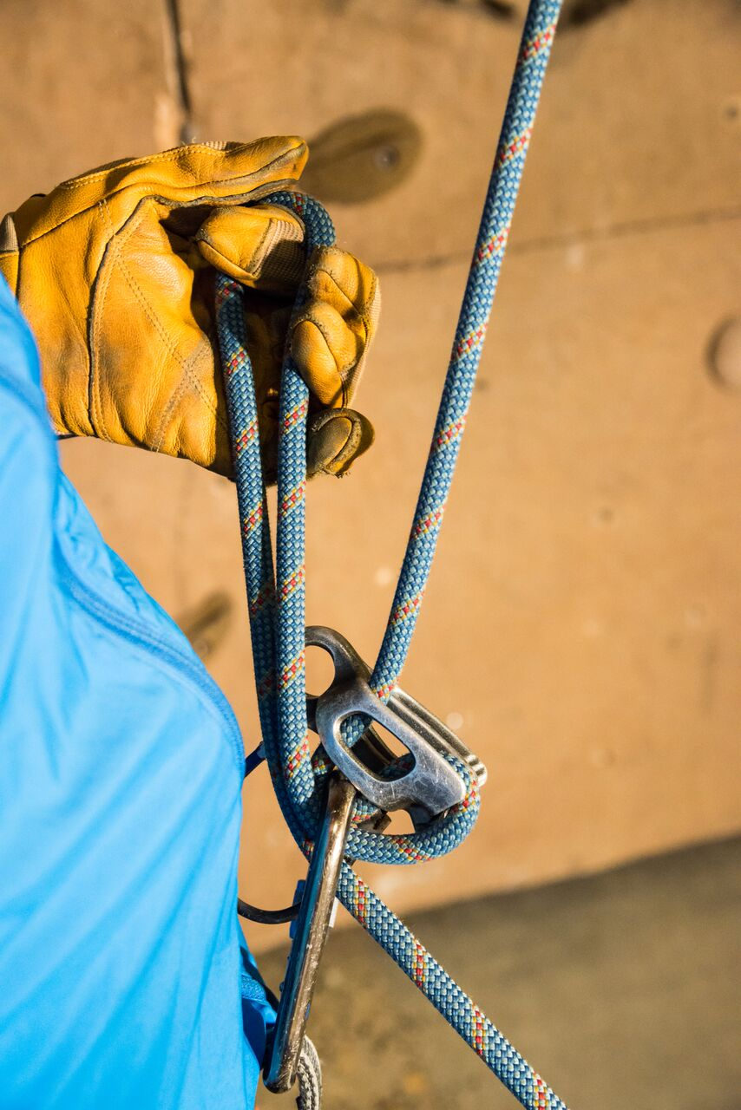 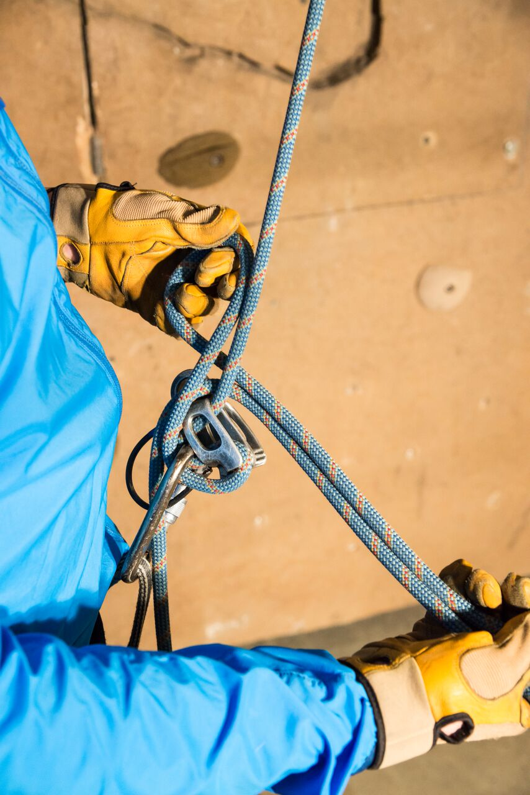 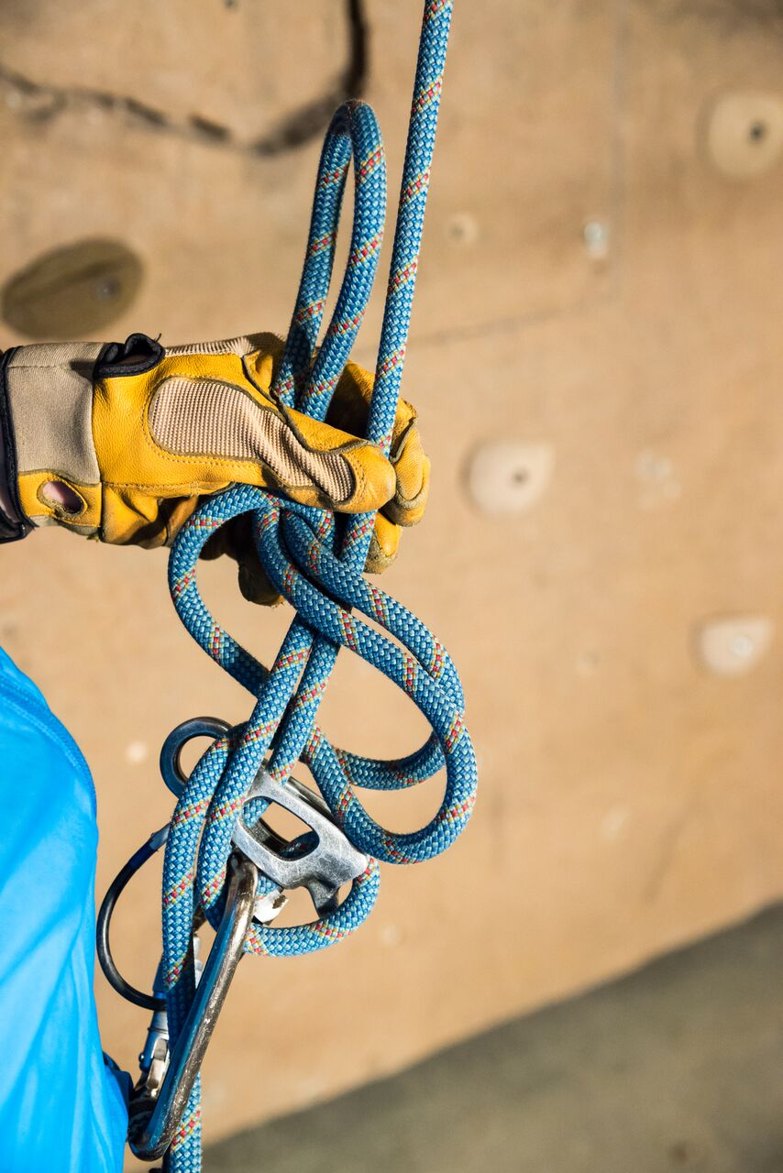

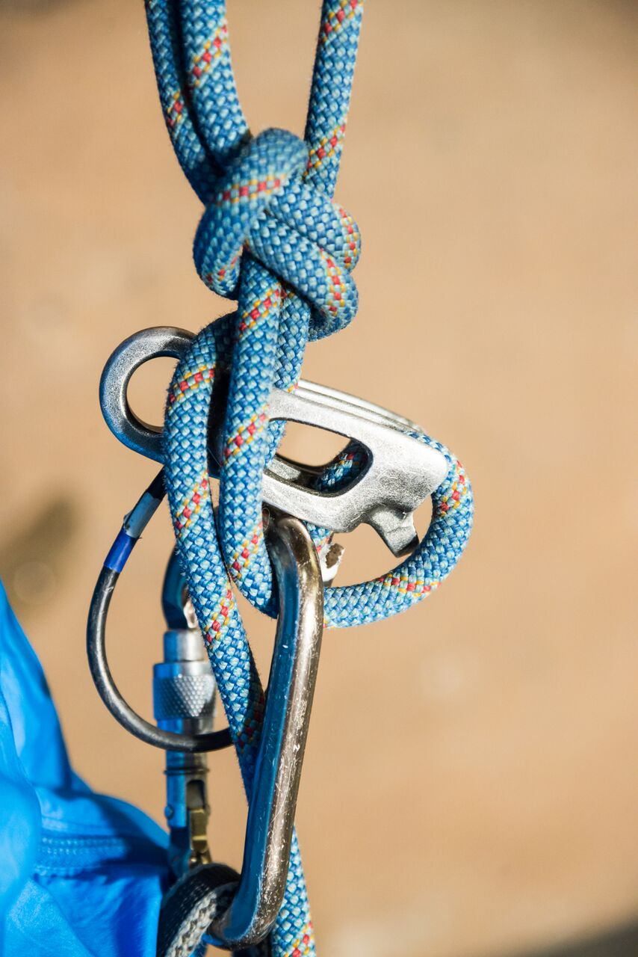 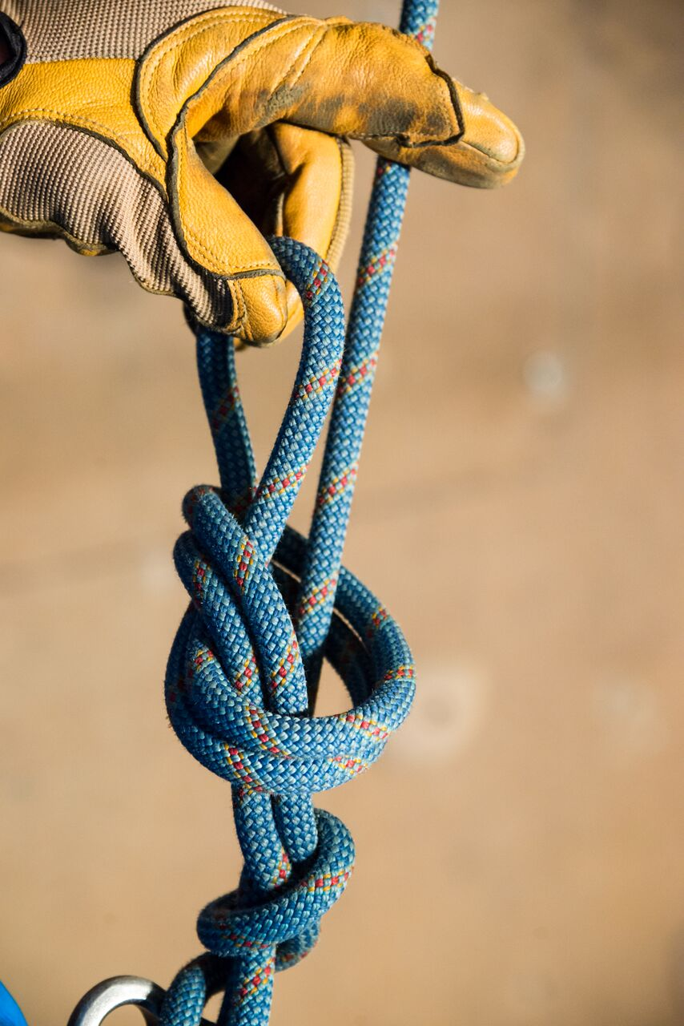 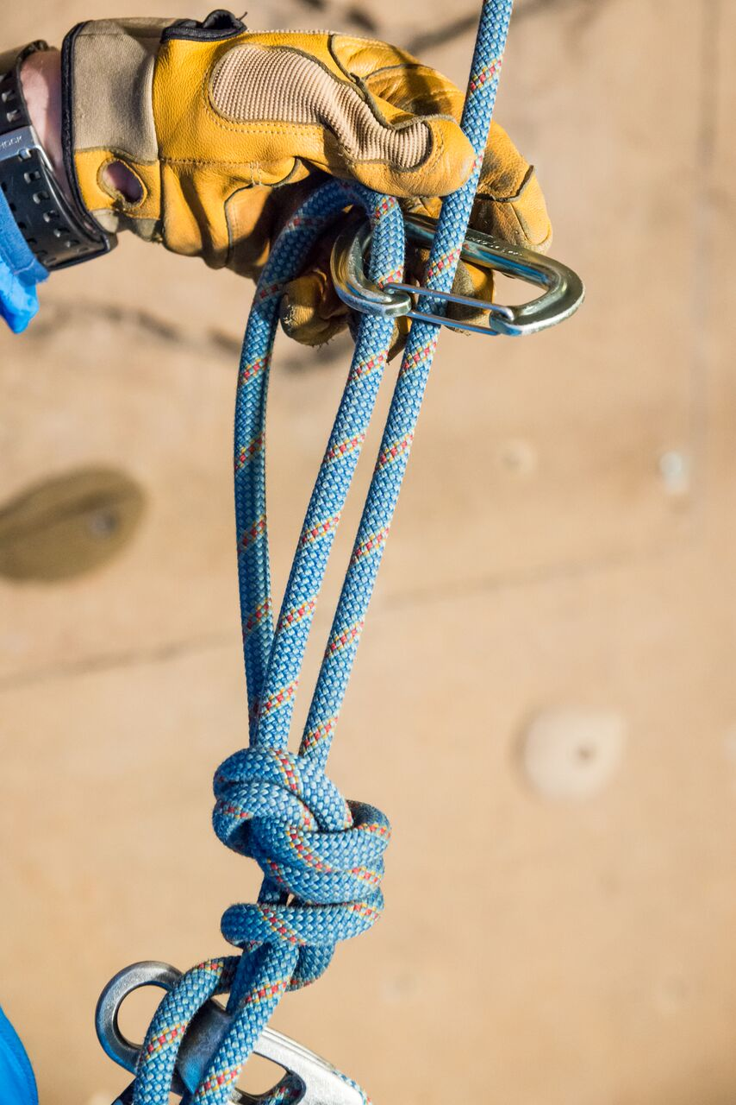

MÜNTER MULE TIE-OFF

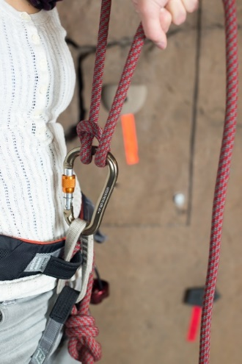 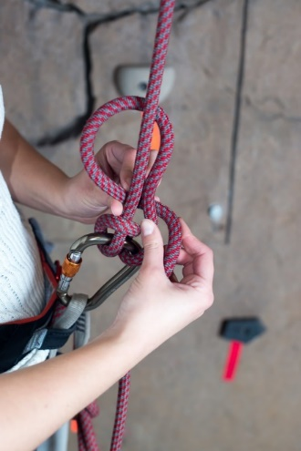 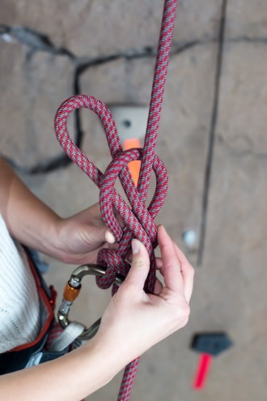

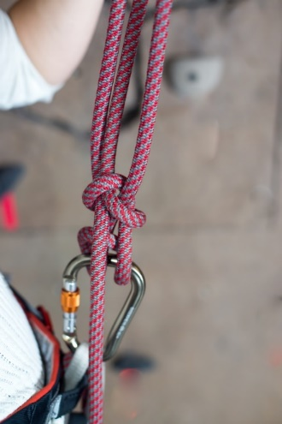 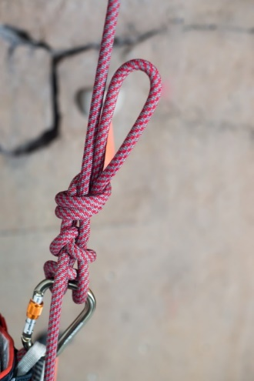 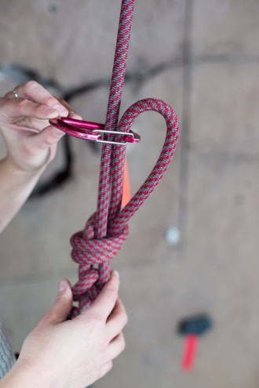

3:1 (Z) Pulley

2:1 (C) Pulley

Ten Essentials

Anchors